Who Wants to be a Millionaire Project Link
https://scratch.mit.edu/projects/3048459/
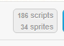 consider the number of scripts are duplicate coding stacks for each of the four multiple choice answers so not as complex as it might look
