WeDo 2 Links
https://kpscobracoders.weebly.com
You need to download the software and the curriculum to use the WeDo 2.0 Kit. The main site page is https://elearning.legoeducation.com/ The download link: https://education.lego.com/en-gb/product/wedo-2
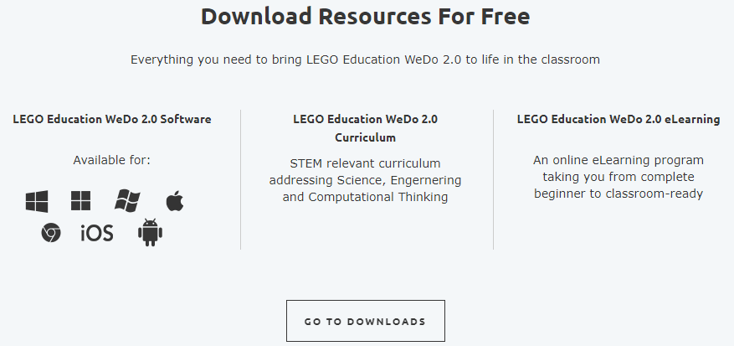
The link for the eLearning is: https://elearning.legoeducation.com/wedo-2-0
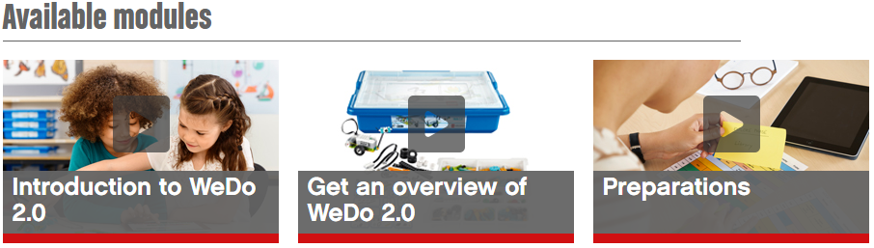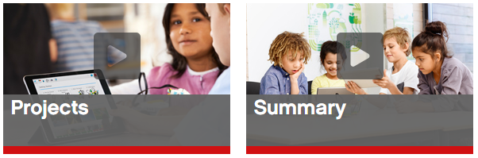
This is a quick “course” and you don’t need to view all the modules but it does explain the organization of the three types of lessons – Getting Started, Guided Projects, and Open Projects.
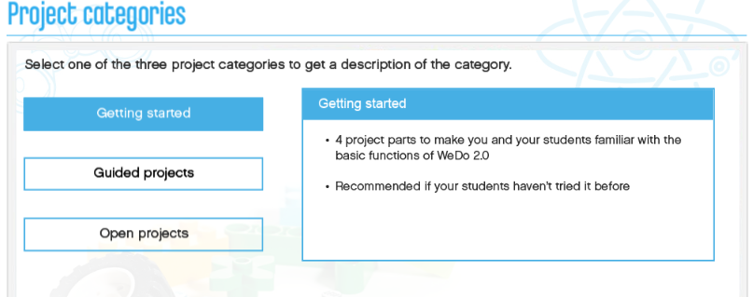
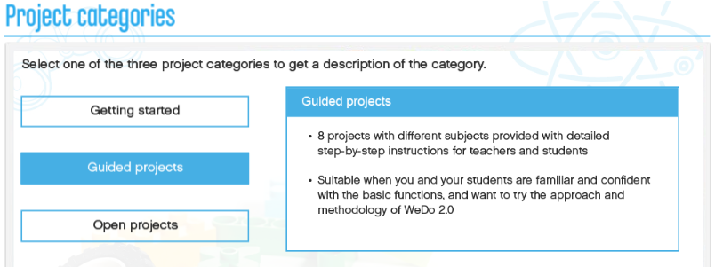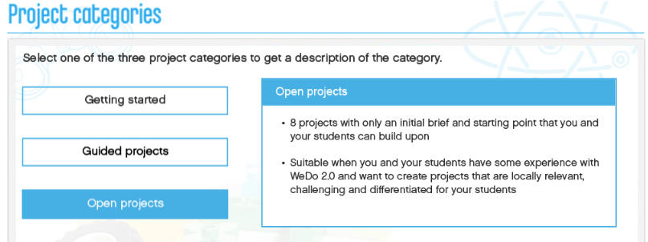
To find a Lesson Plan go this sorting page and click on the categories to refine your search: https://education.lego.com/en-us/elementary/lesson%20plans?Course=Early%20Simple%20Machines&Course=MAKER%20Elementary&Course=Simple%20Machines&Course=WeDo%202.0%20Science&pagesize=9
So, for example selecting Coding & WeDo 2.0 Computational Thinking filters down to 8 projects. All of these 8 are tagged at the Grade 3-5 (Intermediate) or Advanced levels so probably not suitable for SLP students.
While selecting Coding & WeDo 2.0 Science presents 24 projects. These 9 might be suitable for SLP age students.
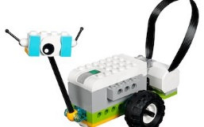Milo
https://education.lego.com/en-us/lessons/wedo-2-mini-lessons/glowing-snail
https://education.lego.com/en-us/lessons/wedo-2-mini-lessons/cooling-fan
https://education.lego.com/en-us/lessons/wedo-2-mini-lessons/moving-satellite
https://education.lego.com/en-us/lessons/wedo-2-mini-lessons/spy-robot
https://education.lego.com/en-us/lessons/wedo-2-science/getting-started-project-a
https://education.lego.com/en-us/lessons/wedo-2-science/getting-started-project-b
https://education.lego.com/en-us/lessons/wedo-2-science/getting-started-project-c
https://education.lego.com/en-us/lessons/wedo-2-science/getting-started-project-d
https://education.lego.com/en-us/lessons/wedo-2-science/pulling

Other on-line resources you might check out:
https://le-www-live-s.legocdn.com/downloads/WeDo2/WeDo2_MAKER_1.0_en-GB.pdf
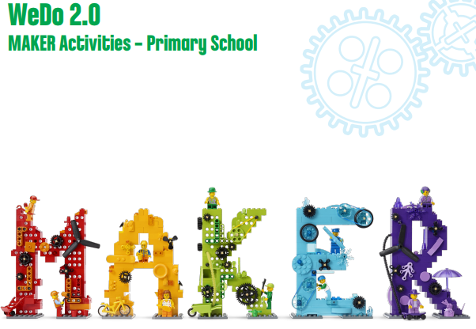
Lessons in this PDF:
Make a Sound Machine Page 8 to 17; Make a Dancing Robot Pages 18 to 25; Make a Life Hack Pages 26 to 33

