Visual Math Studio Links
Here is the Info on this coder https://scratch.mit.edu/users/deck26/ Desk26 has many shared projects (160+)that might be used – please check them out. Also Deck26 has 7 Studios and these projects are from the one titles Visual Math. https://scratch.mit.edu/studios/391821/
https://scratch.mit.edu/projects/20155460/ https://scratch.mit.edu/projects/20145249/ 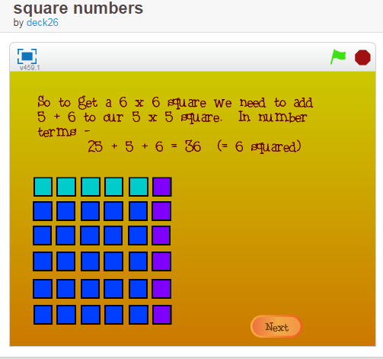 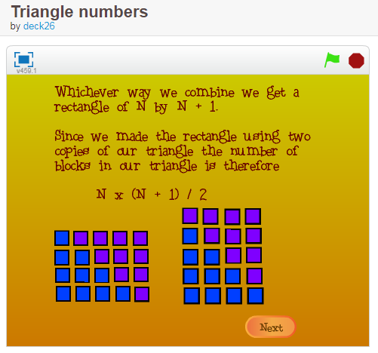https://scratch.mit.edu/projects/20200915/ https://scratch.mit.edu/projects/20344642/
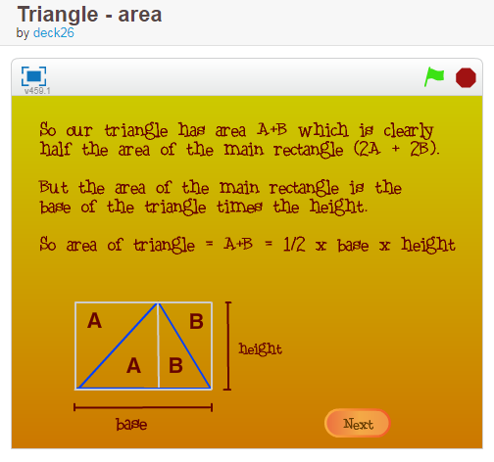 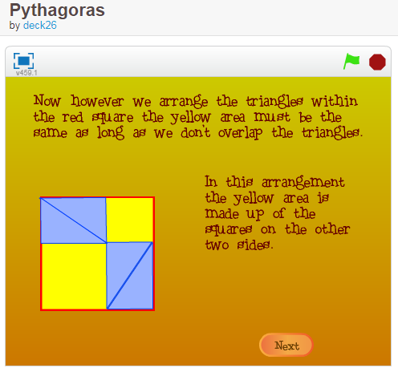https://scratch.mit.edu/projects/20230847/
