Tour Meet MicroBit
Start with the Meet tab and see that the first item has a link to the Features tab.
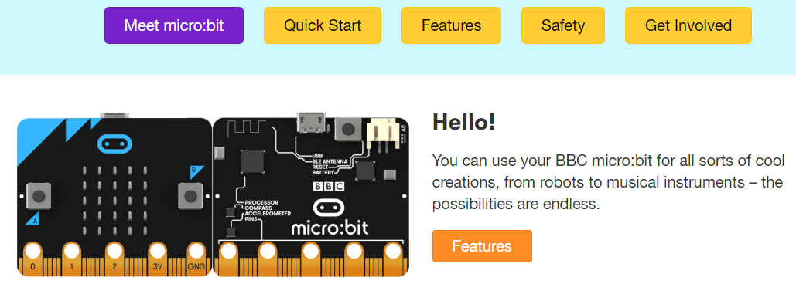
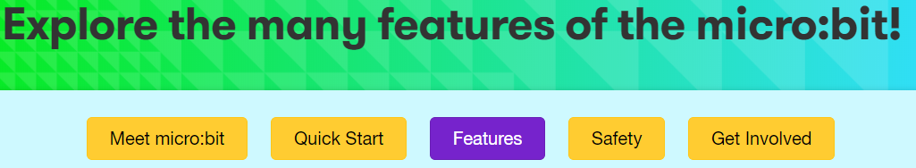
This section has diagrams of the front and back of the Bit. In addition there are photos and short descriptions of:
25 individually-programmable LEDs 2 programmable buttons Physical connections pins
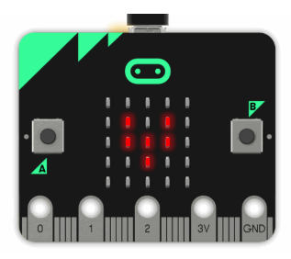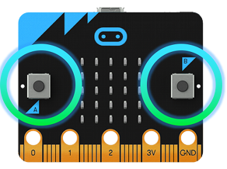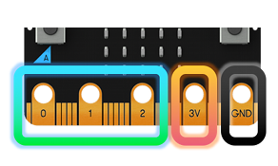
Light Sensor Temperature sensor Accelerometer motion sensor
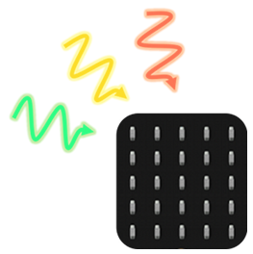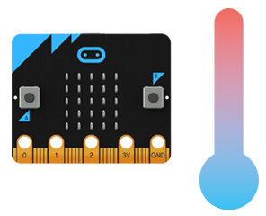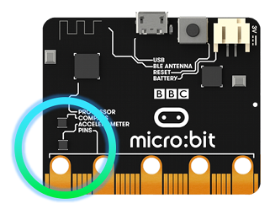

Magnetic Compass motion sensor Wireless Communication: Radio

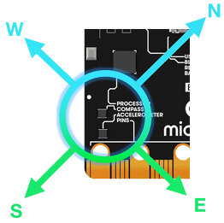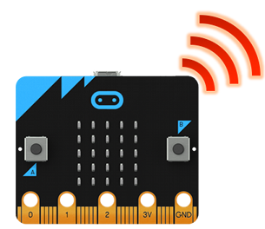
Wireless Communication: Bluetooth USB interface

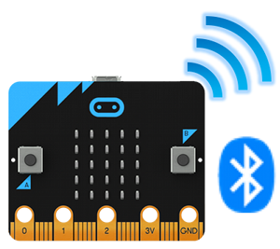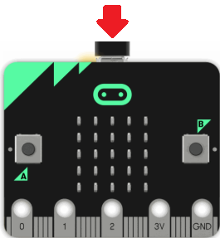

With each is additional information for example LED http://microbit.org/guide/hardware/leds/
Link to MicroPython http://microbit-micropython.readthedocs.io/en/latest/tutorials/images.html and a project https://microbit-micropython.readthedocs.io/en/latest/tutorials/images.html#animation
Link to JavaScript Blocks (remember that Scratch 3.0 will also be a Block platform you can use with MicroBits https://makecode.microbit.org/device/screen and a project https://makecode.microbit.org/projects/flashing-heart

What to use to code & where to find it …
http://microbit.org/code/
Four options
http://microbit.org/en/2017-03-07-javascript-block-resources/

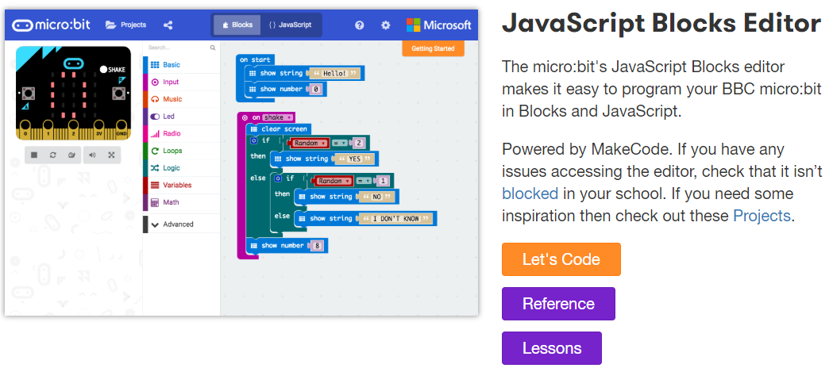
https://python.microbit.org/v/1

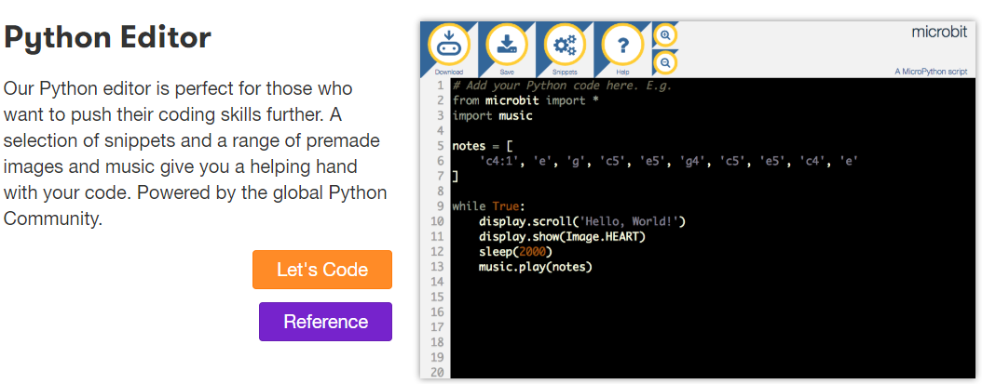

https://www.microsoft.com/en-ca/p/makecode-for-micro-bit/9pjc7sv48lcx?ocid=badge&rtc=1
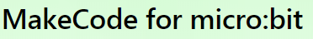
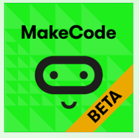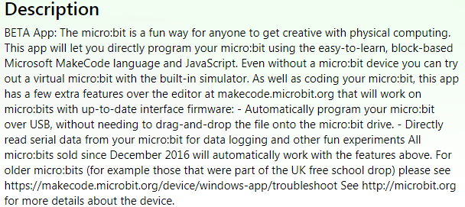
Scratch 3.0 (Beta until January 2 2019) https://beta.scratch.mit.edu/
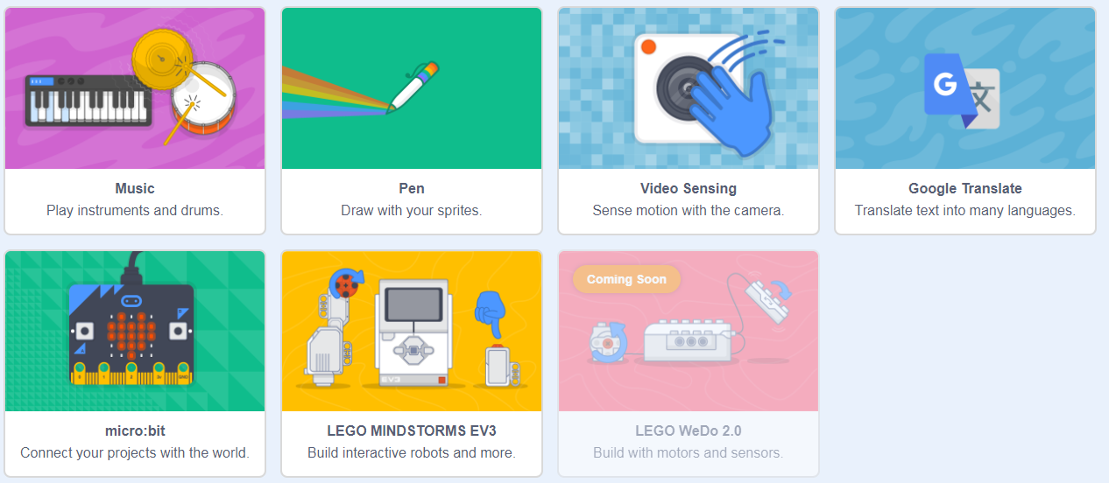

Beginning Lessons
Train the Trainer Lessons
Word Files https://drive.google.com/drive/folders/1IdPHYa129G1tlXhxwQKFpOp7Y9QhDIt9
PDF Files
Hex Files https://drive.google.com/drive/folders/1m27Fwd-HUyC0ipgSP3YjYyVWw0K2kK9y
49 Hex Files
