Text to Speech and Google Speech Extensions for Scratch 3point0
I am starting my discussion with these extensions (Text-to-Speech and Google Speech) for several reasons. One, I consider these to be one of the more significant additions/modifications from 2.0 and two, the fact that they are extensions that do NOT involve purchasing addition items. I will be singing the praises of BBC Micro Bit in a future blog entry and, although it comes at a relatively “cheap” cost, there still is a cost involved. One of the underlying principles of Scratch that I admire the most is its democratic principal of world wide access. Adding any cost immediately excludes someone, somewhere. Everyone with a version of 3.0 whether it be on-line or off-line will have access to these extensions.
This is a joint project between Scratch and Google. The workshop leaders were Eric Rosenbaum (MIT Media Lab) and Katelyn Mann (Google). Eric Rosenbaum is one of the creators of Makey Makey. As you can imagine the participants in the workshop were very excited to see this option available for coders and they had many questions … “Can it do this …?” “Can it do that …?” The responses of Mr. Rosenbaum and Ms Mann were warm and accepting. The members of the Scratch Team state quite openly and often they listen to their users and highly value the voice of teachers – this workshop was no exception. When the Google Translate Extension is added 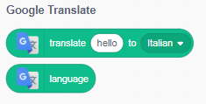 even more possibilities are available!
Goggle Translate is available for use in the Beta 3.0 version now. (See the screen shot of the extensions below – Music, Pen, Video Sensing, Google Translate, Micro Bits, & Lego Mindstorms)
The Extensions for Google Speech and Text-to-Speech are not far enough along in development to be part of the Beta version of 3.0 and were only available for use during the Conference. I did not know this at the time of the workshop and it is just pure luck that I saved my project to my computer and am able to show you this screen shot of the blocks. The screen shot (below) of the Extensions is just for the Beta version and does not show the two Speech extensions for the same reason.
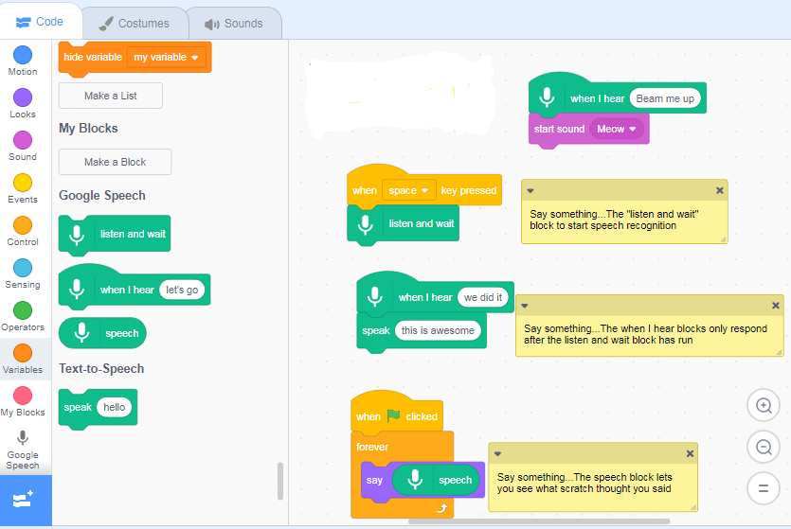
The Listen and Wait block starts the process off and for the workshop demonstration gave a quick “Meow, Meow” sound so that the coder knew the Microphone was initiated. One of the items still to be developed is a designation or label on a project that contained Text-to-Speech & Google Speech blocks so that anyone using the project would know that their voice would be detected and their device’s microphone activated. Perhaps it will be something like this message that comes up, usually for game projects 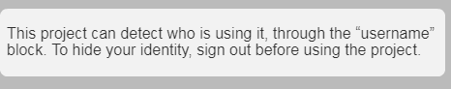
Or when you add the extension Video Sensing this appears as the TAB 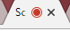 to show the device’s camera is activated.
Here are the extensions for Beta 3.0 as of August 2018.
