Tessellations Projects Links
https://scratch.mit.edu/projects/11577563/
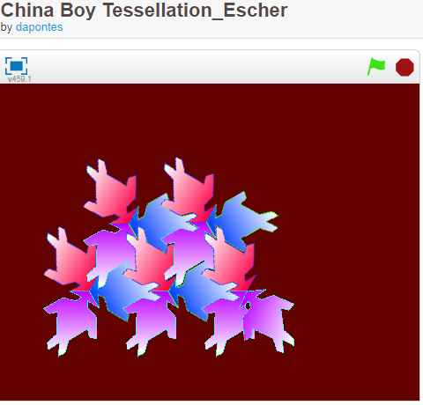
https://scratch.mit.edu/search/projects?q=tessellation/
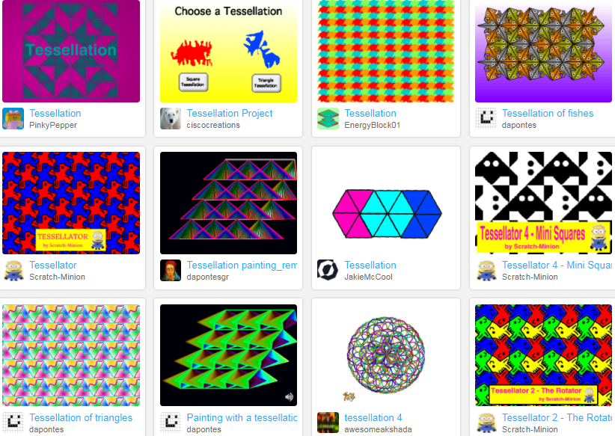
Grade 7 GSP Specific Expectations Location and Movement
By the end of Grade 7, students will: – determine, through investigation using a variety of tools (e.g., pattern blocks, Polydrons, grid paper, tiling software, dynamic geometry software, concrete materials), polygons or combinations of polygons that tile a plane, and describe the transformation(s) involved. Definitions: tessellation. A tiling pattern in which shapes are fitted together with no gaps or overlaps. A regular tessellation uses congruent shapes. See also tiling AND tiling. The process of using repeated shapes, which may or may not be congruent, to cover a region completely. See also tessellation.

