Ten Black Dots & Ten Flashing Fireflies Coding and Robotics Activities
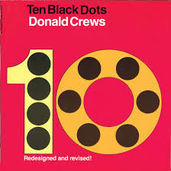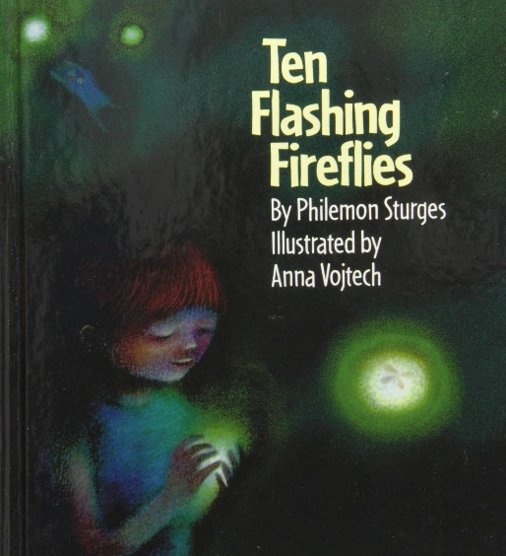

Ten Black Dots by Donald Crews
Link to a reading of the book on You Tube: https://www.youtube.com/watch?v=myhYN-mFW60
Ten Flashing Fireflies by Philemon Sturges
Link to a reading of the book on You Tube: https://www.youtube.com/watch?v=HjUhHAPtl0A
(Note: near the end the audio and pages are out of sync)
http://www.authorstream.com/Presentation/jtilley-1835422-ten-flashing-fireflies-philemon-sturges/
Some possible coding & robotics activities
Students make a copy of a page in the book or their own one design.
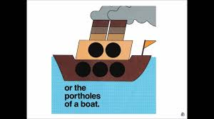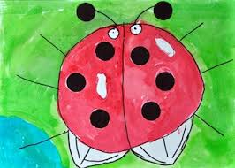
For Sturges book here is a PDF of a jar and fireflies: http://www.k-5mathteachingresources.com/support-files/ten-flashing-fireflies.pdf
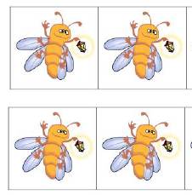

The artwork is spread out on the floor in a random grid.
DASH can be driven or coded to find the numbers in order from one to ten.
DASH can be driven or coded to go to each number and then stop. The students can retell the story up to that point.
DASH can be driven or coded to find Number Partners for 10 (here is a short video explaining the concept: https://www.youtube.com/watch?v=8__Ob36Ap70 ). For example, “Drive to the 3 dots and then drive to the 7 dots. 3 + 7 = 10.
Have a starting line taped on the floor. Code DASH to go 3 units forward, then 7 units forward. Mark the ending spot. Measure the distance travelled. Then return to the start and try another set of 10 partners, like 6 and 4. Mark the ending. Is it the same? Why?
Students can create a problem and have others in the group solve it. For example: “The answer is 17. It takes three moves (numbers) to get the sum 17. What are the numbers? Drive/Code DASH to show your thinking.”
DASH Extension:
Have dot cards or number cards for numbers greater than 10. Then complete these activities with those numbers.
Have the number words on cards and then code DASH to follow the sequence of number words in order.
BlueBot: lay all the numbers on the floor or table. Take a photo of the collage and add it as a background in the BlueBot app. Coding the same problems as DASH for this app.
Scratch Jr: Have two or three characters (Sprites).
Code first one with: Green Flag, Move Forward Block with variable 3, Move Forward Block with variable 7, Red End Block.
Code second with: Green Flag, Move Forward Block with variable 6, Move Forward Block with variable 4, Red End Block.
Code third with: Green Flag, Move Forward Block with variable 9, Move Forward Block with variable 1, Red End Block.
Have a “race” and see if they all end up at the same ending spot. Try it with other 10 Partner Numbers.

