Task #5 Making a Transformations Challenge
Need to take a peek: https://scratch.mit.edu/projects/401368569/
Now you are going to code a sprite to complete a series of transformations and see if a classmate can figure out the sequence of translations, reflections, and rotations the sprite takes from beginning to the end. One stack with a Green Flag event block will show the starting and ending position of Cat. After your classmate figures out the list of transformations, they click on the Space Bar and see if they are correct.
First you need to create your own backdrop. Use the Line tool to create your own grid with cells big enough to hold a sprite. If the grid lines are not straight use the Reshape tool to add handles and move the end points to straighten up the lines.
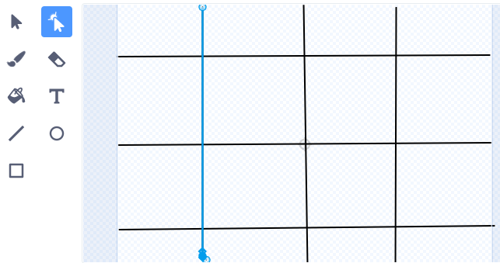
Make three costumes for Cat and label them. 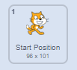 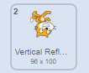 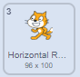
Pick up and move Cat (Start Position) to one of the cells in the grid. Take the Glide to X, Y block 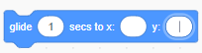 and put it in your stack. Remember Scratch pre-populates the variables as you move the sprite around the stage. Pre-populate means if I move the sprite to X = 60, Y = -85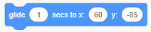 the Glide block will have those co-ordinates already for me or I can click on the variables and change them by typing in the numbers I want. Add the Stamp block.
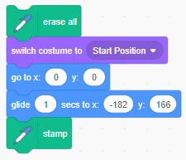 Move Cat to another neighbouring cell (translation) and add the Glide and Stamp blocks to your stack.
Move to another neighbouring cell and add blocks to create a Reflection or a Rotation. Each time remember the Stamp block.
Test out your stack with each move Cat makes.
Add the When Space Bar Event block to this stack.
When you are satisfied duplicate the stack and change the Event block to Green Flag. With this Green Flag stack think about what blocks you need to remove so that only the Cat in the Start Position is seen and the position at the end of the trail is seen. The Cat needs to make the same transformations at the same X & Y coordinates but invisibly. Are there any other blocks you need to add to the stack? In this example the middle two Stamp blocks were removed, and the Hide block added.
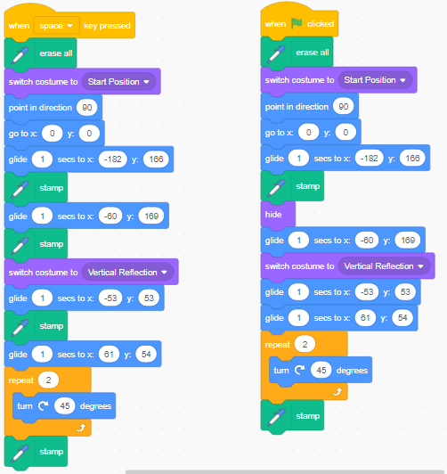
With the Space Bar stack consider adding a Wait block at each transformation so your classmate can follow it closely.
Consider adding the Look blocks so Cat can say the type of Transformation as it happens and perhaps lists all the Transformations at the end of the coding.
Add instructions on the Project page, then Save and Share!
