Task #4b Multiple Rotations
Need to take a peek: https://scratch.mit.edu/projects/399938465/
When Scratch Cat rotated in Task #4a the point of rotation was in the middle of its body and so each turn meant the body of Cat overlapped. For this next task let’s draw a sprite that won’t overlap. When drawing a sprite what physical features will you need to make sure it has so it doesn’t overlap? You might want to draw and cut out a paper shape to try out your ideas.
Create a new project. Title it Geo #4b and save it to My Stuff. Delete Cat Sprite. Click on the Paint Brush option for Choose a Sprite. 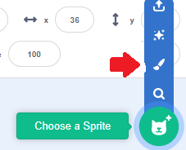
As you learn to code in Scratch you might be interesting in making your own Sprites that are more elaborate than this project’s sprite. If so, here is a link to information about the Paint Editor in Scratch Wiki to get you started. https://en.scratch-wiki.info/wiki/Paint_Editor For now here is some of that file’s info to get you started.

Line Tool
The line tool is used for drawing straight lines in the vector editor. A line consists of two points of the spline: one in the beginning and one at the end. To draw a line, click and hold the mouse, and release to draw the line from the starting point of the mouse-click to the release point.
Note: | to draw a curved line, you must first draw a straight line, select the reshape tool, and shift-click anywhere on the line to create a new point which forms a curve on the line.

Oval Tool (Circle)
The circle tool is used to draw ovals or perfect circles. This can be done by clicking and holding the mouse on the canvas. Then, an oval will form in relation to the mouse's starting and ending coordinates. To draw a perfect circle, hold the ⇧ Shift key while drawing with the oval tool.

Rectangle Tool (Square)
The rectangle tool is used to create a geometric rectangle (4-sided with right-angle corners). When the tool is selected, the rectangle can be drawn clicking and holding down the mouse-pointer, then releasing. The rectangle has four points on it, each at a corner. To draw a perfect square, hold the ⇧ Shift key while drawing with the rectangle tool.

In the bottom right hand corner is click on the + magnifier several times and the checker board pattern of the screen will enlarger. Notice the centre of the screen. to this
We want the one vertex of the sprite to be at this centre point because that is the point of rotation. Click on 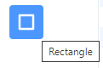 and click and drag the mouse from the corner of that centre spot up to the right. When you release the rectangle has this look – there are “handles” at each vertices and mid-points and a turn handle at the bottom. 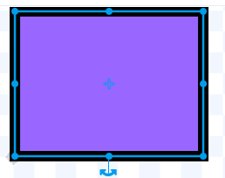 Also notice the rectangle might be filled in and have a wide perimeter in a different colour. These characteristics of the rectangle can be modified. For example, these settings 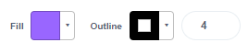 can be modified to 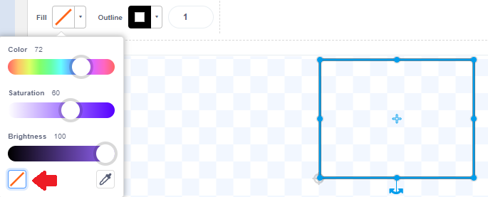 If you don’t want a visible perimeter, make the Colour, Saturation, and Brightness of Fill and Outline the same numbers
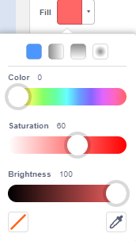 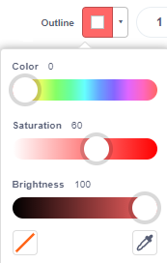 by sliding along the pixel bars. If you want to learn more about color pixels you can search for them on the internet.

Click on Reshape 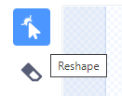 and use the mouse to click and move the handles of the rectangle until you are satisfied with the irregular shape of your rectangle (don’t forget to use the – and + magnifying tool to see parts of the rectangle up close or move out to see the whole rectangle. Any time you can’t see the handles click anywhere on the sides of the rectangle to have them reappear.
Ready to code the sprite and show rotations? Think about the blocks you used before. Will you need Pen Blocks? Motion Blocks? What other blocks might you want to use? Remember to test out your block stack as you build it and debug it as needed.
Hints:
Remember to add information on the Project Page. Don’t forget to Save and Share when you are done.
Remember if you use the Repeat block and the Turn block 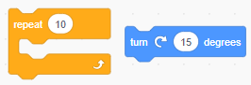 there is a relationship between the number of repeats and the number of degrees AND there are 360° in a circle.
Consider adding this Look block to your stack. 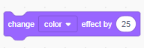 it has a variable you can change by clicking on the white circle.
Does your stack look like this? Remember there can be different ways to code - your stack does NOT need to match this one. For example, the Wait block is something used to show the coding unfold slower.
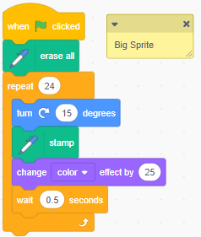 Notice I added a Comment that says Big Sprite. If you want to find out why read on!
Extra Coding Ideas
Make a second sprite. Make this one smaller than the first sprite but the same shape. Remember to make one of the vertices point to the centre spot. Name it, Small Sprite.
Use the same block stack for this sprite. You can create it again or go to the Big Sprite and drag that stack over to the Small Sprite icon under the stage. You will see that icon change to a blue colour and giggle when the stack is right on top of it. Release the stack and it should appear in the sprite’s coding area. You can keep the same Event block or change it – it’s up to you!
If things don’t go as you planned, you might need 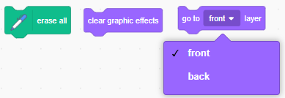 one of more of these blocks.
Also, what happens if you use to rotate each sprite in a different direction or change the direction starting point for each sprite? 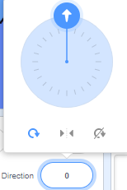
What other additions to coding could you do? Add a sound? Move to the four quadrants and have the sprite rotate? Change the color of the backdrop? …
