Task #4a Scratch Cat Makes Rotations
Need to take a peek? https://scratch.mit.edu/projects/398236634/
Before you start a new project think about what a rotation is and what blocks you might use to make a sprite rotate. Select the grid background you want to use. Click on Scratch Cat sprite 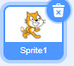 Click on Costumes Tab and change the name of the sprite to Cat. Make this stack 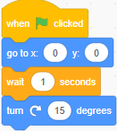 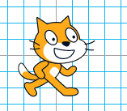
Click the Green Flag or the stack itself over and over (count how many times!) watching Cat rotate around Cat is back to where it started. As you click notice the Direction display underneath the Stage.
After six repeats did the Direction say and did Cat look like 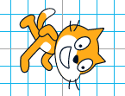 ?
After 12 clicks and 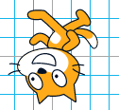 ?
After 18 clicks and 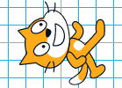 ?
After 24 clicks back to ?
It takes 24 times to rotate Cat 15° (degrees) to “get around” and back to the start position. Hmmm 24 X 15 = 360.
360° (degrees), that is the number of degrees in a circle. Protractors show 180° (degrees).

Ready for some math? How many rotations if we…?
Rotate Cat 10°? Rotate Cat 90°? Rotate Cat 180°? Rotate Cat 1°? For 1° did you think 360 times? Well, let’s add a Control Block to simplify the process. Let’s add the Repeat block. By clicking on the VARIABLE in the Repeat any blocks inside the Repeat arms will carry out the coding that many times.
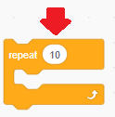 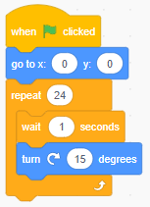 Add the Pen blocks to the palette and include the Stamp block to show all the rotations in the stack.
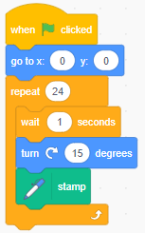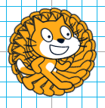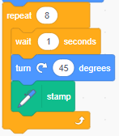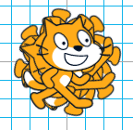
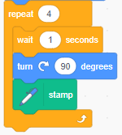 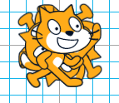 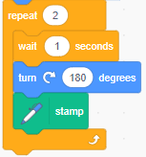 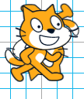 Did you remember from the other coding tasks to have block handy to clear out the stage each time you change the variable? Almost done. Let’s show four different Scratch Cat rotations by using the different keys in the Event Block. Right click on the top block and duplicate it three times. Also change the X & Y coordinates so Cat is in each of the four quadrants (X, Y), (-X, Y0), (-X, -Y), & (X, -Y). Finally change the number of repeats to correspond to the rotation degrees.
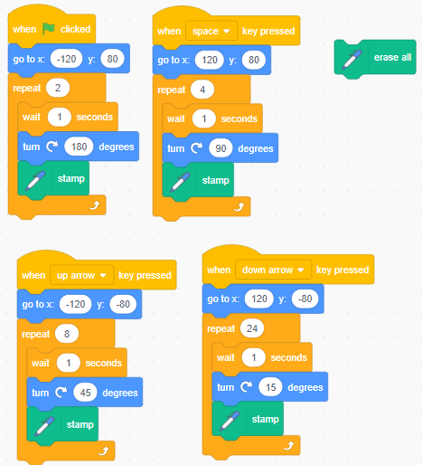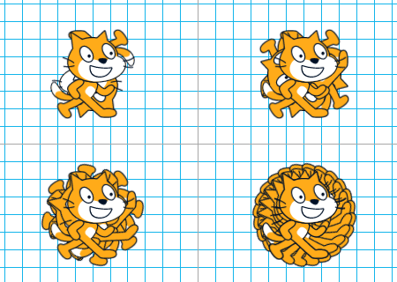
Don’t forget to add instructions on the Project Page, Save, and Share your work!

