Task #3b Multiple Reflections
Need to take a peek? https://scratch.mit.edu/projects/395796927/
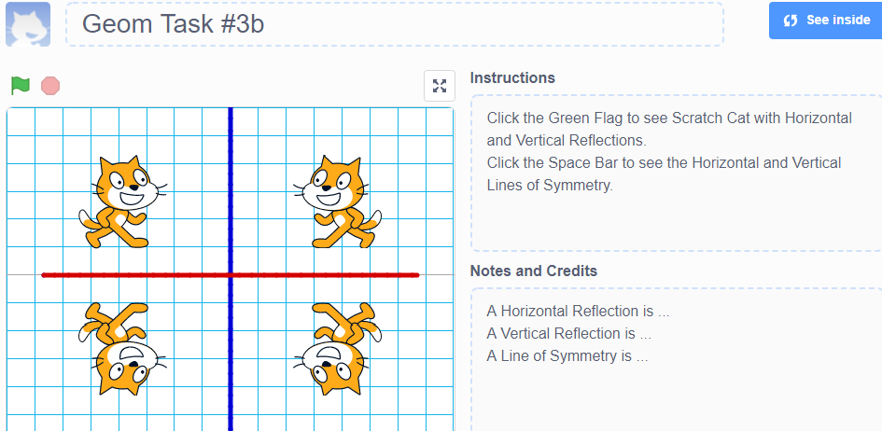
Start a new project. Select the grid background you want to use. Click on Scratch Cat sprite 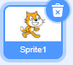 Click on Costumes Tab. and click on 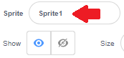 and change the name to Cat, click Enter. 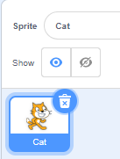 and change here 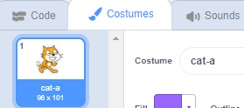
This may seem unnecessary and for a project with only one sprite maybe it is, but as you use Scratch more and more you will use more and more sprites. It will help you keep them organized if you give them names that mean something to you.
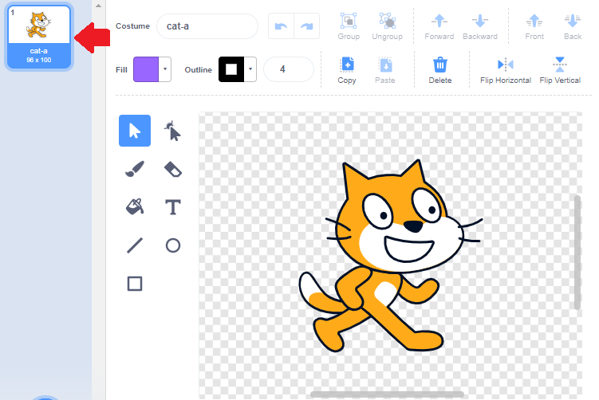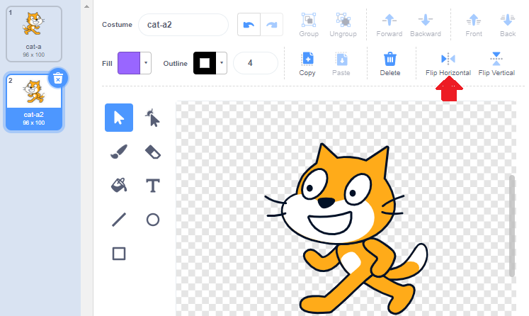
Right click on the small Cat-a in the upper Left-hand corner and select Duplicate to make Cat-a2. Then Click Flip Horizontal. Then Duplicate both these Costumes and Flip Vertical. Now you have 4 Cat Costumes! If you want to have them in order, click on a Costume and Drag it up or down.
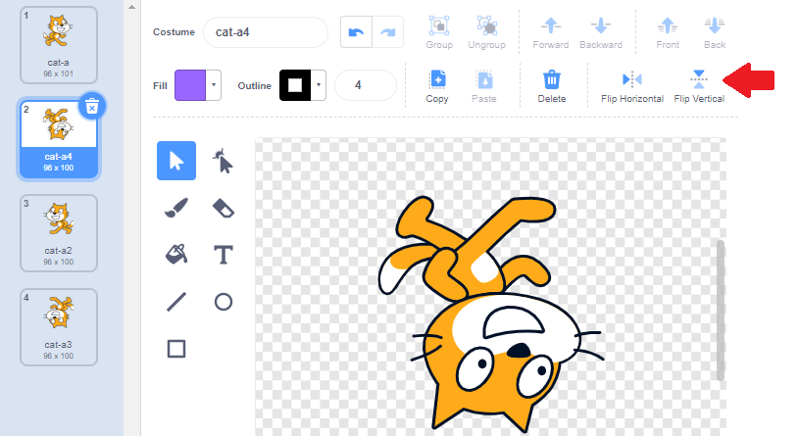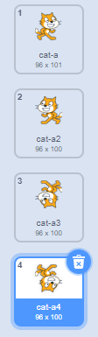
Now we are ready to code.
Title this project Geo Task #3b
Select one or more of the Grid Backgrounds to your Project. Add Pen Blocks to your Block Palette.
Select an Event Block to start your block stack. Add Erase All Block so that each time you run your program the Stage is empty.
Decide which of your four cat costumes you want to start with and which quadrant you want it to be in: (Upper Left (-X, Y); Upper Right (X, Y); Lower Left (-X, -Y); Lower Right (X, -Y). Move the sprite to that location and add the Glide block.
Add the Stamp block. Decide what to do next. Do you want a vertical reflection or a horizontal reflection? Duplicate the blocks and change the values of X &/or Y and the costume to suit the quadrant.
Then code for the remaining two quadrants. Attach them together to make a long block stack.
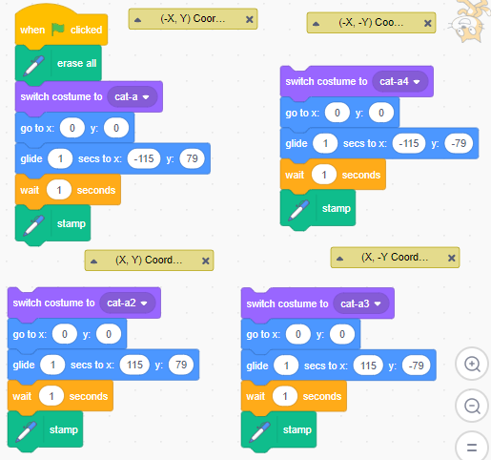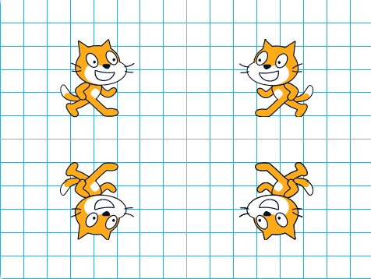
Now code for the Lines of Symmetry.
Think of the coordinates to draw a straight line. Do both the X and Y change? Which coordinate changes to draw a vertical line and which coordinate changes to draw a horizontal line?
What blocks will you need in your stack? An Event Block? Motion Blocks? Pen Blocks? Each time you code try and figure out more and more on your own. Remember testing as you go helps not only your project be successful, but it will help you learn and remember what the blocks do. For example, the project draws a line where you don’t want it to be, you think, “In the last project I remember using the Pen Up and Pen Down blocks – oh, when I debug this stack I see I didn’t use the Pen Up block at the start of the stack!”
Also think about the idea that there might be several different sets of blocks that get the same results. If your block stack is different than the ones used in this plan, but the results are the same that’s OK. Does your stack have these blocks? Did you come up with another way to draw the Lines of Symmetry? Did you decide to use a different colour for the vertical Line of Symmetry than the horizontal Line of Symmetry?
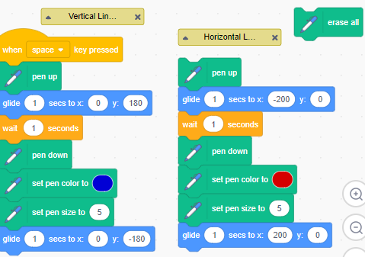
Did you notice the Erase All block off to the side? It’s not connected to the stack. That’s a shortcut to use when you are building your stack. Anytime there is a problem and you need to debug just click on an individual block such as the
Erase All 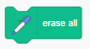or Go to X=0, Y=0 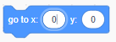 and try it again.
Don’t forget to add Comments to label your lines. Also, it is time to add Instructions to the project page.

Extra Coding Ideas
Can you create a project that has two Scratch Cats in positions that has a diagonal Line of Symmetry? You can take a peek with Sprite Cat2’s coding.
Hint: Different ways to code this and you might try these blocks
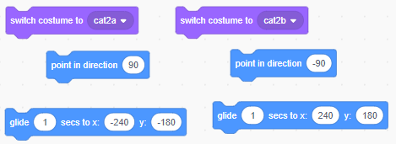
Point in Direction is an interesting block. Here is what it looking like when you click on the white oval. 