Task #3a Simple Reflections
Need to take a peek? https://scratch.mit.edu/projects/395044956/
Select Create to make a new project. Title it Geo Task #3. We are starting with the Ball Sprite to learn coding, but better examples of coding AND reflections will come when we use different sprites and the last part will be the best, when you create your own sprite and code it’s reflection!
Add the three grid backgrounds to your project. Click on Choose a Sprite and click on Ball Sprite
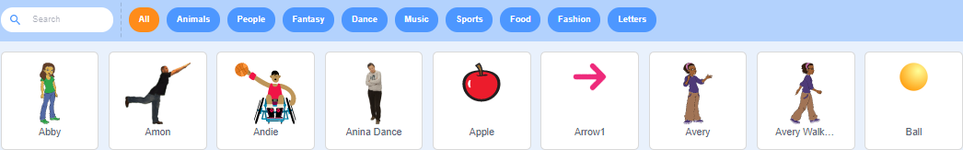
Click on the Trash Can X to get rid of Scratch Cat Sprite. 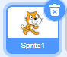 you should have only one sprite, Ball Sprite.
Remember in Tasks 1 & 2 we moved Scratch Cat to a spot in each of the four quadrants? (X, Y), (-X, Y), (Z, -Y), & (-X, -Y)
Code Ball Sprite to start at (0, 0) when Green Flag is clicked; Wait 1 second; glide to a spot in (-X, Y); wait 1 second, glide to a corresponding spot (corresponding spot - use the same numerals, but the actual number might need a - sign) spot in (X, Y); and Wait 1 second. Add a Comment note: Ball Sprite
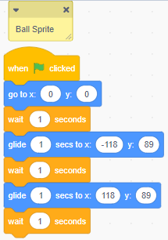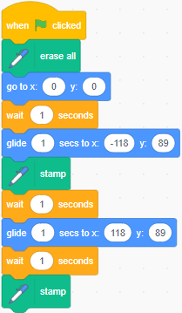
This could be a Translation move and it could be a Reflection move, plus it is not a very interesting move at that. The reason it could be either is the Ball sprite doesn’t have a distinguishable top, bottom, left, or right. Let’s add more coding and make it a Reflection.
First add the Pen Blocks like you did in Geo Tasks #1 & 2. Add the 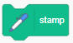 block to two places in your block stack. See the difference this block makes.
Now, let’s make a Line of Symmetry. Understand this: On the grid from (-118, 89), the sprite needs to move to the RIGHT 118 pixels to get to the halfway point. From (118, 89), the sprite needs to move to the LEFT 118 pixels to get to the halfway point. What would X = ? at the halfway point (__, 89)? To make a line we want to start above Y = 89 and end up lower than Y = 89.
So, let’s use the Pen Blocks we used to mark the trail of Scratch Cat to draw a line of symmetry and these blocks as well 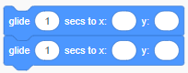 The Hide block will hide the Ball Sprite. Add an Event Block and a Comment for Line of Symmetry.
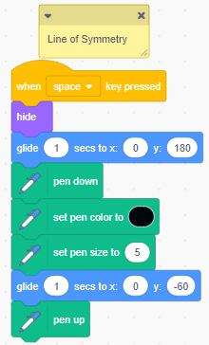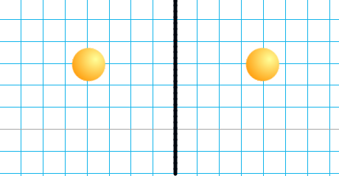
This is a Reflection for an object that is uniform from all sides. Let’s see a reflection of a sprite that is not uniform, like Scratch Cat.
Remember to:
Test out your coding as you create your block stack. Waiting until the end can make it difficult to find out where you need to debug you programming.
Name this project Geo Task #3a
Add notes to your coding so others can understand the thinking behind your choices.
Any changes you make and appears. Click on Save Now before you leave this project and if you are having problems with your device click on it while you are working – just to be sure your most up-to-date coding is saved in My Stuff 