Task #2 Scratch Cat Makes Translations
OK, Lets get Scratch Cat moving around on the grid. Go to the bottom left hand corner and Click on 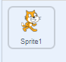 and it will change to white inside the box 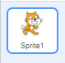and have a Delete Sprite Garbage Can 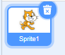 You will also notice the three Tabs on the left-hand top of your screen are now
Underneath the Stage you will see 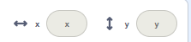 in Backdrops but once you start coding the Sprite you will see 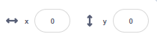 if Scratch Cat is in the middle of the stage.
Use your mouse and pick up Cat and move it to the upper left-hand corner. 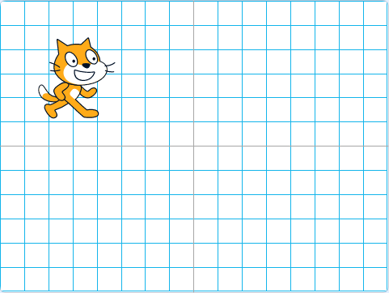When you release the cat check out the X & Y coordinates under the stand. Is your X coordinate a negative (-) number? 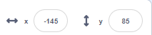 Move Cat to the upper right-hand corner. Check out the coordinates now. 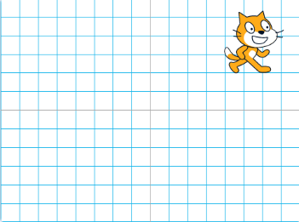 Before moving Cat to the lower left-hand and right-hand corners of the stage, what do you think will be different about the X & Y coordinates?
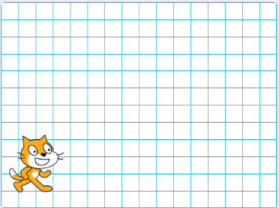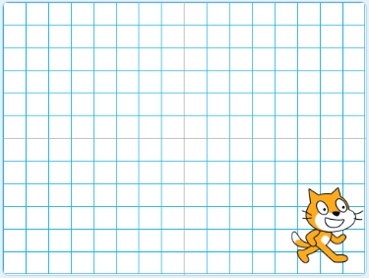
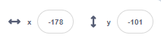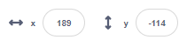
OK, you have moved Scratch Cat around the 4 quadrants with your mouse, now let’s code Cat to move on its own.
Make sure you are using blocks for Cat. Here’s how you can check. First is there a blue box around the Cat below the Stage? It should look like this 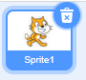 not this 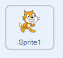 and the Tabs above the Block palette should be not
Cat should start in the middle of the grid. Think of what the XY coordinates should be. Did you decide (0, 0)? OK add them to a move block. 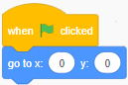 Make four sets of these three blocks 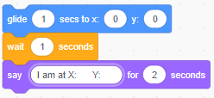 and type in X&Y coordinates so that Cat moves to a position in all four quadrants. Anything in the white circles or ovals can be altered by you by clicking on it and changing the contents. These are called VARIABLES – just like in math!
Have Cat show its location at each resting spot. Remember the Say block shows the text. If you would like the Cat to say the location 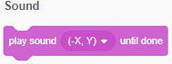 click on Sounds Tab, click on Record. 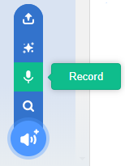
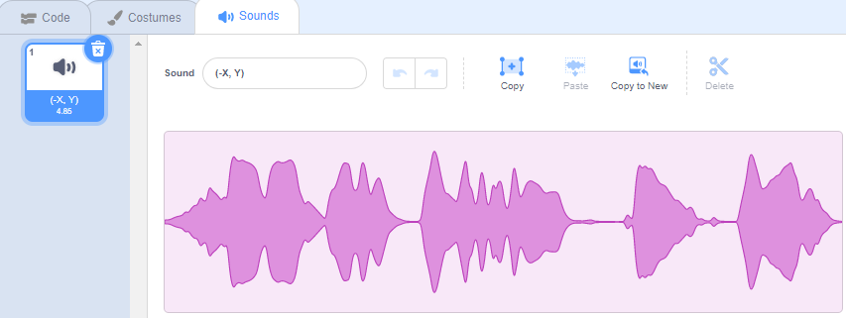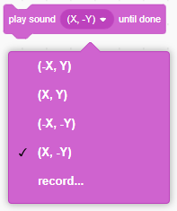
Remember to:
Test out your coding as you create your block stack. Waiting until the end can make it difficult to find out where you need to debug you programming.
Name this project Geo Task 2
Add notes to your coding so others can understand the thinking behind your choices. Right click on the Script Area and this pops up 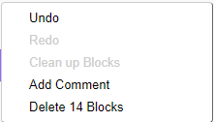 Select Add Comment and type in the information
Click on and directions on how to run the project and a definition of Translations to the Note and Credits section 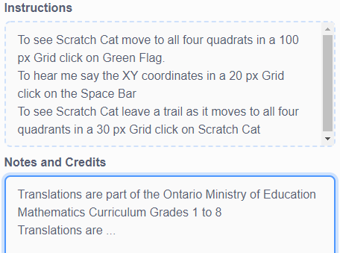
Any changes you make and appears. Click on Save Now before you leave this project and if you are having problems with your device click on it while you are working – just to be sure your most up-to-date coding is saved in My Stuff 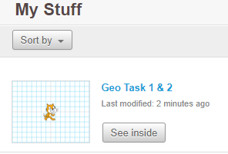

Extra coding ideas
Can you code Scratch Cat to make Translation moves using both the Say Block AND the Play Sound Block? Check inside Project 391834828 for different coding stacks used for these activities.
Can you code Scratch Cat to leave a trail as it moves to each of the four quadrants?
Hint: You will need to add Pen Blocks 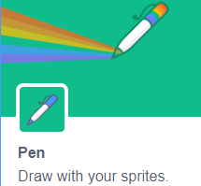 Don’t worry if you don’t try this one. In Geo Task #3 there will be instructions how to use Pen Blocks.
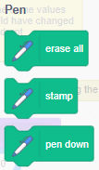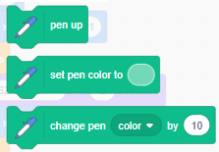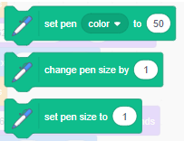
Extra - Extra coding ideas
Can you code Scratch Cat to make 10 random Translation moves AND say what the XY coordinates are at each spot?
Hint: here are three new blocks you might want to use
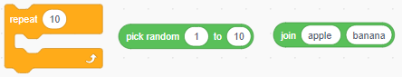
The Join block is interesting because you can join Join blocks together! Remember any information in a white oval is a VARIABLE. By changing the Variable you change the code.
