Scratch Geometry Activities
Task #1 Get a Grid Background and Move Scratch Cat Around
Need to take a peek? https://scratch.mit.edu/projects/391834828/
Once you are on the Scratch Create screen go to the top and change the title from to DO NOT click Share yet.
Then go to the bottom right hand corner and click on and this menu will pop up. 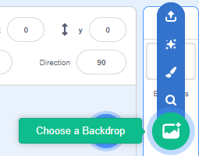 You will go to a screen with many backdrops.
Stay in ALL and scroll down to the bottom. 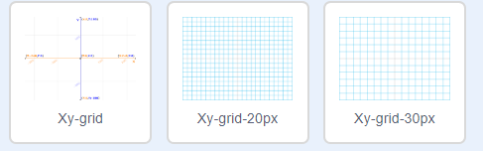
You can select one or why not all three and then you can shift from one to the other.
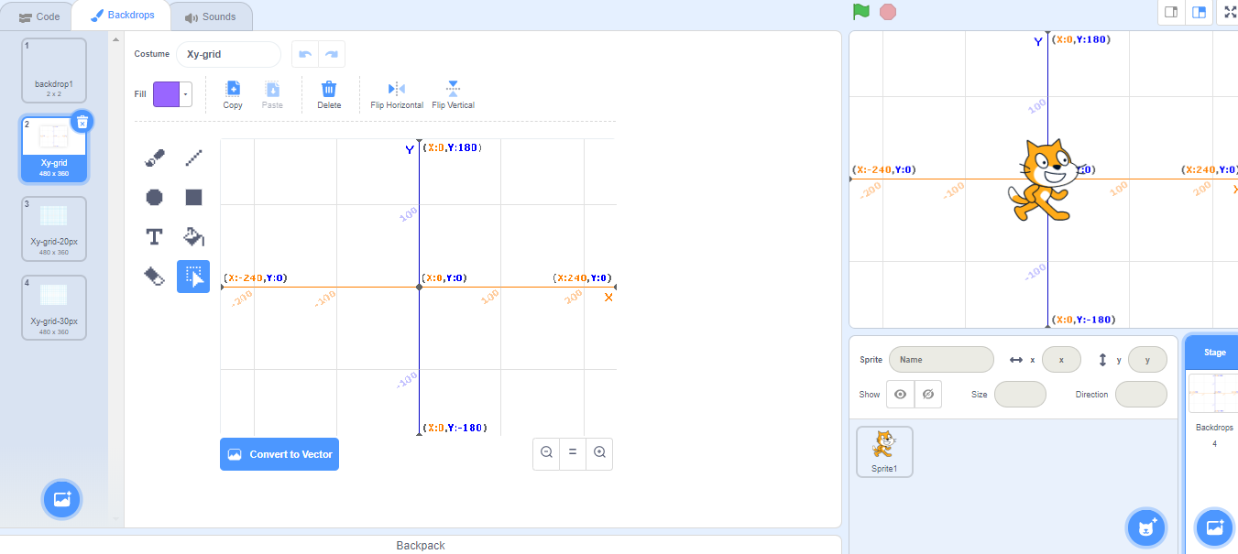
Xy-grid has lines 100 pixels apart, the other two have grid lines 20 and 30 pixels apart.
Backdrops have some blocks but not all the ones the Sprites have. You will know you are coding for a Backdrop if you see these three tabs on the right-hand top of your screen
You can code the backdrops to switch from one to the other. In LOOKS there are 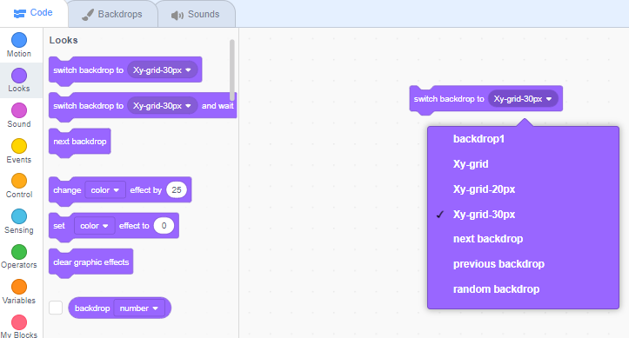 these 3 blocks you will probably use 