Social Studies Geography Projects Links
Inspirations and Connections: Each month or so Scratch has a new Scratch Design Studio (SDS) (https://en.scratch-wiki.info/wiki/Scratch_Design_Studio ). The list of topics can be a good source of projects based on a single idea or theme. Here is the link to see all the ones to date: https://en.scratch-wiki.info/wiki/Scratch_Design_Studio/Studios
These studios are curated by Scratch people at MIT so the quality of individual projects seems to be higher than other studios. Students should have the list of SDS links. The 87th theme was Scratch Around the World!: https://scratch.mit.edu/studios/974688/
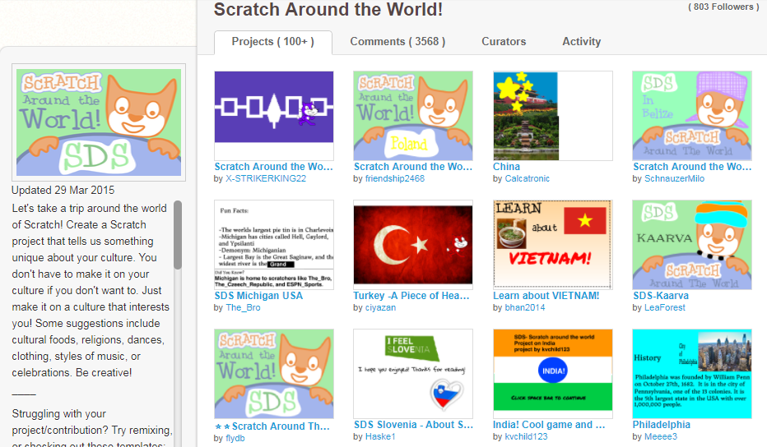
https://scratch.mit.edu/projects/13198938/ https://scratch.mit.edu/projects/10440575/
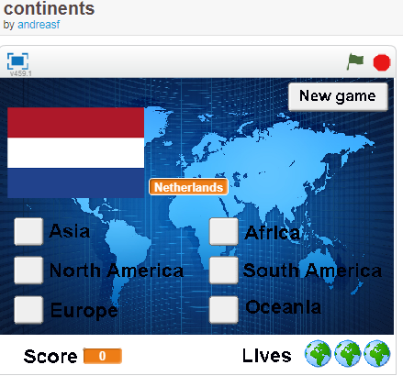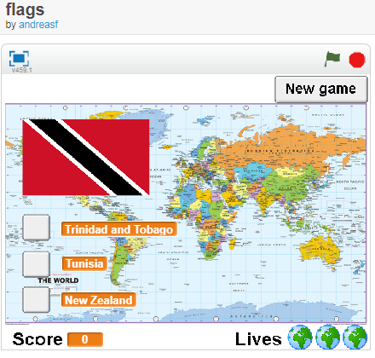

Thanks to Doug Peterson’s Daily Blog (https://dougpete.wordpress.com/ ) March 17, 2018
This site would make an interesting source for Scratch projects https://native-land.ca/
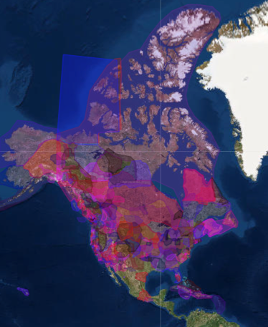
https://scratch.mit.edu/projects/111711535/ Mammoth project, a Featured Project, certainly not one to remix but to view for ideas Tags: map, geography, continents
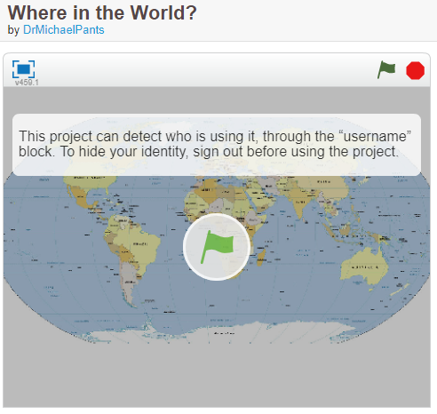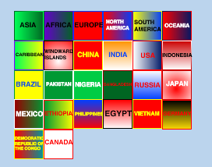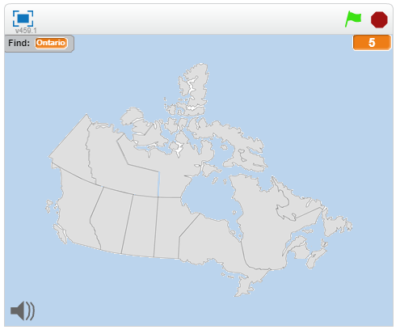
https://scratch.mit.edu/projects/95721352/ Note: ask the player for their name, possible coding stack for a question
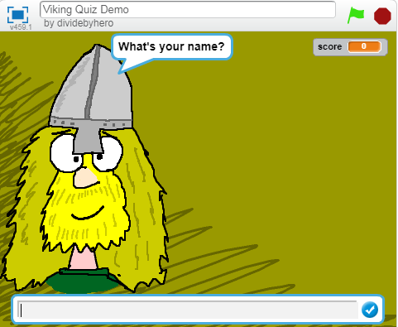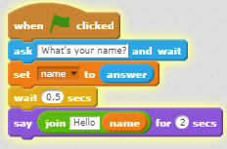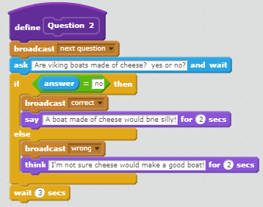
https://scratch.mit.edu/projects/160136581/ Note: the choice of answers is in the question so just select a or b
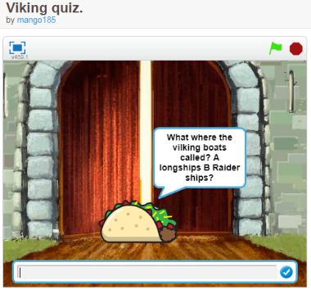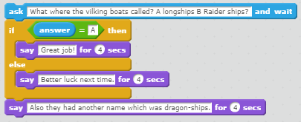
Note: check mark when answer is correct, X when answer is wrong https://scratch.mit.edu/projects/95911754/
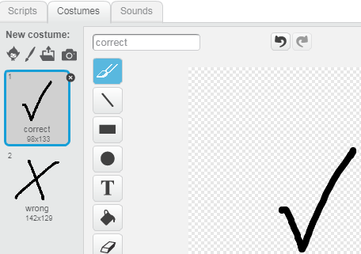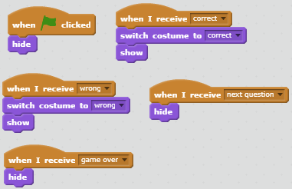
Note: player has opportunity to try again https://scratch.mit.edu/projects/17920411/
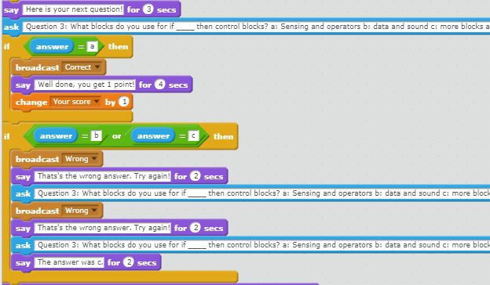
Reduce Recycle Reuse Earth Day (Original project in Greek, some remixes English)
https://scratch.mit.edu/projects/10154015/ https://scratch.mit.edu/projects/10166121/
