Scratch Teacher Account
http://kpscobracoders.weebly.com/
https://scratch.mit.edu/educators/faq
Having a Teacher Account is something Educators asked the Scratch team for and they made a considerable effort to address all the needs. I was lucky enough to be at the Scratch Conference when this new feature went live. The Scratch people have taken into account that some teachers (and parents) are apprehensive about the feature of Scratch that shares projects with the world. There are a group of employees who monitor negative comments and incidents of cyberbullying. Creating a Teacher Account means your students’ work does not go out past the account.
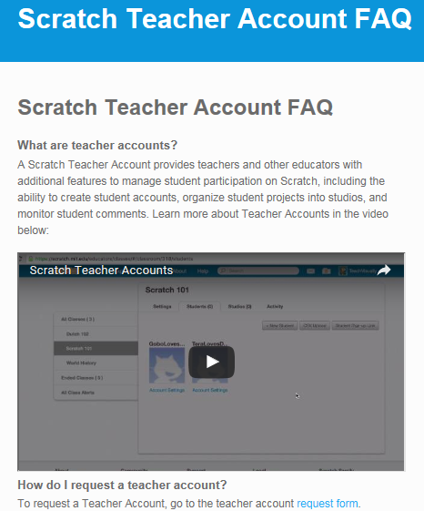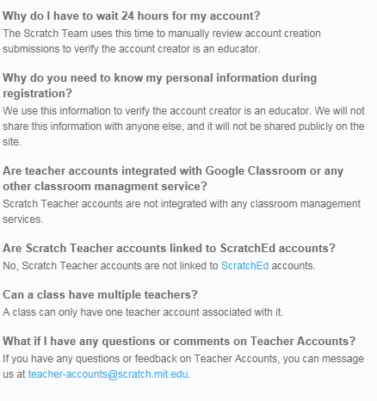
One you fill out an application you have partial access to additional information. Once you submit your information you will get an automatic reply email with this information…
From: https://scratch.mit.edu/educators/register
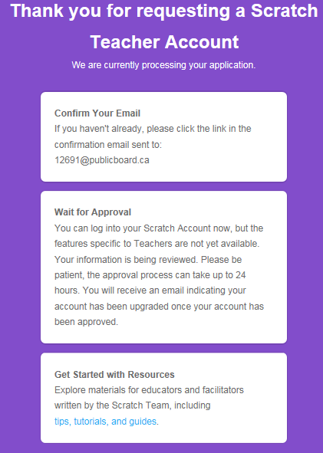

Thank you for requesting a Scratch Teacher Account
We are currently processing your application.

Confirm Your Email
If you haven't already, please click the link in the confirmation email sent to:
XXXXX@XXXXXXXX.ca

Wait for Approval
You can log into your Scratch Account now, but the features specific to Teachers are not yet available. Your information is being reviewed. Please be patient, the approval process can take up to 24 hours. You will receive an email indicating your account has been upgraded once your account has been approved.
Get Started with Resources
Explore materials for educators and facilitators written by the Scratch Team, including tips, tutorials, and guides.
Here is the tips, tutorials, and guides screen but remember you won’t have access to this unless you complete and send it a request for a teacher class account:
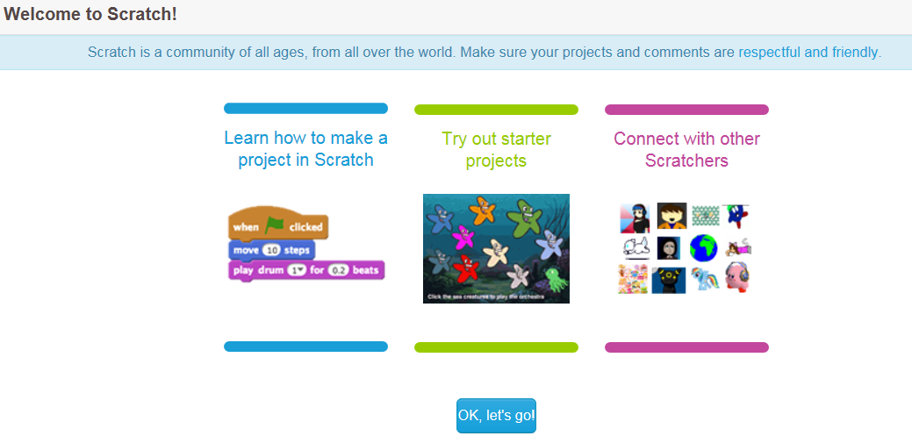
Developed by ScratchEd team

