Scratch Dice
Link: http://scratched.gse.harvard.edu/resources/dice-4-scratch
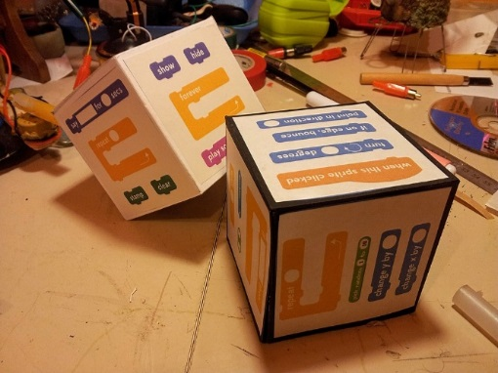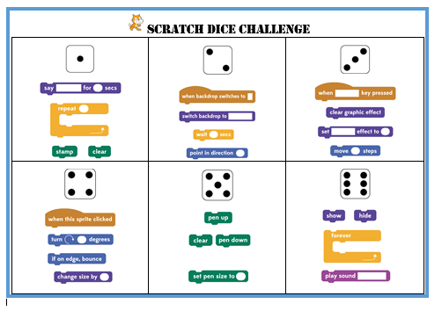
What we think: this is a great idea to challenge your students. Having something like this on hand for when you have a student or small group of students needing something to do pull these out. Don’t’ forget - ScratchED is the place to go for ideas such as these and for help with questions you have!!!!
Here is the source information for the idea: Contributed by Adriano Parracciani November 25, 2014.
He suggests challenges such as: (1)make three throws (you will have 12 blocks of code); (2)use these 12 blocks to create a project in 10 minutes; and (3)all the blocks MUST be used (The number of rolls and time can be altered, of course)

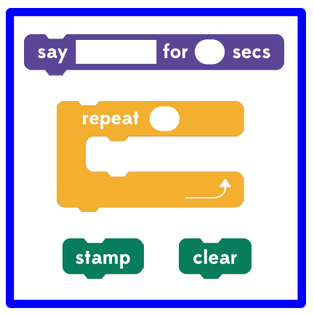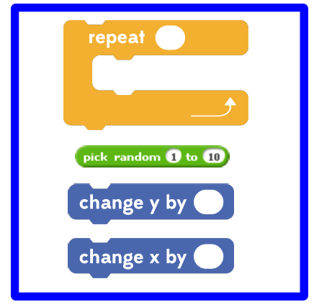

There are 3 PDF files attached to the activity. Two are the dice faces with blocks - one basic (example on the left) and one more advanced (example on the right). The third file is a cube pattern. Each side is an 8 cm square to fit his coding blocks. He suggests gluing them on the sides but perhaps you can use a sheet of labels that size and save some time.
I have added a Word File based on the ideas from The Digital Scoop. They took the Parracciani idea and modified it for DASH, then made a one sheet poster instead of the dice – saves you making the dice (and your kids losing the dice!). So I took that idea and brought it back to Scratch. Here is the DASH link:
http://www.thedigitalscoop.com/the_digital_scoop/2015/01/dash-and-dot-rolling-for-code.html
The source for the blocks he used is also a good resource to keep handy. It is a zip file and has individual files for each block. http://scratched.gse.harvard.edu/resources/vector-scratch-blocks Contributor for vector blocks: Paul Heather, January 23, 2014

