Scratch Classroom Jobs
At the Scratch site things are always being updated and on display. If you are looking for activities for students that combine oral reporting and coding you might want to consider some of these ideas:
Scratch Main Screen Featured Projects
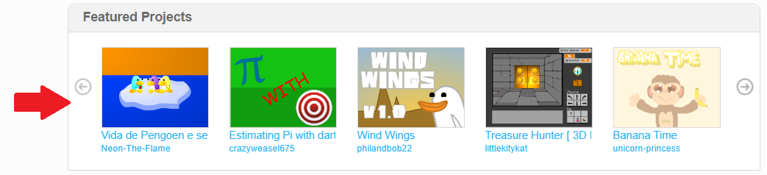
Students can look through the projects and find one they found interesting and share a 2 minute summary of the project. Information could include a teaser of what to expect with the project; explain interesting coding blocks; information about the coder (country of origin, how long in Scratch, number of shared projects, etc). They might point out any other projects of the coder that their classmates might find interesting. If your students do this reporting over time they can keep track of the coder’s country of origin; find the average length of time Featured coders have been a part of Scratch, etc. This activity has multiple benefits, giving your students a purposeful reason to present information and broadens your students’ (and your) knowledge of the Scratch community.
Scratch Main Screen Projects Curated by …
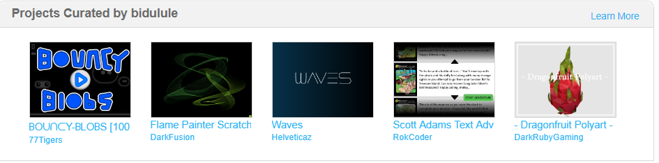
The same type of reporting could be done about the Projects Curated section but I have found that typically the projects selected by a coder tend to be more complex and are more game style projects. So perhaps not as useful to your students as ideas for them to try. Here is information about Curators from Scratch Wiki https://en.scratch-wiki.info/wiki/Curator_(front_page) and the list of previous Curators https://en.scratch-wiki.info/wiki/Curator_(front_page)/List_of_Curators
Scratch Main Screen Scratch Design Studio
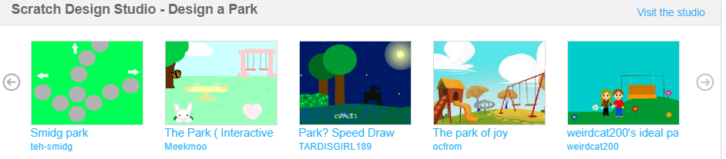
Scratch Wiki Report
Visiting the Wiki site is a great way to learn more about Scratch. For example, here is a link to the Pen Down Block. https://en.scratch-wiki.info/wiki/Pen_Down_(block)
For a quick link to block information when you are in a Scratch project you can get information about blocks. Place a block in the coding area, click on the blue question mark, and move the black question mark over to the block. The information appears on the right hand side. You can also access this information by clicking on All Tips, then the Block tab, then on the particular set of blocks you want.
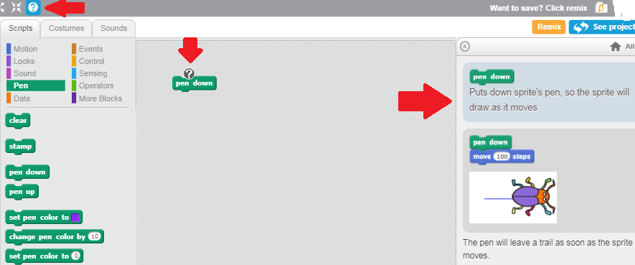 or 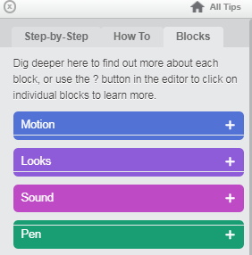
In the Wiki Entry there is more information. For this example there are a series of block stacks that give ideas on how to use it.
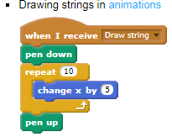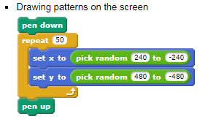
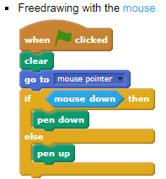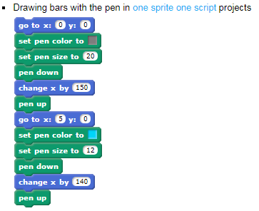
Assigning a student to report on a particular Block (https://en.scratch-wiki.info/wiki/Blocks )or Action (for example Project Tags - https://en.scratch-wiki.info/wiki/Project_Tags ) or Feature (for example Backpack - https://en.scratch-wiki.info/wiki/Backpack ) is another way to build understanding. Also if a student gives a report on say this Pen Block then they can become to “Go-To” person listed on your Community of Practice board.

