Scratch and Scratch Jr Lesson Plans
https://code.org/educate/curriculum/teacher-led
As of Summer 202 this link is not active but all the individual links to the lessons below are still active

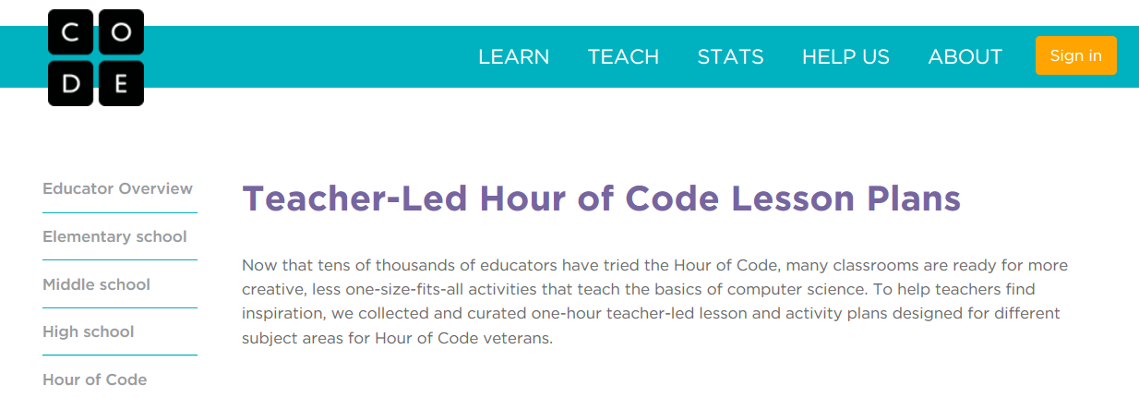

Elementary School
Scratch Animate Your Name
Ages 8 to 16. Programming, Creativity, Web-based. Students will animate the letters of their name, initials, or favorite word using Scratch!
Scratch Hide and Seek Game
Ages 8 to 16. Programming, Creativity, Web-based. Students will gain experience with coding as they make a hide-and-seek game.
Scratch Dance, Dance, Dance
Ages 8 to 16. Programming, Creativity, Web-based. Participants will create and code an animated dance scene.
ScratchJr: Can I Make a Spooky Forest?
Ages 5-9. Art, Storytelling, Sequence, Unplugged. Students will learn more features of ScratchJr by creating a spooky forest with multiple characters!
ScratchJr: Can I Make My Characters Greet Each Other?
Ages 5-9. Art, Storytelling, Events, Unplugged. Students will learn advanced features of the ScratchJr app when they make a dog and kitten meet each other and exchange hellos!
ScratchJr: Can I Make the Sun Set?
Ages 5-9. Programming, Storytelling, Mathematics, Creativity, Unplugged. Students will get an introduction to programming by making a sun set over a city landscape using ScratchJr!
My Robotic Friend
Ages 5-18. Sequence, Algorithms, Programming, Unplugged. Students use paper and pencils to create programs to teach their "Robotic Friends" how to stack plastic cups into a specific design.
Conditionals with Cards
Ages 8-12. Sequence, Algorithms, Conditionals, Unplugged. Use playing cards (or dice, or sheets of paper...anything with the ability to randomize) to create a program on paper for the class to follow. This program will utilize the randomization, along with "if" and "else" statements, to add uncertainty to your game's outcome.
Binary Baubles
Ages 8-18. Sequence, Algorithms, Programming, Unplugged. Make fun take-home items that "store" students' initials using only two colors.
Bomberbot Hour of Code Activities
Ages 8-12. Sequence, Algorithms, Programming, Unplugged or Web-based. Students will learn a series of programming concepts and apply them to programming a robot.
STEM Projects
Ages 5-18. Programming, Science (Ecology), Science (Space), Web-based. Code and animate a Solar System simulation, an interactive ecological pyramid, a working analog clock, and more.
Rock, Paper, Scissors
Ages 10-15. Science (Biology), Unplugged. This activity builds off of the classic game of Rock/Paper/Scissors, known to most students, and relates it to a phenomenon seen in biology.
Kodable fuzzFamily Frenzy
Ages 5-9. Seqence, Algorithms, Programming, Unplugged. Students will learn basic programing language and use math concepts to move a “robot” forward, spin, and jump.
Google CS First
Ages 9-14 Sequence, Programming, Art, Storytelling, Web-based. Students use Scratch to code a story about being lost at sea.
Bitsbox Coding + Math
Ages 5-13. Programming, Math (General, Geometry), Web-based.
Bitsbox Coding + Science
Ages 5-9. Programming, Science (General, Biology, Chemistry, Physics), Web-based.
Bitsbox Coding + Art
Ages 5-9, Programming. Language Arts, Visual Arts, Music, Web-based.
Flocabulary On One Condition
Ages 7-13. Programming, Language arts, Storytelling, Web-based. Students will learn how to write conditional statements and complete an activity sequence where they generate their own conditionals, evaluate given conditionals to determine the outcome of a program.

Middle School
Scratch Animate Your Name
Ages 8 to 16. Programming, Creativity, Web-based. Students will animate the letters of their name, initials, or favorite word using Scratch!
Scratch Hide and Seek Game
Ages 8 to 16. Programming, Creativity, Web-based. Students will gain experience with coding as they make a hide-and-seek game.
Scratch Dance, Dance, Dance
Ages 8 to 16. Programming, Creativity, Web-based. Participants will create and code an animated dance scene.
STEM Projects
Ages 5-18. Programming, Science (Ecology), Science (Space), Web-based. Code and animate a Solar System simulation, an interactive ecological pyramid, a working analog clock, and more.
Bomberbot Hour of Code Activities
Ages 8-12. Sequence, Algorithms, Programming, Unplugged or Web-based. Students will learn a series of programming concepts and apply them to programming a robot.
Input and Output, Math Activity
Ages 12-16. Math (Algebra), Math (Functions), Unplugged. Connect JavaScript functions to both math and real world problems.
Climate Science
Ages 12-16. Science (Climate), Science (Environment), Unplugged. Students draw a picture, and take turns giving the class steps to recreate their drawing.
Google CS First
Ages 9-14 Sequence, Programming, Art, Storytelling, Web-based. Students use Scratch to code a story about being lost at sea.
Arduino Activity
Ages 12-15. Programming, Arduino Ever wonder how toys make noises and blink lights when you push buttons? Microcontrollers and circuits are used in all sorts of everyday objects. From remote controlled cars to robots and drones.
Secret Codes Activity
Ages 12-15. Ciphers, Math (Cryptography), Scratch, Web-based. Turing has done many things for computer science (often called the father of computer science) but today we will focus on one very important one that helped with the invention of computers.
Computer History Activity
Ages 12-15. History, Storytelling, Scratch, Google Docs, Unplugged Your class will be be creating a 'history of computers' web page/Scratch project/video that we can share with the world. To make this web page, you and your partner will do research and write about one important event or person in computer history
Grace Hopper Debugging Activity
Ages 12-18. History, Language Arts, Storytelling, Unplugged Students will research Grace Hopper and learn the story of the first "bug".
Flocabulary On One Condition
Ages 7-13. Programming, Language arts, Storytelling, Web-based. Students will learn how to write conditional statements and complete an activity sequence where they generate their own conditionals, evaluate given conditionals to determine the outcome of a program.

