Scratch 3 Preview Version
https://preview.scratch.mit.edu/
Screen Shot…
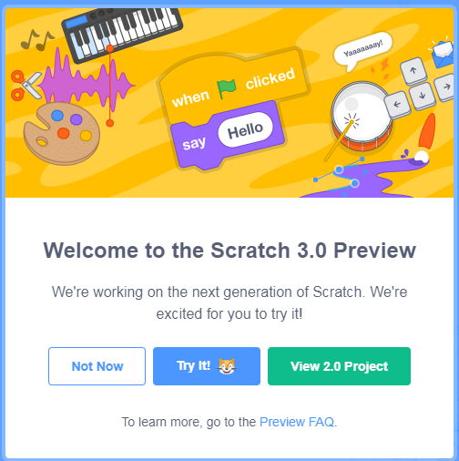
Main Screen screen shot…
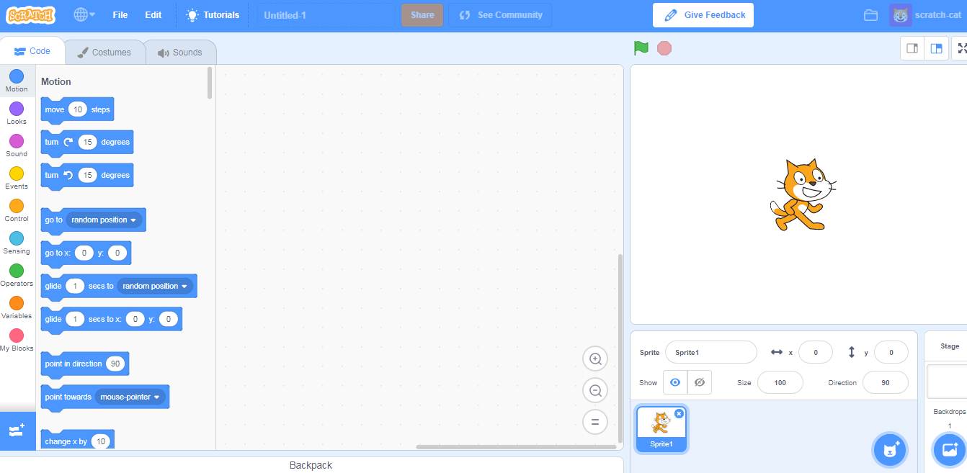
Most of the tabs are inactive on this version.
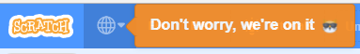

To save a project in 3.0 it is similar to what happens when you use Scratch 2.0 Off-Line version, you save to your own computer’s hard drive.
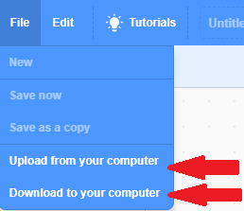
There are Tutorials available.
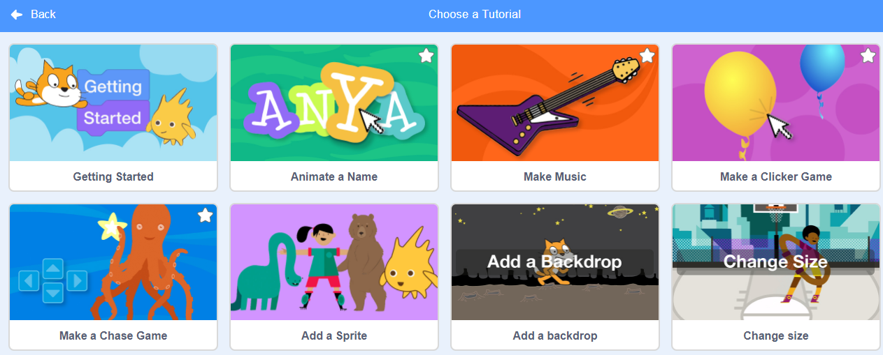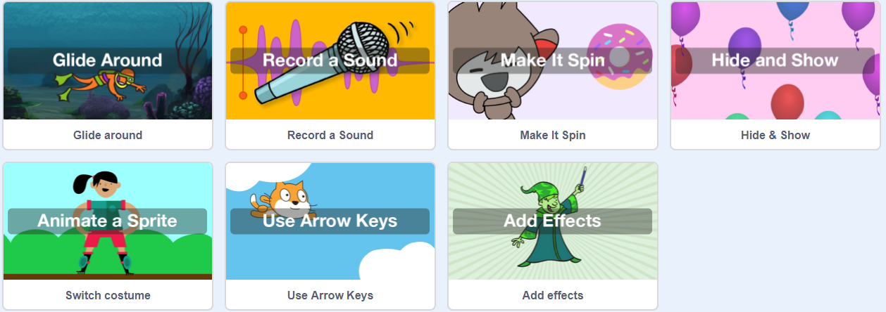

For Sprites and Backdrops there is a new element labelled Surprise. Surprise makes a random selection for you from the Sprites and Backdrops included in the program.
