Scratch 3.0 News
If you have gone to your Scratch account as of July 31st/August 1st you will see this banner on the home screen…
Here is it! https://beta.scratch.mit.edu/
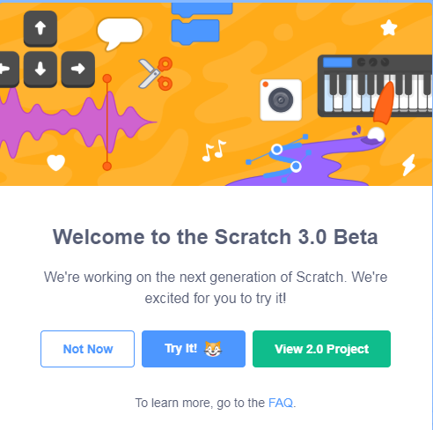
Check out … (https://scratch.mit.edu/discuss/topic/308020/ )
… and Introductory Video https://scratch.mit.edu/discuss/youtube/6ofHiea__hU/
… and read FAQ section. For a more extensive FAQ section go to https://scratch.mit.edu/3faq
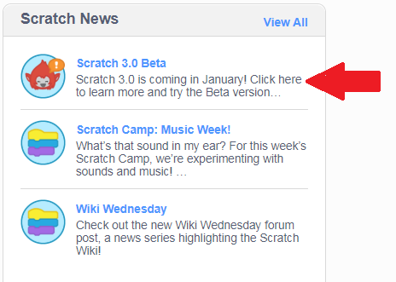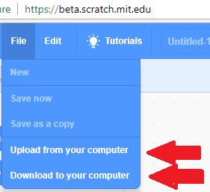

JUST REMEMBER YOU CANNOT SAVE TO YOUR SCRATCH ACCOUNT YET. ANY WORK MUST BE DOWNLOADED TO YOUR COMPUTER

