Pattern Projects Links
https://scratch.mit.edu/projects/106877518/
square sprites, four direction arrows then space bar to drop down square, N key changes sprite colour, good for connection from BlueBot and Spatial reasoning Coding is easy enough for Junior students and then work with younger students to produce pattern
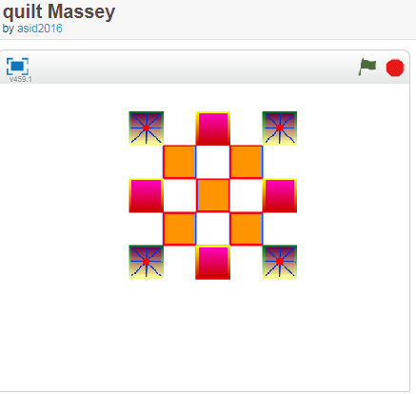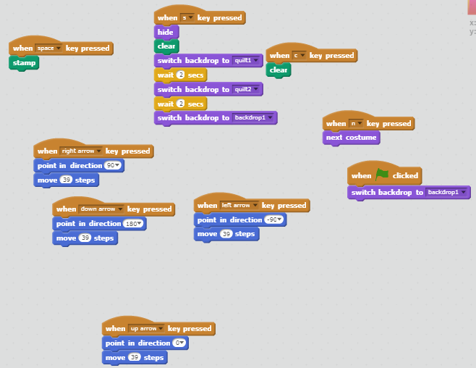
This has great labels to explain coding for tiles on a grid https://scratch.mit.edu/projects/200612186/#editor
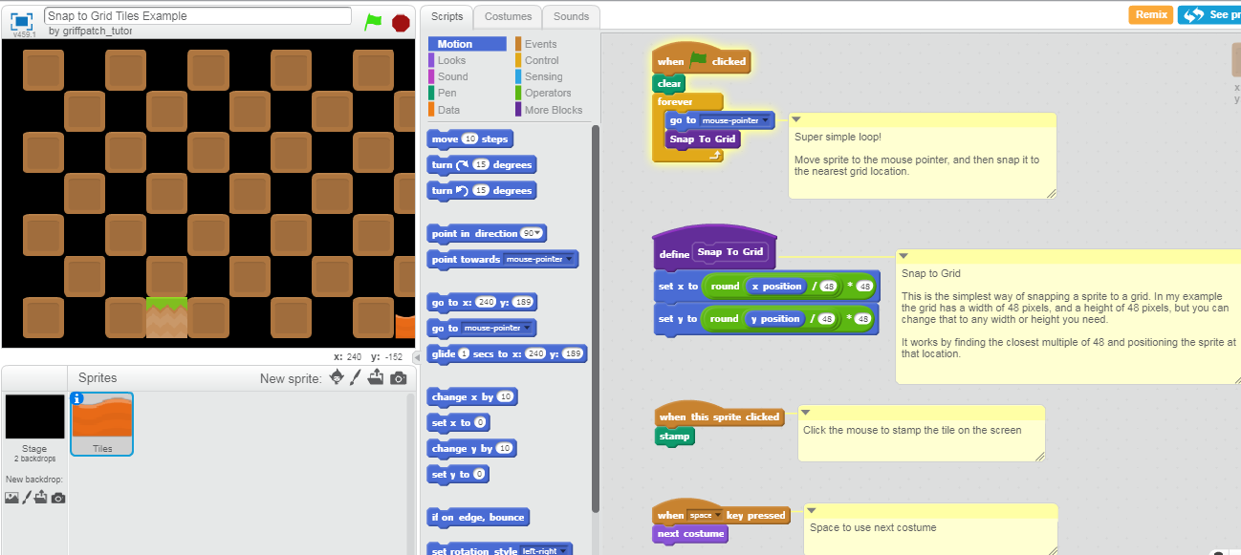
https://scratch.mit.edu/discuss/topic/185793/?page=1#post-1822485 Discussion on tiles
