New Makey Makey Website Links
Just returned from Scratch18 Conference and one of the business people I had a chance to talk to was Mr. Tom Heck of Makey Makey and today I was sent an email announcing the updated web site. Here are some links.
Screen Shot (Links not active in photo). See below for active links.
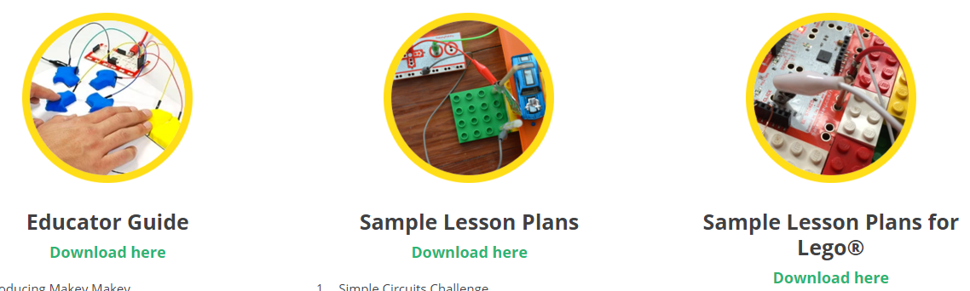
Link to Lesson Plans: https://cdn.shopify.com/s/files/1/0162/8612/files/lesson-plans.pdf?16481577170705338427
Link to Educator’s Guide: https://cdn.shopify.com/s/files/1/0162/8612/files/Makey_Makey_Educators_Guide.pdf?16481577170705338427
Link to Lego + Makey Makey Lesson Plans: https://cdn.shopify.com/s/files/1/0162/8612/files/lesson-plans-lego.pdf?16481577170705338427
Link to Labz where you can see photos of projects and read instructions from Makey Makey and projects submitted by users : https://labz.makeymakey.com/
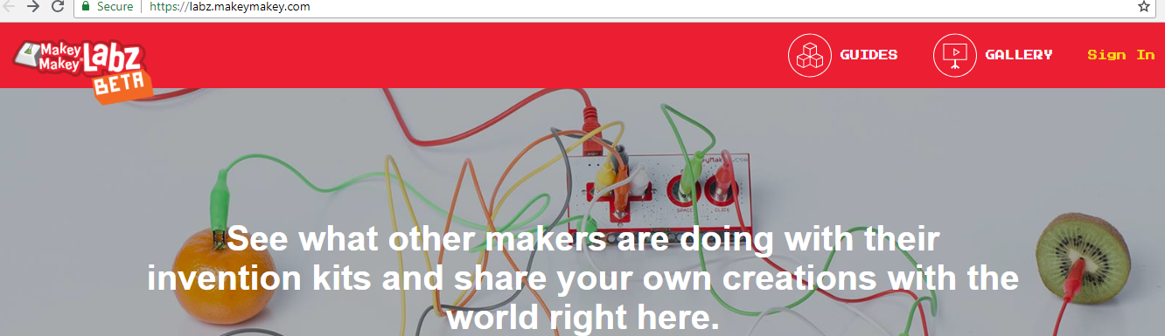
Information provided for projects (screen shot). Red arrows: Print (click on three dots and Print button appears, Tags to search for other projects with similar traits, and Supplies needed.
