Music Generator Projects Lesson
http://kpscobracoders.weebly.com/
Lesson: In this plan is a guideline for free exploration of the Sound blocks to start students learning about Scratch and music/sounds. Then there are resources from within Scratch and Jared O’Leary – both are excellent. Third, there are some individual projects located by a simple search within Scratch. Some information from Scratch Wiki is fourth. Finally is Curriculum expectations for Music and Science.
With the resources provided by Scratch there is probably no need for a teacher directed lesson unless there is a specific task requested (In that case a task designed to meet a specific curriculum expectation should come after this one).

The chance for ‘free exploration’ is well suited for music generation projects (If some direction is needed perhaps groups of students could be asked to start their exploration of different instruments or effects).

The free exploration time would be a great time to use a Community of Practice space in the classroom. A Community of Practice space has students writing down something they have learned to do or what a student wants to learn. So for example:

Student A writes on the board, “I know how to record sounds and use the Play Sound block”
Student B writes, “I want to know how to plan 3 different notes in a row.”
The whole class has an easy way to see who to go to for assistance (and takes the pressure of the teacher trying to know it all!).

This space gives students a chance to share with each other and grow as a coding ‘community’ and the use of the term ‘Practice’ helps to underline a non-threatening environment, one of play and practice to engage all the students.

Resources and Connections
Scratch has a short video (https://vimeo.com/163472795) (0:56) to introduce the key elements to generate music. Within Scratch home screen is an on-line tutorial or a printable set of instruction cards at https://resources.scratch.mit.edu/www/cards/en/musicCards.pdf
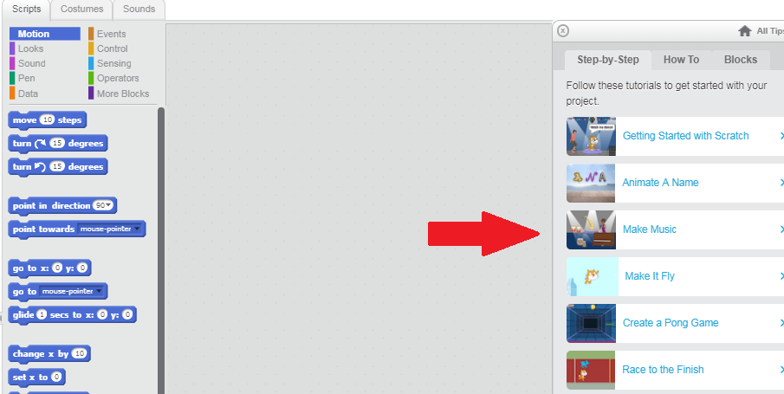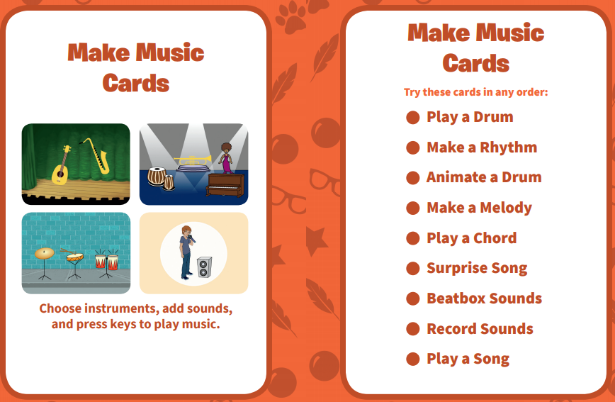
Developed by ScratchEd team
Also here is a project with suggested blocks to use. https://scratch.mit.edu/projects/embed-editor/133865393/?isMicroworld=true
This is part of Microworld section of Scratch (https://scratch.mit.edu/microworlds/go )
https://en.scratch-wiki.info/wiki/Microworlds “At the 2016 Scratch Conference, the Scratch Team announced plans for a project named microworlds. The name "microworld" comes from combining "micro" and "world", which symbolizes a world that teaches powerful ideas, yet having a limited scope. Interest-based microworlds are microworlds aimed at a specific interest or goal, like animation. A Scratch microworld has a limited palette of blocks, to reduce the number of blocks a Scratcher has to dig through.”

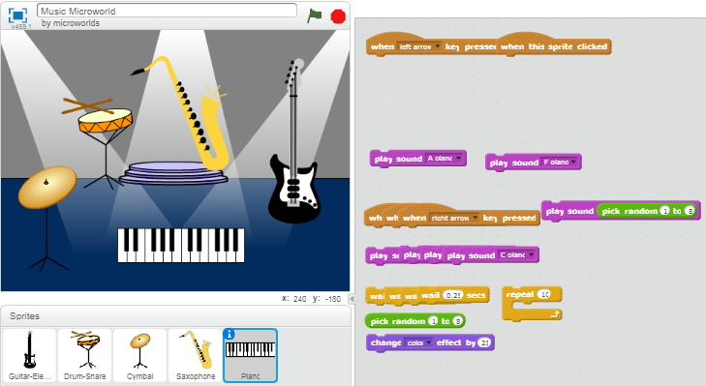

Here are some other projects developed by ScratchTeam. Remember anything by the ScratchTeam will be a good project to use with your students to develop beginning ideas.
https://scratch.mit.edu/projects/90316728/ https://scratch.mit.edu/projects/2543877/
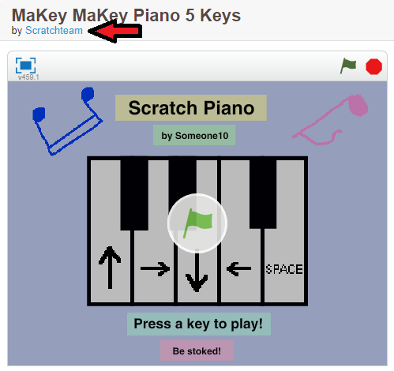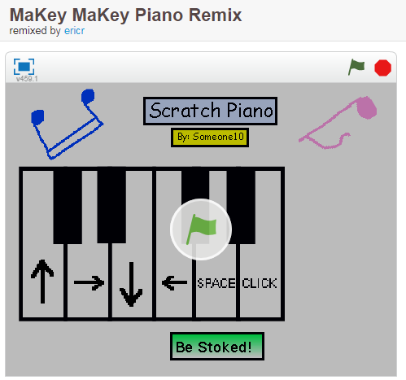
https://scratch.mit.edu/projects/10128362/ https://scratch.mit.edu/projects/91841139/
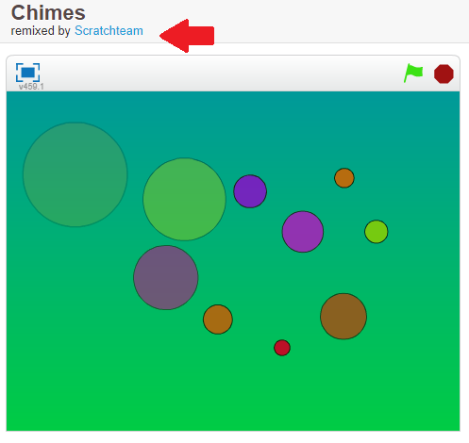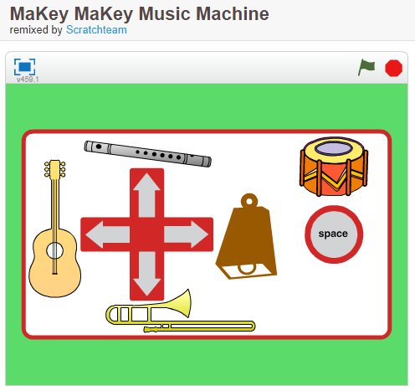
https://scratch.mit.edu/projects/11640429/ https://scratch.mit.edu/projects/10128483/
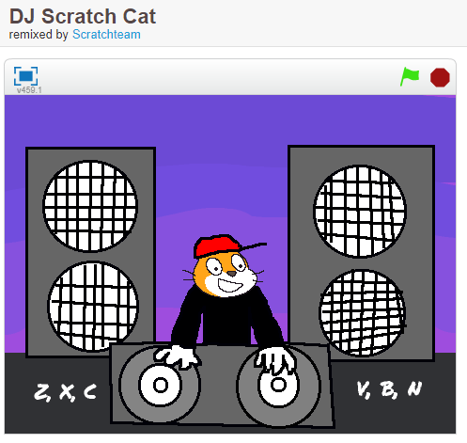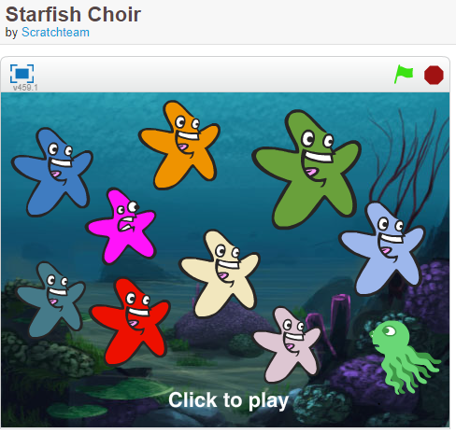

Any project by DTTechnology, Jared O’Leary and his other entities are a great resource! As always be sure to acknowledge his work as the source in any projects or videos used.
https://jaredoleary.com/scratch-resources/ (Scratch in general)
https://jaredoleary.com/music-coding/ (creating music in a variety of platforms including Scratch) His YouTube Channel https://www.youtube.com/user/OCPDMusic/featured
and https://bootuppd.org/ (Scratch projects, lessons, tutorials – fantastic resources)
Here are some to use for Music projects:
https://www.youtube.com/watch?v=H1cT_8iIIcs (2:24) explains sound blocks – great to Introduce adding sounds to projects. No project # with this video it is simple to follow without one.

https://www.youtube.com/watch?v=MDNKXTHfFU4 (3:18) project plays Hot Cross Buns and explains how/why to use Make Blocks. In video and in project the code is shown two ways, first with thee Make Blocks and then just sound blocks and illustrates the value of Make Block functions when coding. Students could use this as a template to create their own music or recreate familiar music. Project to accompany video https://scratch.mit.edu/projects/147164734/#editor
https://www.youtube.com/watch?v=hxbWrV1YwlI&t=10s (7:20) project explains how to use Random operator, If/Else block, Repeat Block, Nesting (Repeat blocks inside Repeat blocks) and make a List to produce random sounds. This is a longer video with a great deal of information. There is a shorter video that goes into more detail about Repeat blocks and Nesting but only those ideas and not the rest from the longer video. https://www.youtube.com/watch?v=dC9sLoetDbw Project to accompany video https://scratch.mit.edu/projects/146777398/#editor
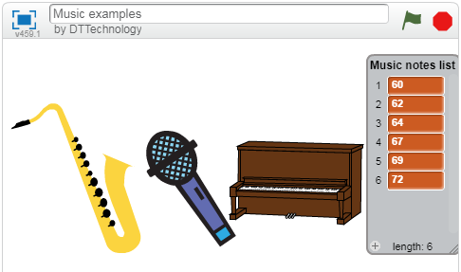

https://www.youtube.com/watch?v=vivOLc86YoQ&t=88s (4:26) https://scratch.mit.edu/projects/147180682/
This project has a YouTube video https://www.youtube.com/watch?v=vivOLc86YoQ explaining the reasons behind the block selections.
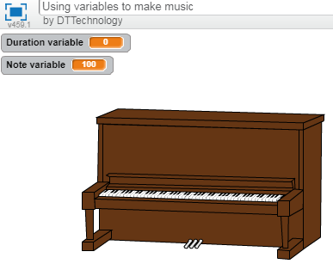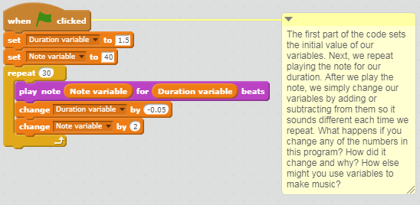

Other Scratch Projects to view (be sure to search using tags such as Music for other projects & studios)
https://scratch.mit.edu/projects/15153662/ Like Simon, repeat pattern back, Play showing keys or without is good ear training projects https://scratch.mit.edu/projects/134221757/
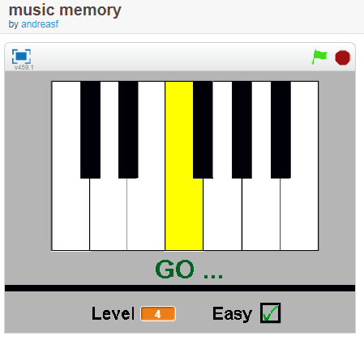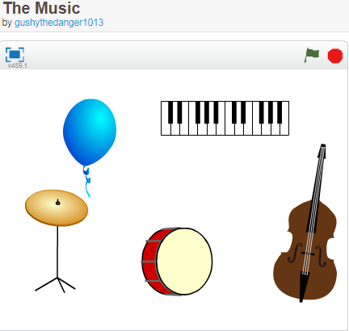
Very Easy coding in this project
https://scratch.mit.edu/projects/33139512/ https://scratch.mit.edu/projects/33302196/
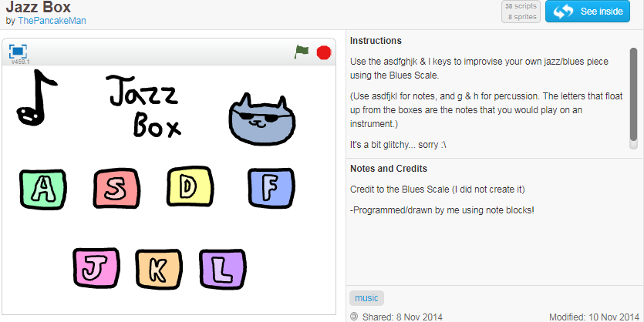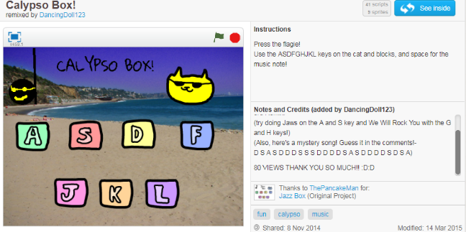
Questions to ask students: What makes the sounds different from Jazz to Calypso? Also check out the Mystery Song by keyboard letters. Challenge the students to develop a notation system that also shows the value of the note (see Wiki Entry below for help).
https://scratch.mit.edu/projects/2728243/ https://scratch.mit.edu/projects/130608744/
chimes and rain stick
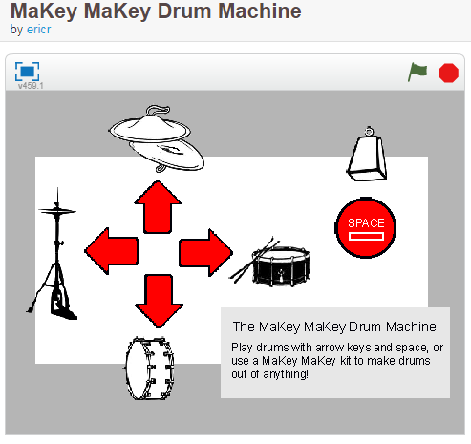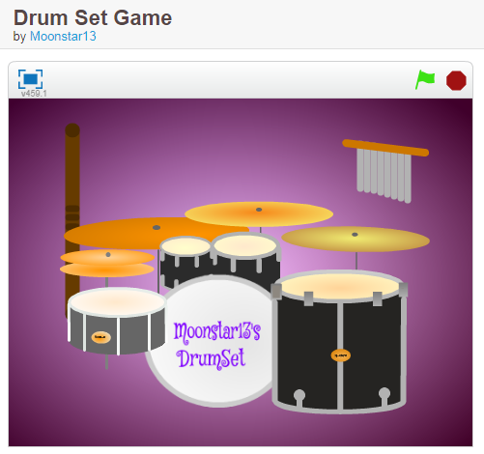

For more advanced coding information in the Scratch Wiki
https://en.scratch-wiki.info/wiki/Making_a_Note_Block_Project
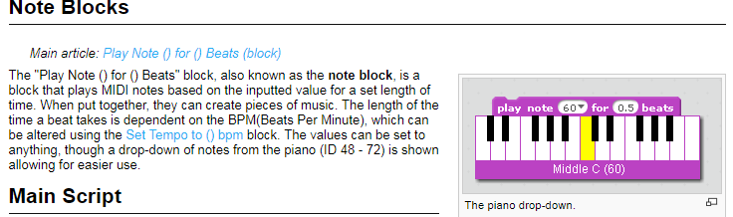
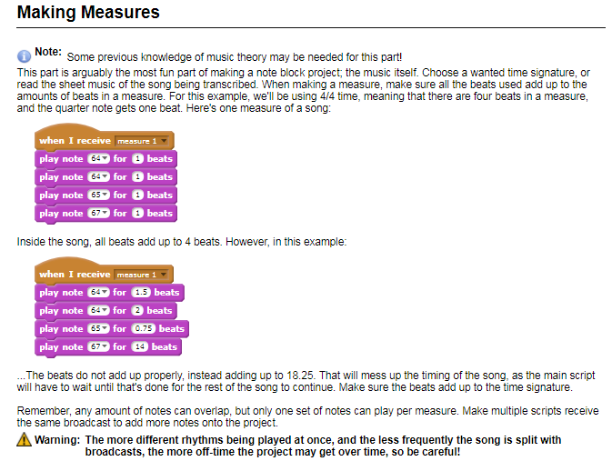
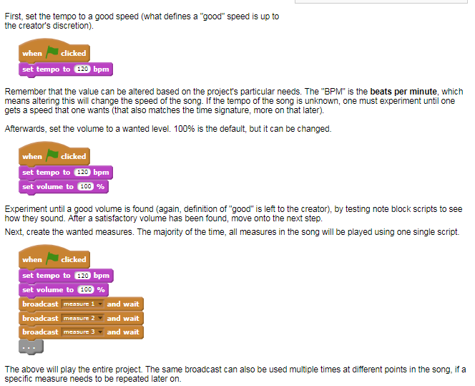
For Further information check out: https://en.scratch-wiki.info/wiki/Composing_Music
Developed by ScratchEd team

Curriculum Music & Science
Music
Grade 4
1Creating and Performing
C1.2 apply the elements of music when singing and/or playing, composing, and arranging music to create a specific effect (e.g., compose pieces using different expressive controls, such as staccato/legato or crescendo/decrescendo, to create contrasts and changes in mood; compose a pentatonic melody for recorder or voice with a bordun for an accompaniment) Teacher prompts: “What element could you change to further alter the effect?” “What family of instruments could you use for your arrangement? How would changing the instruments change the effect?” “What can you do to create a musical texture that is like the tex
C1.3 create musical compositions for specific purposes and audiences (e.g., write a composition for recorder using musical notation on the five-line staff; compose a piece using non-traditional notation, such as a melody map or icons; compose a soundscape to represent the physical landscape of Canada; create a composition to accompany a dance piece)
Grade 5
C1.2 apply the elements of music when singing and/or playing, composing, and arranging music to create a specific effect (e.g., form, timbre: create a rondo [ABACADA form] using a familiar song as the repeating A section, and compose short rhythmic or melodic materials for the B, C, and D sections using pitched or non-pitched percussion instruments, found sounds, recorders, or body percussion)
C1.3 create musical compositions for specific purposes and audiences (e.g., compose an accompaniment for a story, poem, or drama presentation to address an environmental issue such as water conservation, recycling, or planting trees; create a piece that uses a rhythmic ostinato in time and that includes both eighth and sixteenth notes; use body percussion, found sounds, voice, and non-pitched percussion instruments to vary the timbres in their work)
Grade 6
C1.2 apply the elements of music when singing and/or playing, composing, and arranging music to create a specific effect (e.g., compose a piece in the theme and variations form, using a well-known song for the theme to engage the listener; change the metre of a familiar eight-bar melody and describe the effect of the change; remove tone bars on a xylophone to create a pentatonic tonality, and then improvise a pentatonic response on the xylophone to a call played on a recorder)
C1.3 create musical compositions for specific purposes and audiences (e.g., write a melodic composition reflecting a piece of art of their own or by another, such as Norval Morrisseau or Emily Carr; create a rhythmic composition using nonpitched percussion to accompany a First Nation legend, story, or poem; with a partner, compose a song to promote Canada to the rest of the world)
Grade 7
C1.2 apply the elements of music when singing and/or playing, composing, and arranging music, using them for specific effects and clear purposes (e.g., create a class chant or song to build community spirit; manipulate the rhythm or dynamics in a familiar piece to create an accompaniment for a media presentation)
C1.3 create musical compositions in a variety of forms for specific purposes and audiences (e.g., use available instruments to create a composition in response to an object, a visual image, or a silent film; add rhythmic, melodic, or chordal accompaniment to a familiar song; improvise rhythmic or melodic phrases over a variety of ostinati; create compositions using found sounds or recycled materials)
Grade 8
C1.2 apply the elements of music through performing, composing, and arranging music for a specific effect or clear purpose (e.g., create a jingle to advertise a product; improvise a simple melody over a 12-bar blues progression; arrange a piece of their choice from their method book for a quartet of mixed instruments)
C1.3 create musical compositions in a variety of forms for specific purposes and audiences (e.g., write lyrics and a melody for a protest song based upon a current social issue; compose a melodic theme for a computer game)
Science and Technology
Grade 4
2Developing Investigation and Communication Skills
2.3 investigate the basic properties of sound (e.g., conduct experiments to show that sound travels, that sound can be absorbed or reflected, that sound can be modified [pitch, volume], that there is a relationship between vibrations and sound)
2.4 use technological problem-solving skills (see page 16) to design, build, and test a device that makes use of the properties of light (e.g., a periscope, a kaleidoscope) or sound (e.g., a musical instrument, a sound amplification device) Sample guiding questions: How might you use what you know about sound or about light and mirrors in your device? Which properties of light or sound will be most useful to you in your device? What challenges might you encounter, and how can you overcome them?
2.5 use scientific inquiry/research skills (see page 15) to investigate applications of the properties of light or sound (e.g., careers where knowledge of the properties of light and/or sound play an important role [photography, audio engineering]; ways in which light and/or sound are used at home, at school, and in the community; ways in which animals use sound)
2.6 use appropriate science and technology vocabulary, including natural, artificial, beam of light, pitch, loudness, and vibration, in oral and written communication
3Understanding Basic Concepts
3.8 identify devices that make use of the properties of light and sound (e.g., a telescope, a microscope, and a motion detector make use of the properties of light; a microphone, a hearing aid, and a telephone handset make use of the properties of sound)

