MicroBit Site Resources

This is a tour of the MicroBit site. Each section has one or more pages with screen shots so that you can go to the site and follow along with the tour.
Home Screen http://microbit.org/ has two main branches …
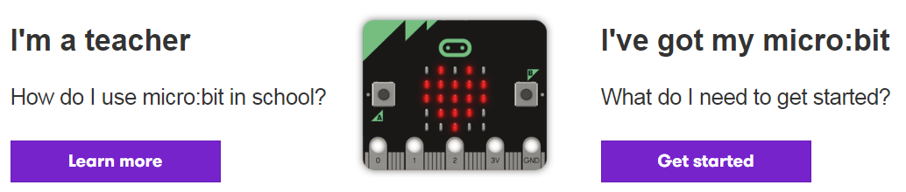
Click on I’m a Teacher – Learn More takes you to Teach Tab
Click on I’ve got my MicroBit – Get Started takes you to the Meet MicroBit tab

…Along with 6 tabs: Let’s Code, Ideas, Meet MicroBit, Teach, Buy, and Language choice for viewing.
For each of these sections I have taken screen shots of the information presented to assist in this tour.
The Quick Start Guide link is found in several different spots (http://microbit.org/guide/quick/ ) so that is the last page of this file.
Let’s Code (1 of 4 pages)
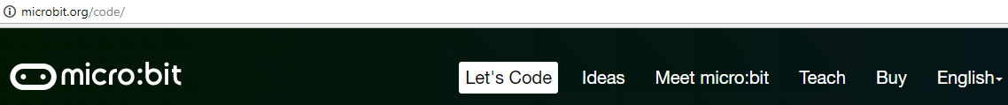
http://microbit.org/code/
This page has three key sections. The JavaScript Blocks Editor, the Python Editor, and the additional Editor platforms. There is also a link to the Quick Start Guide.
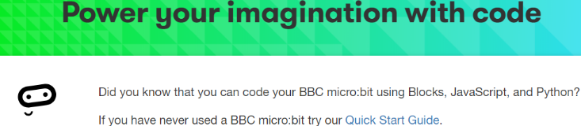
Note: This section has information on using MircoBit with the two platforms available now (Summer 2018) but it does not have a direct link to the Beta Scratch 3.0 platform. To use Scratch with your MicroBit go to www.Beta.Scratch.mit.edu (until the complete 3.0 version is available – date is January 2nd 2019) or http://microbit.org/code-alternative-editors/ and scroll down to Scratch and use the link from there.
Why use the Scratch platform if JavaScript Blocks and Python are already up and going? Scratch will provide you with a way to “see” other coders’ coding and remix and also a way for you to share your work.
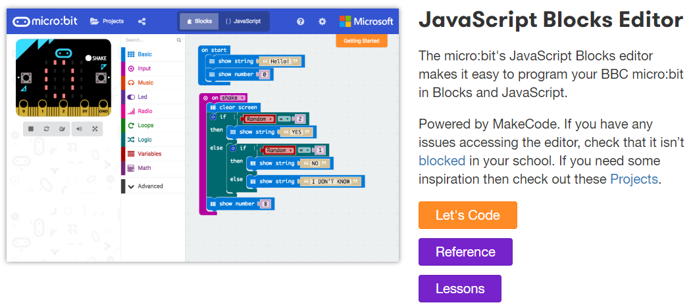
Let’s Code links to https://makecode.microbit.org/#
Reference links to https://makecode.microbit.org/reference (see screen shots below) Note that this Reference section has a different format than the one for Python Editor.
Lessons links to http://microbit.org/en/2017-03-07-javascript-block-resources/#lessons_a (see screen shots below)

Let’s Code Continued (page 2 of 4)
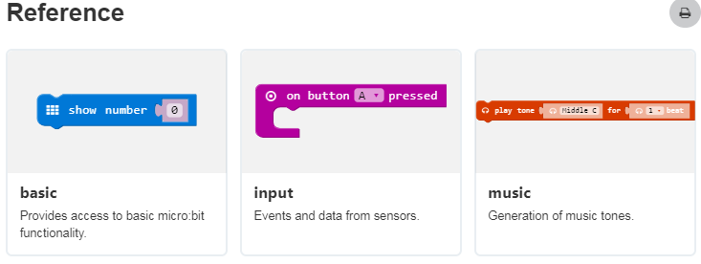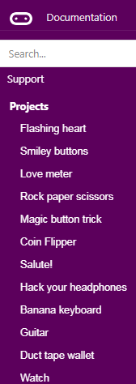
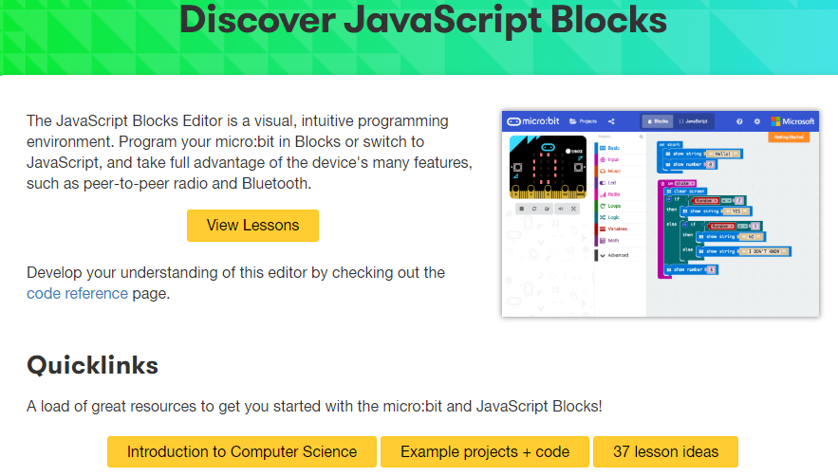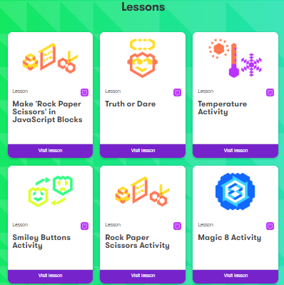
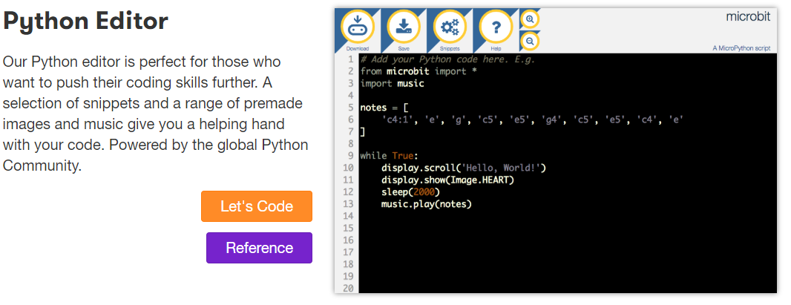
Let’s Code links to https://python.microbit.org/v/1
Reference links to http://microbit.org/guide/python/ (see screen shot below) Note this Reference section has a different format than the one for JavaScript Editor.
Let’s Code Continued (page 3 of 4)
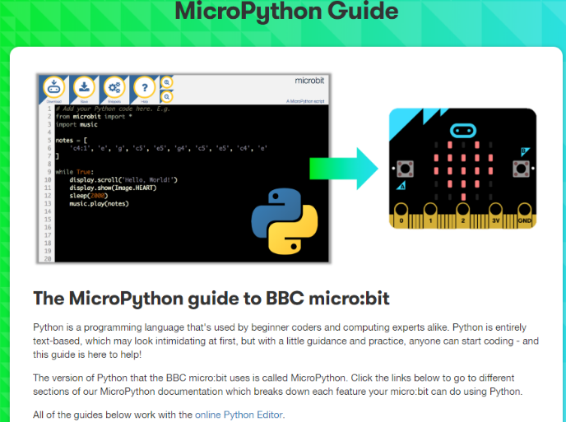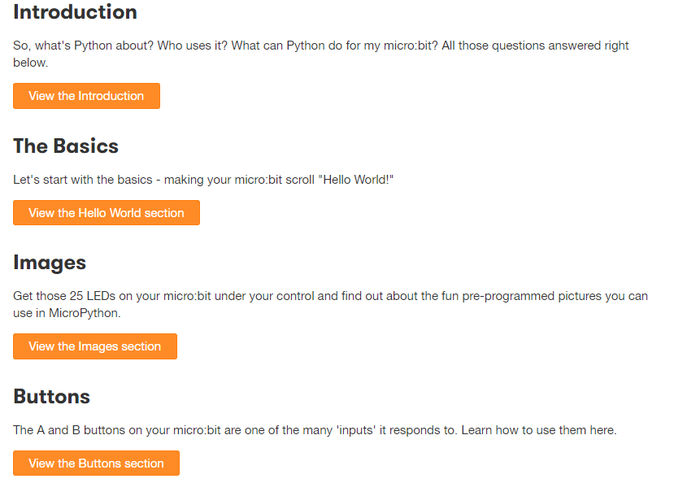

At the bottom of this page http://microbit.org/code/ you will see
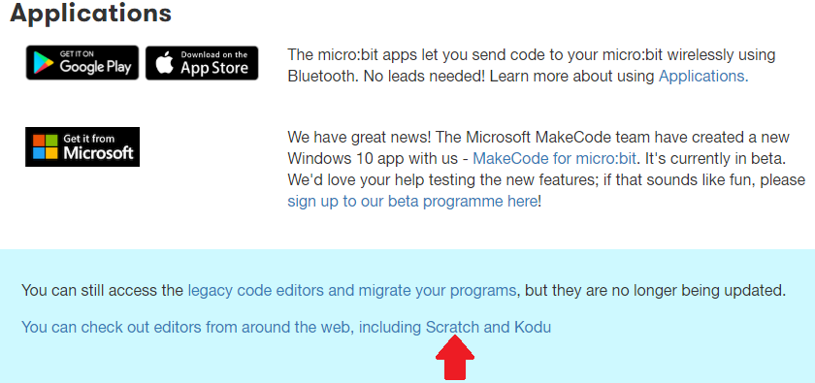
Click here and you will go to http://microbit.org/code-alternative-editors/
Scroll down to see this (Screen Shot)

Let’s Code Continued (page 4 of 4)
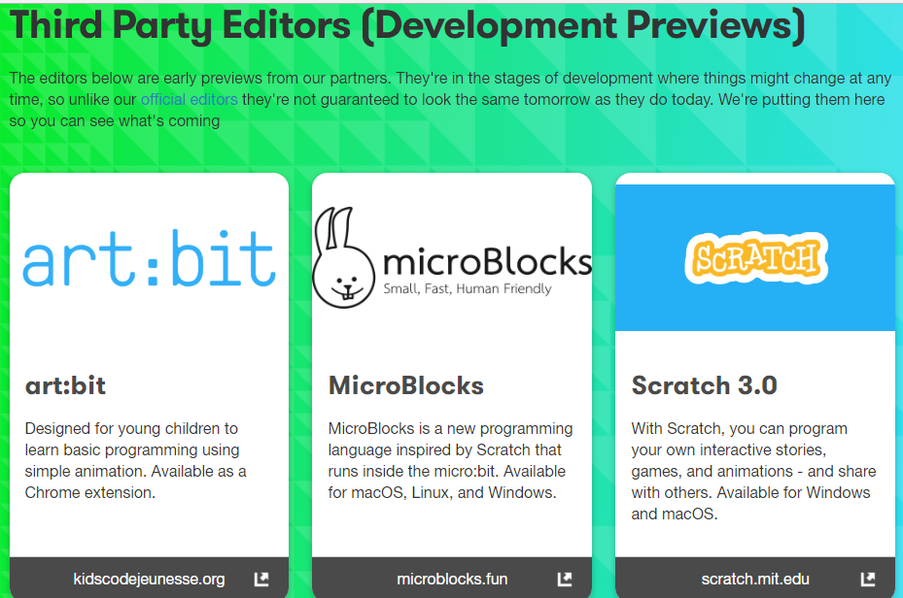

Ideas (1 of 1 page)
http://microbit.org/ideas/
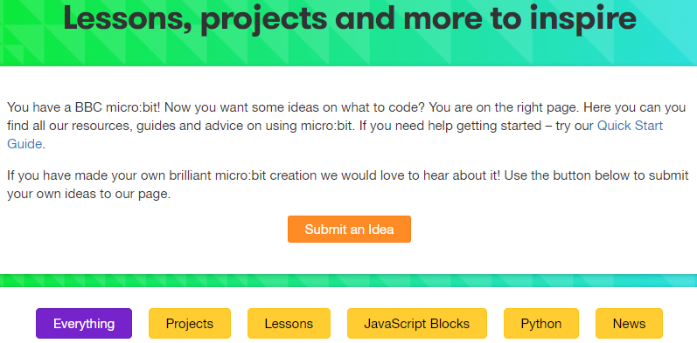
The default setting is to show EVERYTHING – and at the time I was writing this file that mean 145 items! Since I am intending to use Scratch 3.0 with MicroBit I will be looking at the entries in Projects (45 projects), Lessons (28 lessons), and JavaScript Blocks (19 lessons and projects) knowing that JavaScript Blocks will be similar to the Scratch Blocks and will be the easiest to transfer. Having said that I did take a peek at the News section and found this link to a great poster http://microbit.org/assets/documents/microbitcommunityposter.pdf
The symbol means part of the MircoBit website & means Python coding.
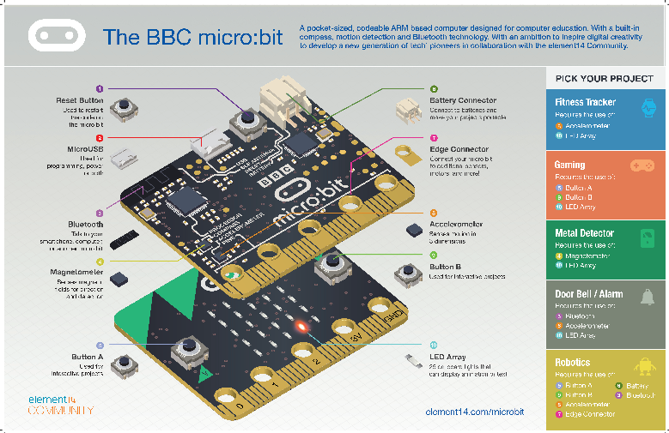
News is also subdivided:
Meet MicroBit (1 of 1 page)
http://microbit.org/guide/ This main page is similar to the Main page (http://microbit.org with its Learn More and Get Started buttons) in that it has links to other pages with the details and information. For a detailed tour of this section see the weebly file titled Tour Meet MicroBit
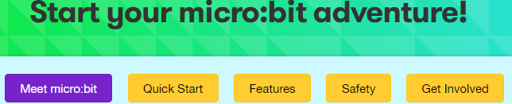
Hello! Is a link to Features (http://microbit.org/guide/features/ )
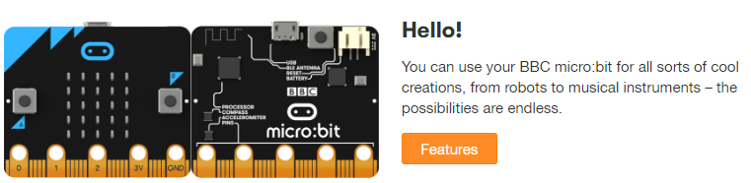
Easy Peasy takes you to Let’s Code (http://microbit.org/code/ )
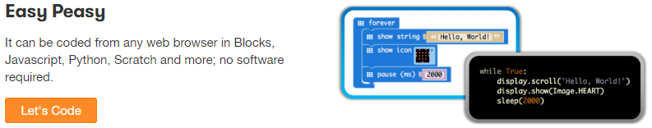
Get Inspired takes you to Ideas, Lessons and Projects ( http://microbit.org/ideas/ )
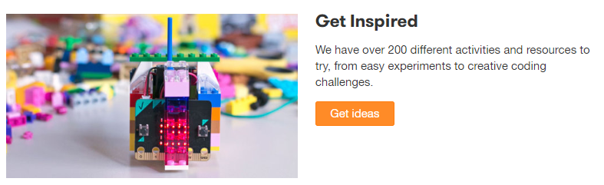
Learn More takes you to the Teach subsection ( http://microbit.org/teach/ )
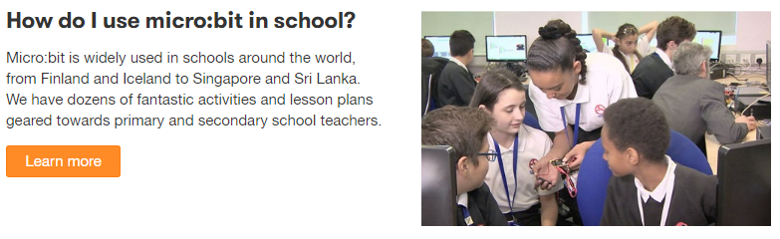
Teach (1 of 1 pages)
http://microbit.org/teach/
Like the Ideas page Teach resources can be sorted into categories
The symbol means part of the MicroBit website & means Python coding.
Start at Curriculum for multiple lessons/activities or Get Started for single lesson/Activity.
For example:
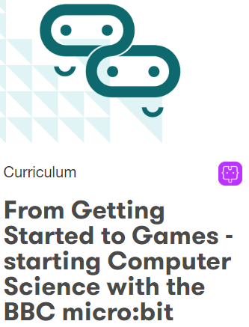
Links to http://microbit.org/en/2018-01-19-train_the_trainer/ for a series of 8 lessons:
Finding your way around the MicroBit;
Basic commands;
Working with inputs;
Basic loops and conditionals;
Generating sounds;
Icons and animation;
Math, Variables, and processing data, and
Games.
Each lesson is a multiple page PDF file (for example: Lesson 1 http://microbit.org/assets/posts/2018-01-19-train_the_trainer/topic_1.pdf ) and links to Hex files (https://drive.google.com/drive/folders/1m27Fwd-HUyC0ipgSP3YjYyVWw0K2kK9y ).
There are some Scratch resources already starting to appear at this site. In particular http://microbit.org/scratch/
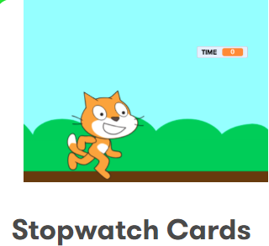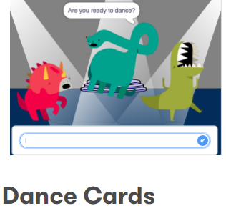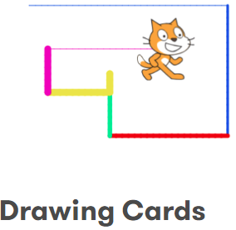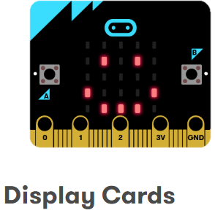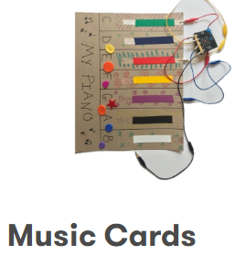
FYI: The Teach and Ideas sections make this a more complex site than looks would imply. My suggestion is that you keep track (in whatever fashion you use) of the addition resources from within or outside resources because I found some and just went on my search looking for others. After several days I went back and find them and it took a great deal of time to locate them again!
Buy (1 of 1 pages)
http://microbit.org/resellers/
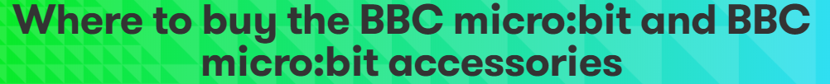
At first I searched the Internet and several Amazon sites only to be discouraged because MicroBits were out of stock at each location. I stumbled on this page and ended up using one of the resellers – Ellwood Electronics (to my American Scratch Conference friends who read this blog – lots of places for you to pick from also!).
They had everything I needed in stock (MicroBits, 3V Power Board, Safety Case, Mover Mini, and Wearables Kit!). So as I learn to use all these items I will post the files for them. This page also has a link to a 99 (!) page PDF of MicroBit Accessories from various sources. http://microbit.org/assets/documents/AccessoryGuideSummer18.pdf
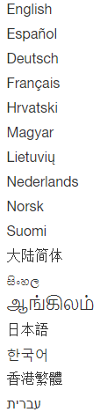
As far as I can tell the translations into other languages is only for the pages within the site. Additional resources do not automatically translate. Perhaps Google Translate will help with those resources. The Scratch 2.0 version already translates into many languages and Beta Scratch 3.0 version will incorporate Google Translate along with its Text-to-Speech function.
Quick Start
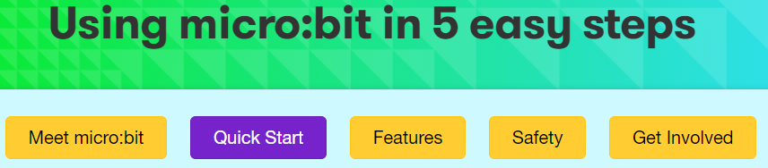
http://microbit.org/guide/quick/
This is a short introduction to BBS Micro:Bit with five steps short video clips and minimal written instructions. Step 1: Connect It, Step 2: Program It, Step 3: Download It, Step 4: Play It, and Step 5: Master It.
Step 2: Program It contains a link to the MakeCode site (https://makecode.microbit.org/ ) so coders can go directly there and start to code. An interesting feature is the ability to switch from Blocks to Python. 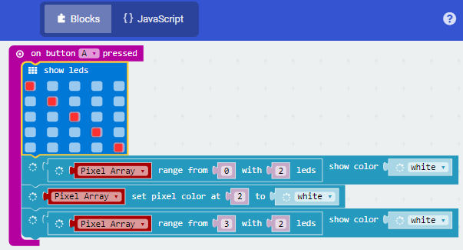 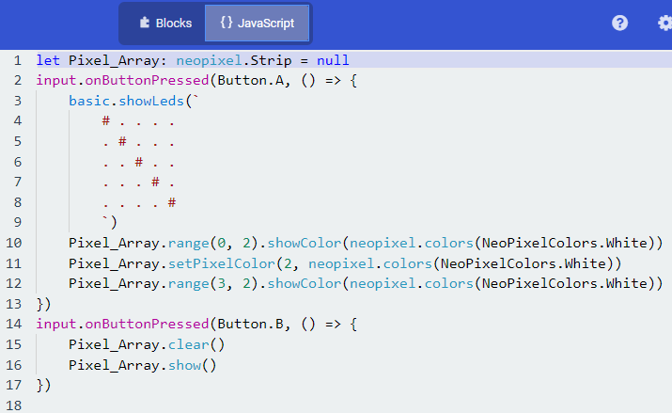
Step 3: Download It has the following directions and then short video clips for Windows “Send to” and Mac “Drag & Drop”
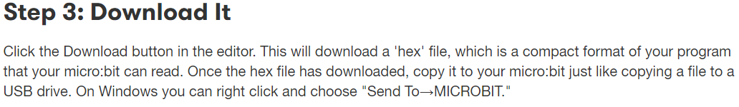
Step 4: Play It
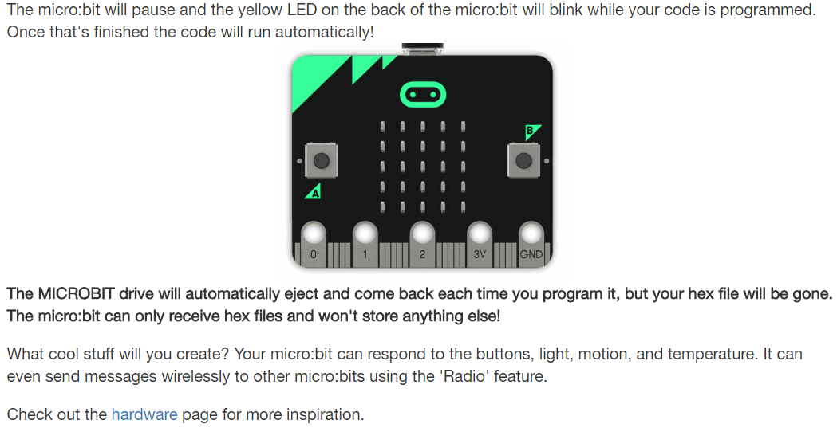

Step 5: Master It has links to Let’s Code and Ideas (see earlier in this document for information on those sections)

