Mazes and Pathways Task:
Lesson Plan
http://kpscobracoders.weebly.com/
If students have had experiences with robots such as BlueBot or DASH they are familiar with the idea. If not, to prepare for this task students should make paths or mazes on paper. Then they can move an object such as a toy person on the path and say or write down the code. Graph paper with 1” squares is better than graph paper with smaller cells for younger students. Older students using smaller squares will see a connection from the grid on the paper to the grid option in ScratchJr. 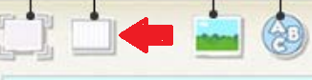 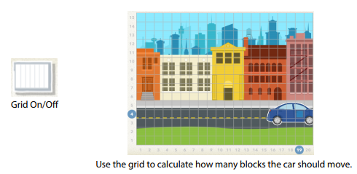 Grid on
The students can make their own using the 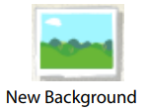 then in the Paint Editor screen. Once they make the pathway or maze clicking on the Grid feature will help judge how far to move the Sprite.
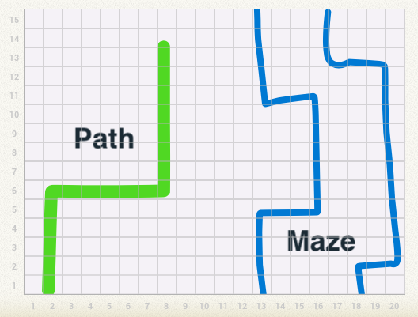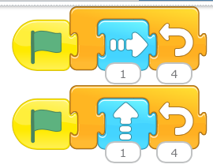
If the students are familiar with robots such as DASH that can be coded to different degree turns they will need to be reminded Cat can only go up, down, left, and right – or can it? If two coding trains are run at the same time, say move up one and move right one, it will approximate a 45⁰ angle.

Mazes and Pathways Task:

http://kpscobracoders.weebly.com/

Once you have completed your paper path or maze and have coded it select Make a New Project.
Select a New Background Click on to go to the Paint Editor screen.
Select the colour and the size of the line
and your tool . Use your finger to make the path or maze.
Make sure your lines only go ─ or │ or / or \.
Click the and wait for it to be saved.
Now click on the Grid button on .
Make a second Sprite like a red stop sign and move it to the end of the path/maze.
Now either you code it yourself or give it to a friend.
Before you give it to a friend …Write up a set of instructions. Make sure to:
Give them this hint: “Count the squares in the grid to help you decide how far to move along the path or maze.”
Remind them to: “Code the second Sprite to say “The End” when the first Sprite bumps into it.”
Remind them to: “Code the first Sprite to do a dance when finished.”

