Math Facts Project Links

Sometimes problems can arise with the coding if the ‘math’ doesn’t work out ‘exactly’ or ‘evenly’ and in those cases the Rounding Block may be added to the coding. Here is a link to the Scratch Wiki about this block:
https://wiki.scratch.mit.edu/wiki/Round_()_(block). As with any Wiki post it is very informative and provides multiple examples of coding and situations to use the Round Block. 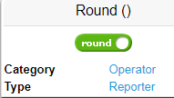
(Note, this is the OLD domain and The Scratch Wiki will be transferred to its new domain: https://en.scratch-wiki.info on the 16th of February, 2018, at 14:00 (UTC).)

https://scratch.mit.edu/projects/172324701/ https://scratch.mit.edu/projects/39620/
Students can create problems to add to a class project
Such as this one
detailed explanation of all the steps (several spelling errors)
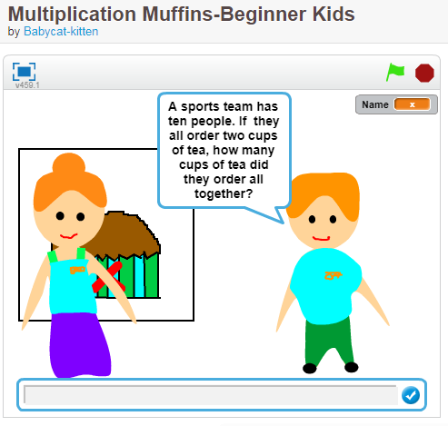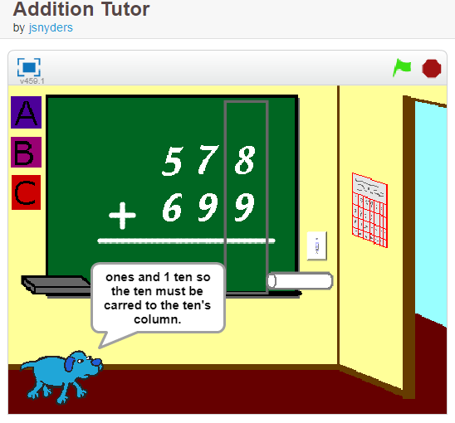

https://scratch.mit.edu/projects/33662962/ https://scratch.mit.edu/projects/96190850/
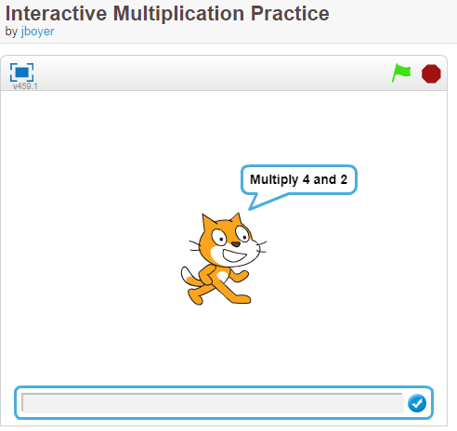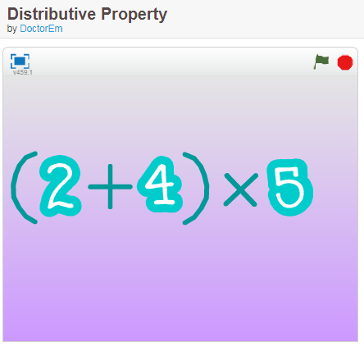

https://scratch.mit.edu/projects/10226299/ https://scratch.mit.edu/projects/346072/
Other games in 2D shapes file

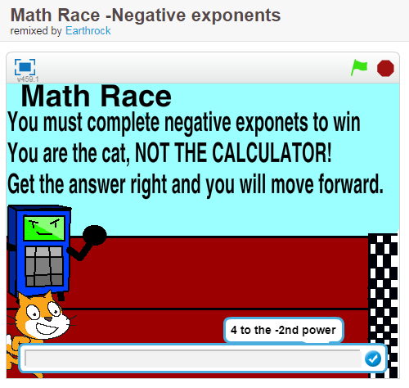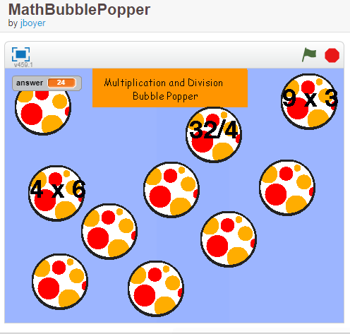

https://scratch.mit.edu/projects/184416234/ other projects at https://scratch.mit.edu/studios/4316910/
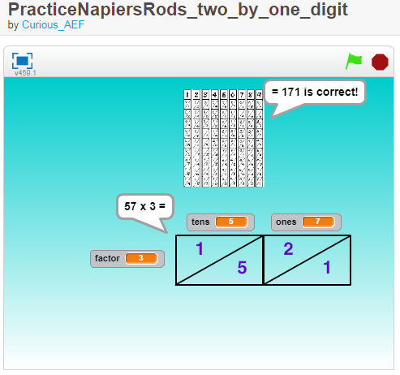
https://scratch.mit.edu/projects/90258028/ https://scratch.mit.edu/projects/168313052/
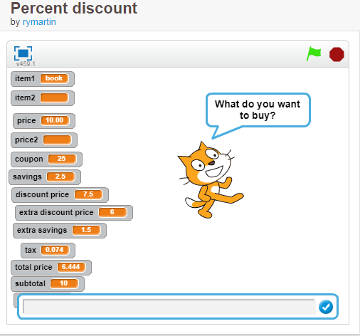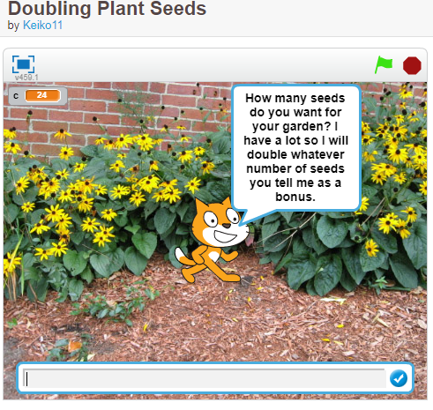

https://scratch.mit.edu/projects/1513651/ https://scratch.mit.edu/projects/2116566/
Uses integers The high jump bar getting taller as the game proceeds
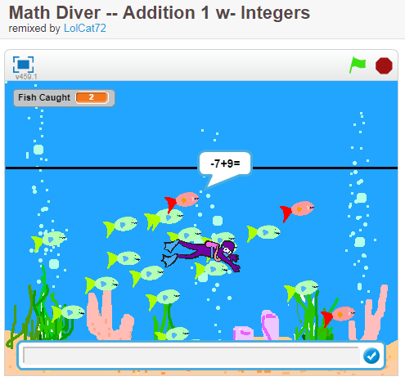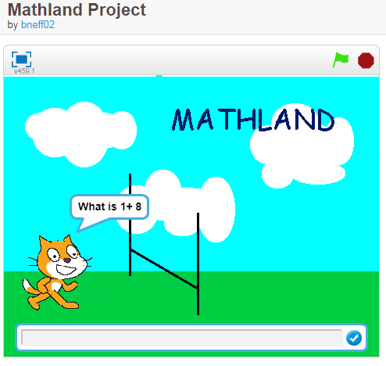
Note: This Mathland Project no connection to Mathland Studio (Ontario content) that I can find

https://scratch.mit.edu/projects/95042837/ https://scratch.mit.edu/projects/55841806/
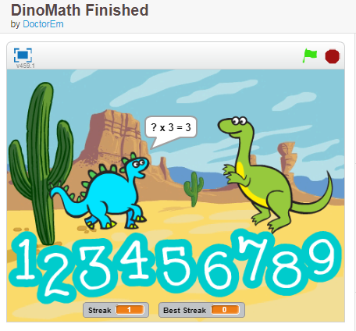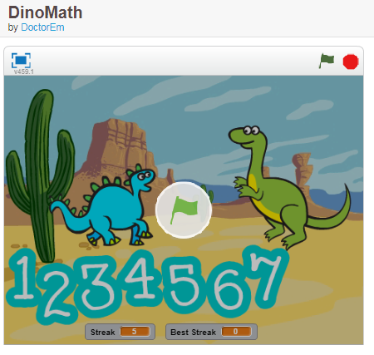
https://scratch.mit.edu/projects/94217115/ https://scratch.mit.edu/projects/94343552/
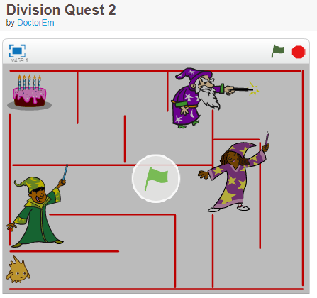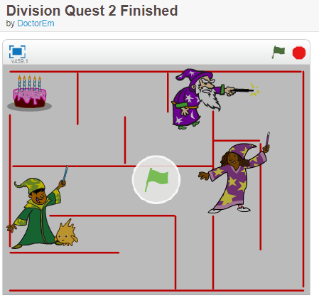
DoctorEm is a California teacher check out other projects https://scratch.mit.edu/users/DoctorEm/
https://scratch.mit.edu/projects/92751691/ https://scratch.mit.edu/projects/13853051/
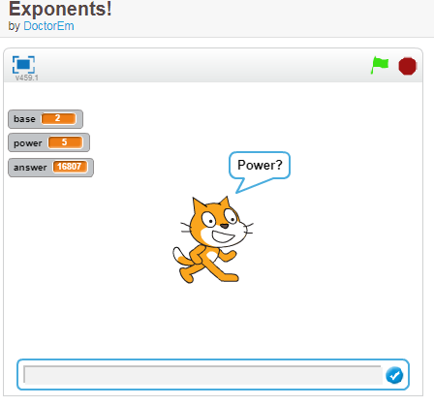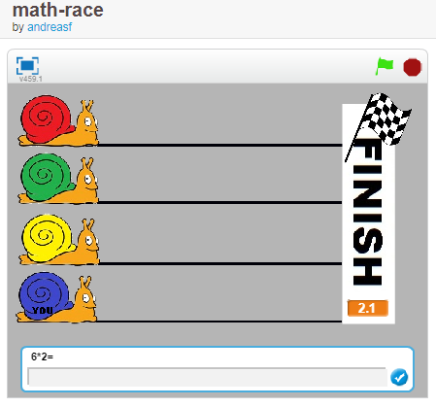
https://scratch.mit.edu/projects/82165036/ https://scratch.mit.edu/projects/81954470/
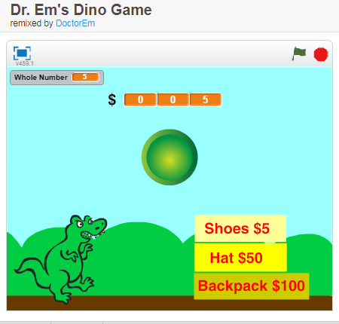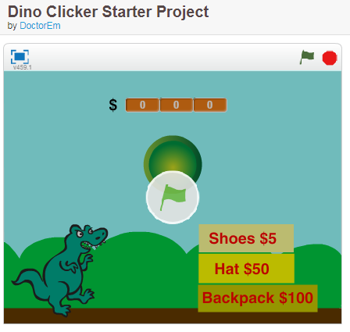
Lots of games at this studio
https://scratch.mit.edu/users/LolCat72/projects/?page=3
As always you can search in Scratch for projects using the Tabs’ names or even search using your OS search engine.

