Lightbot Level 3-1 Planning Sheet
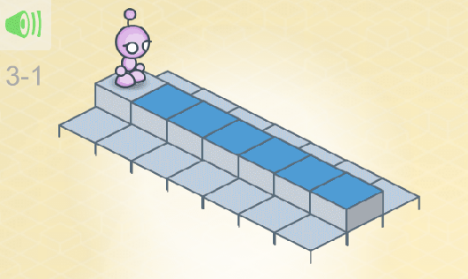

Lightbot Level 3-2 Planning Sheet

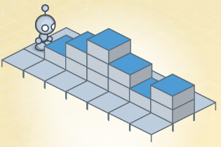

Lightbot Level 3-3 Planning Sheet

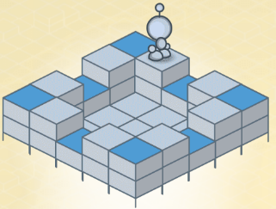

Lightbot Leve 3-4 Planning Sheet
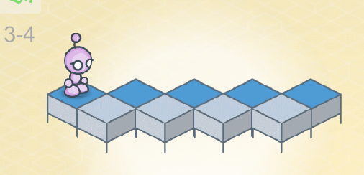

Lightbot Level 3-5 Planning Sheet
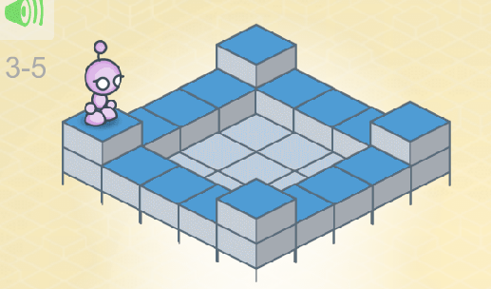

Lightbot Level 3-6 Planning Sheet
