Lightbot Level 2-1 Planning Sheet

Lightbot Level 2-2 Planning Sheet
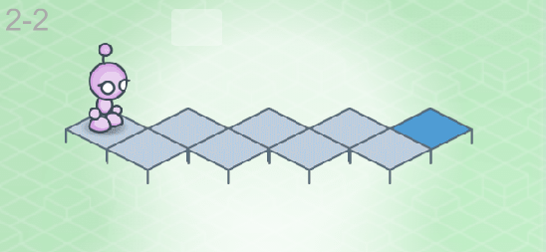

Lightbot 2-3 Planning Sheet
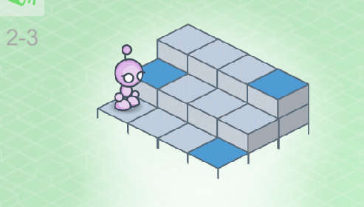

Lightbot Level 2-4 Planning Sheet
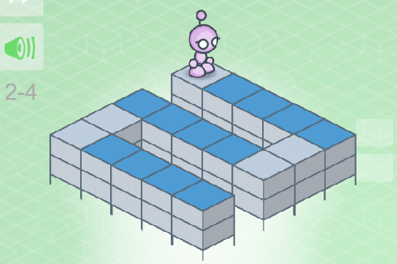

Lightbot Level 2-5 Planning Sheet
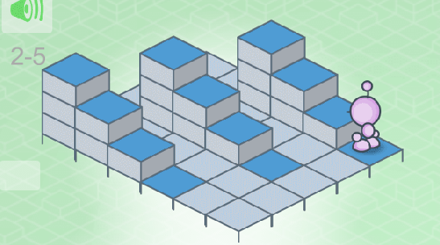

Lightbot Level 2-6 Planning Sheet

