Lightbot Level 1-2 Planning Sheet

Lightbot Level 1-3 Planning Sheet

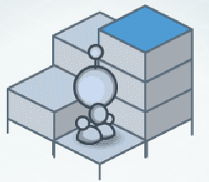

Lightbot Level 1-4 Planning Sheet

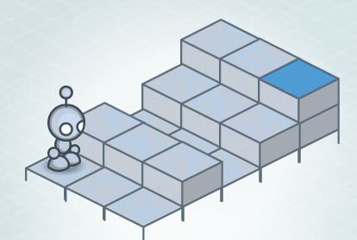

Lightbot Level 1-5 Planning Sheet

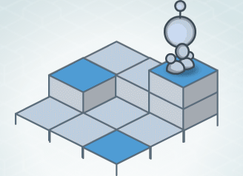

Lightbot Level 1-6 Planning Sheet

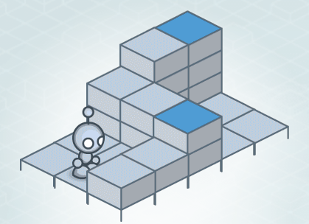

Lightbot Level 1-7 Planning Sheet

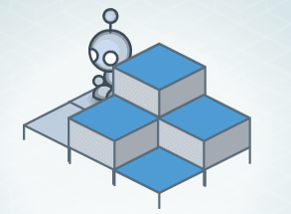

Lightbot Level 1-8 Planning Sheet

