Intermediate Geometry & Trigonometry Links
Inspirations and Connections:
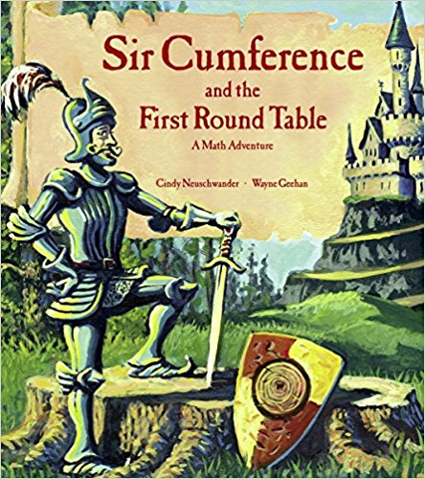 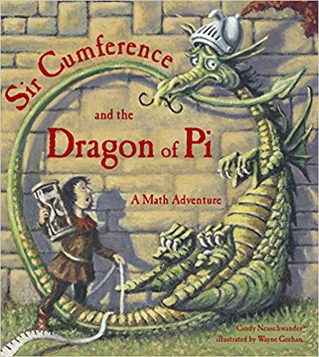 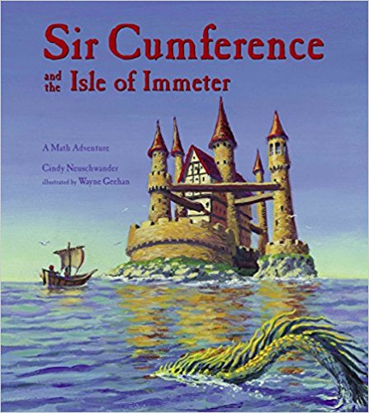 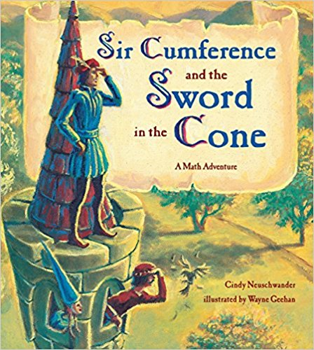 and others
Author: Cindy Neuschwander Illustrator: Wayne Geehan
The Scratch Wiki has a great entry with the coding needed to complete tasks. Here is a screen shot of the Operators needed for the area and surface area of a Cone and Cylinder as examples.
https://en.scratch-wiki.info/wiki/List_of_Mathematical_Functions_Done_in_Scratch

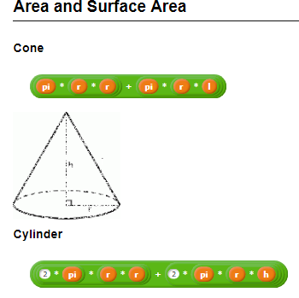
Also https://en.scratch-wiki.info/wiki/Trigonometry
And https://en.scratch-wiki.info/wiki/()_of_()_(Operators_block)
https://scratch.mit.edu/projects/2199227/
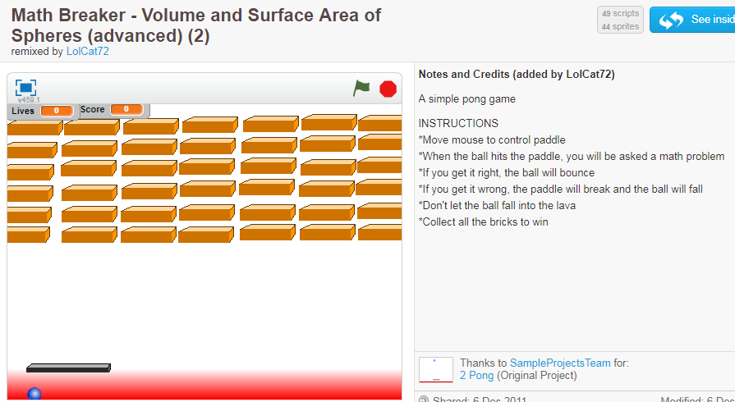
https://scratch.mit.edu/projects/2158183/ https://scratch.mit.edu/projects/2035435/
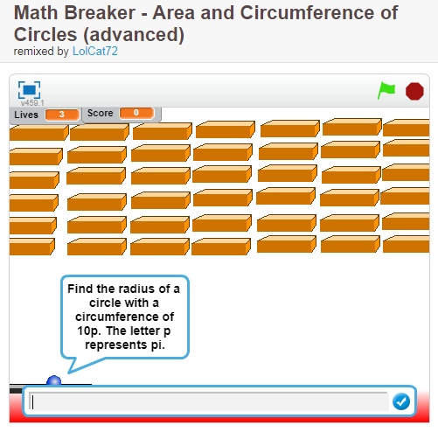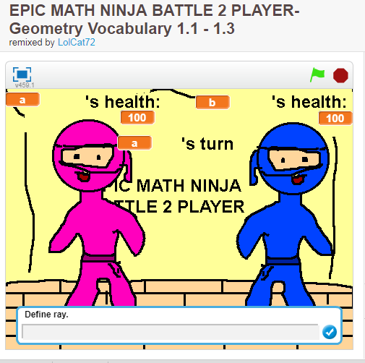
https://scratch.mit.edu/projects/2269760/ https://scratch.mit.edu/projects/1730410/
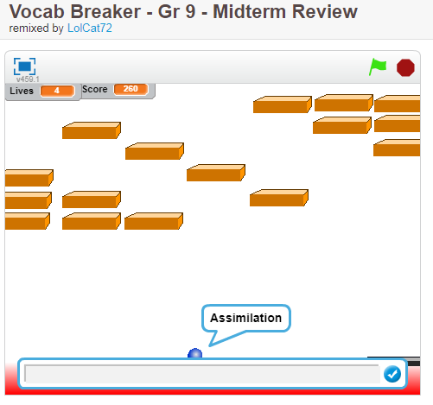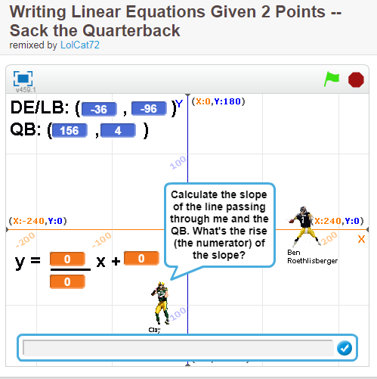
https://scratch.mit.edu/projects/105798078/ very good tutorial, many facts, here is one screen shot from middle of tutorial
