Hour of Code 2018
From: www.kpscobracoders.weebly.com
In this file you will find information on how to:
●Make a Teacher Account for Hour of Code (page 1);
●Find suitable coding activities for your students and the devices available to you (pages 2-3);
●Lesson plans to use with your students from Hour of Code, Code.org (pages 4-5);
●Scratch resources at www.scratch.mit.edu site and with Hour of Code (pages 6-7);
●Activities for LEGO Mindstorms, WeDo, DASH, MicroBits, OzoBots (pages 8-9);
●Unplugged activities (pages 10-11); and
●Print certificates for your students (page 11).
You Tube video (3:34) showing how to set up student accounts within your teacher account.
https://www.youtube.com/watch?v=_smelV_KISE&feature=youtu.be
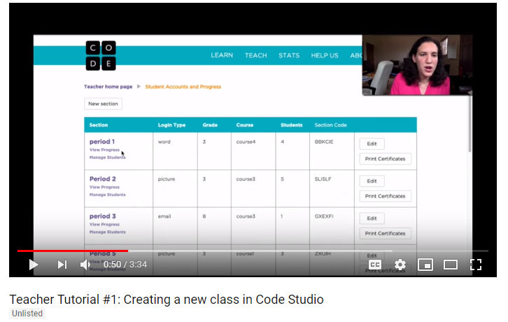
Then your class will get a 6-letter class code to use to log in. Using the code and a password (you can use a word password, an email password or picture password) will mean their work will be saved from one time to the next.
Hour of Code will generate a log in “card” for each of your students. I always print 2 copies. One to glue into their agenda book and the other for me to keep for when they forget their agenda book!
Here is an example
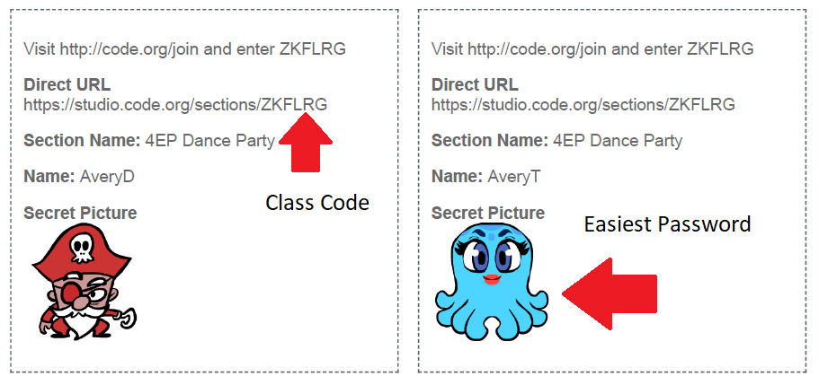

Select an Hour of Code Activity
How to select an activity for your class. Go to this link: https://hourofcode.com/ca/learn
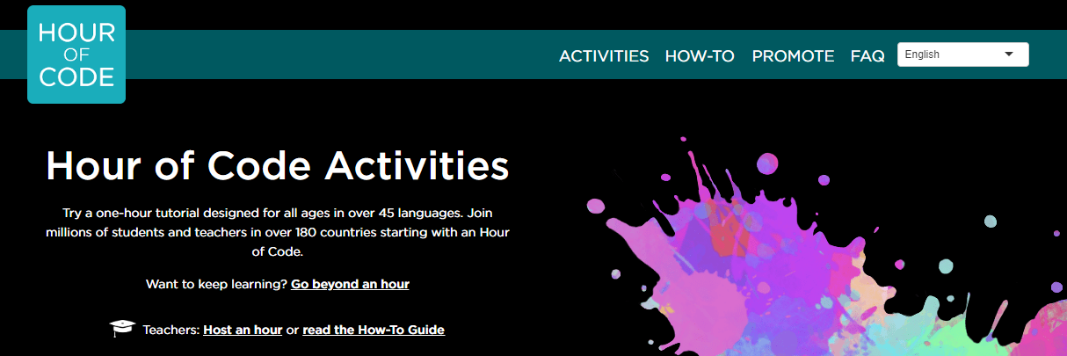

Under this banner there are two ways to find an activity. The first is with this horizontal bar …

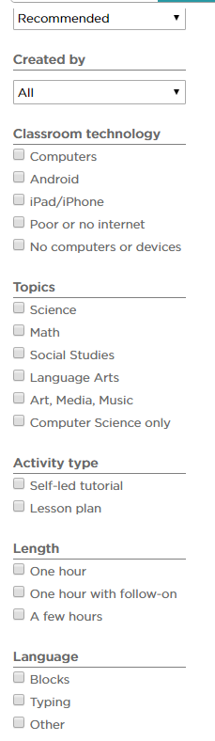
The other is the vertical bar on the left hand side of the screen. This is a multiple level sort sot that you can find activities based on: organization or company that created the activity, your devices, subject matter, length of activity, and self-directed or lesson.
So, for example, if you want iPad/iPhone activities here are the first 9 listed…
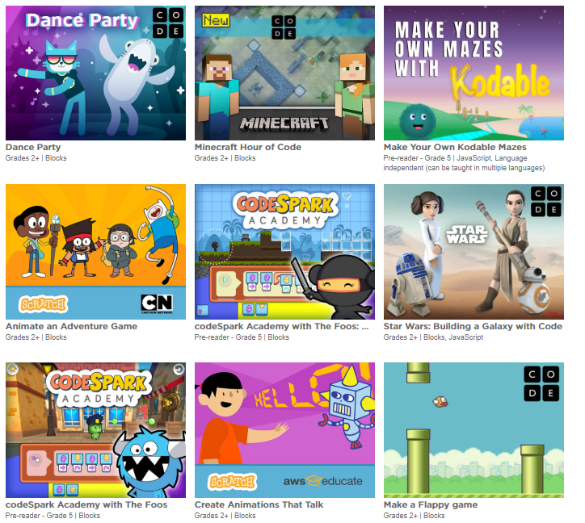
If you click on Computers …
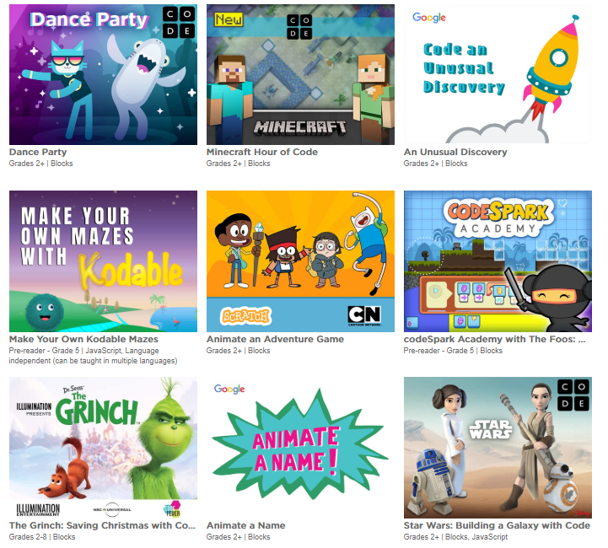
As you can see, some are common to both, so if you have a varied collection of devices you might want to pick some activities that can be used on both.

Lesson Plans
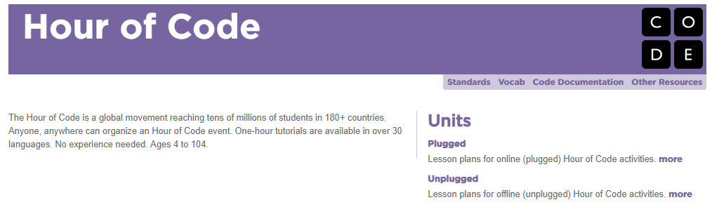
Also, some of the activities have teacher information. CODE.org has Full PDF of 8 lessons for the following activities: https://curriculum.code.org/hoc/plugged.pdf The links below the pictures of the activities are to the activities and at each activity there is a link to the PDF for that single lesson.
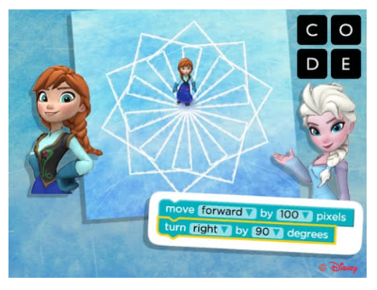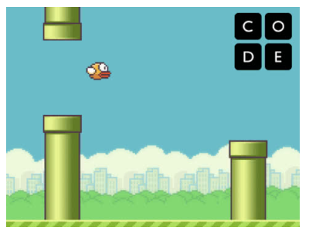
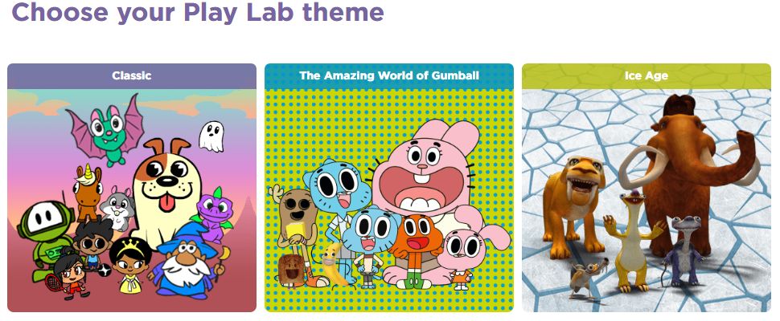
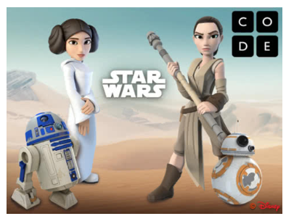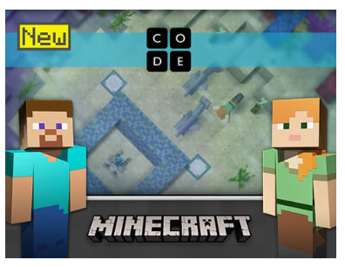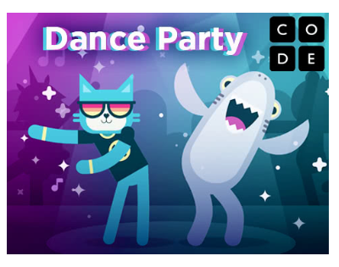
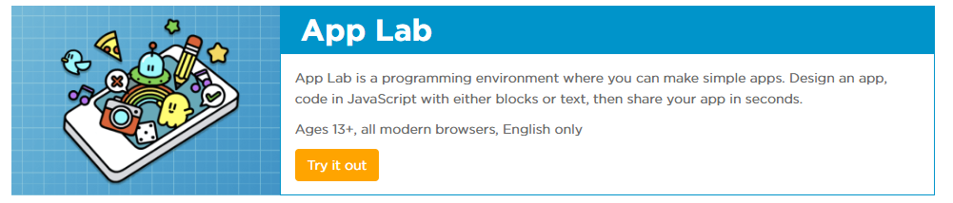
https://hourofcode.com/frzn https://hourofcode.com/flap
https://code.org/playlab
https://hourofcode.com/star-wars https://hourofcode.com/mchoc https://hourofcode.com/danceparty
https://code.org/educate/applab

Scratch Resources
Scratch has organized all their resources on one page https://scratch.mit.edu/tips
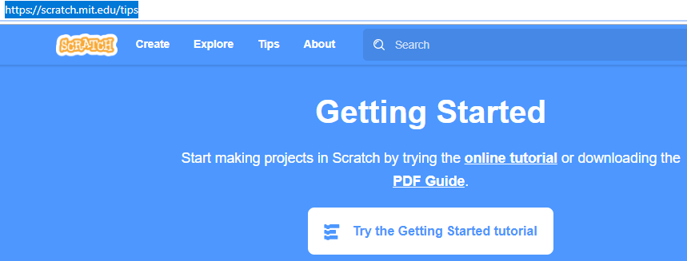
The PDF guide https://resources.scratch.mit.edu/www/guides/en/Getting-Started-Guide-Scratch2.pdf is a 2013 23 page guide to start to code. It is very similar to the Scratch Cards with each page introducing a different block. I have always found the order the blocks are introduced backwards to the way found in the cards for example, the last two items are learning to add a backdrop and change a sprite.
https://scratch.mit.edu/tips is the link to the tutorials; the cards (the first set of instructions we used at the workshops to learn to code in Scratch); educator guides (these PDF’s are a lesson plan or workshop guide to using the cards – probably not something you would need to use with your students, especially if you had trained your coding coaches to teach the rest of the students in your class); and the starter projects.
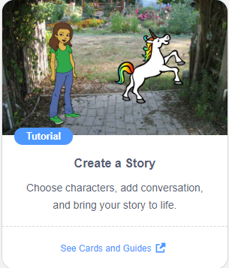 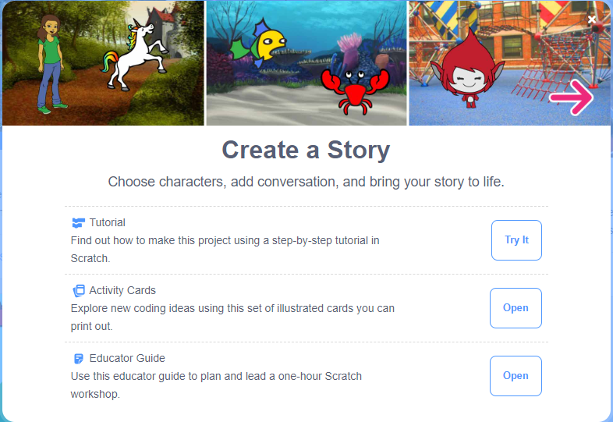 for each set of cards
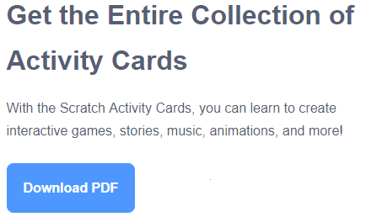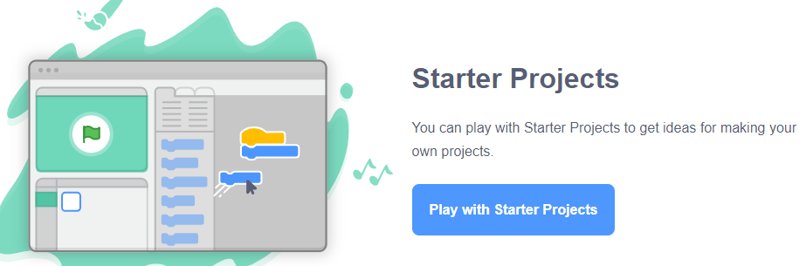
one PDF of all 75 cards ↑

Back to Hour of Code, the activities created by Scratch.Mit.edu are
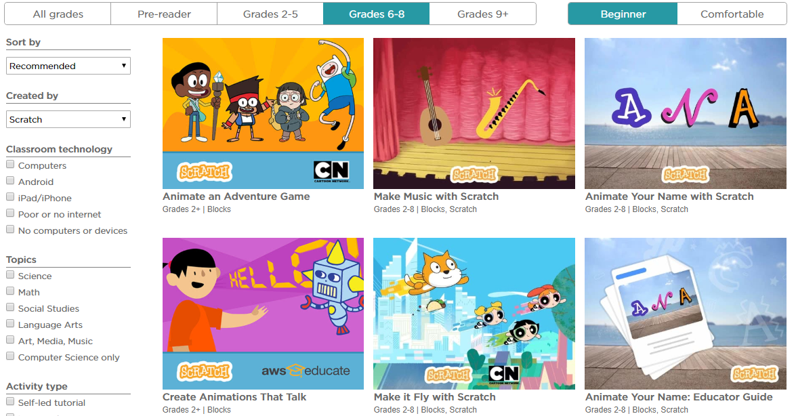
But if you click on Blocks for the language 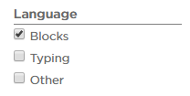you end up with over 120 activities! Students with experience in ScratchJr and Scratch could try any of them.

There’s more … scroll down to the bottom of https://hourofcode.com/ca/learn and click on 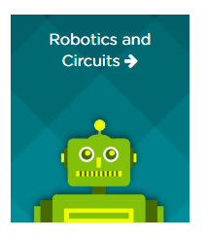check out https://hourofcode.com/ca/learn/robotics
Want to try out your LEGO Mindstorms and WeDo kits during Hour of Code Week?
https://hourofcode.com/ca/learn/robotics
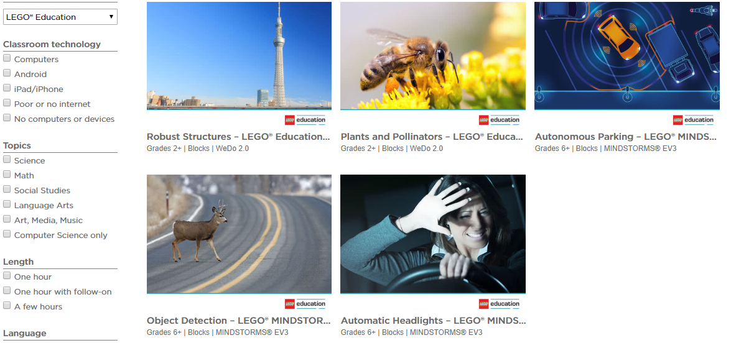
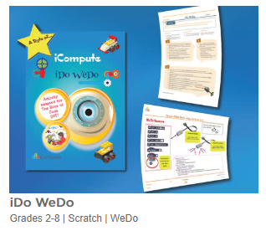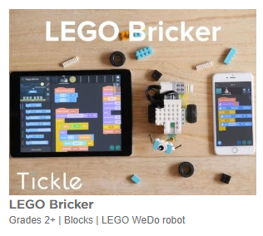
MicroBit?
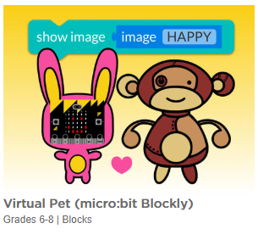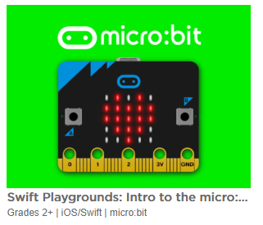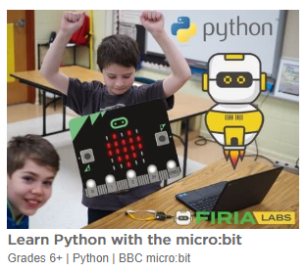
WonderWorkshop DASH & DOT?
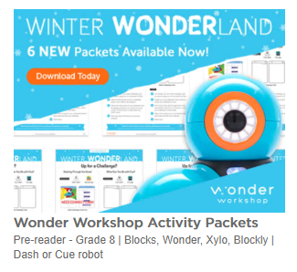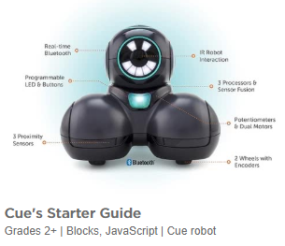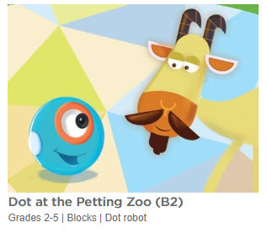
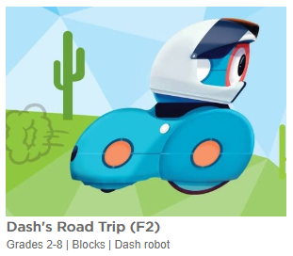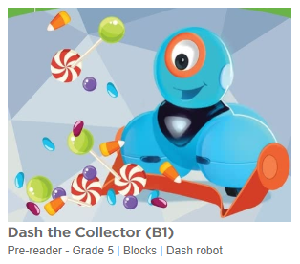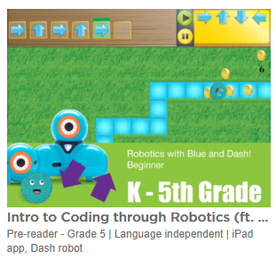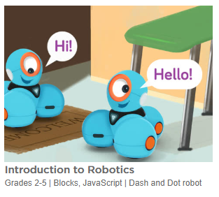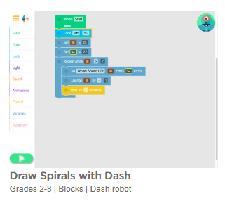
OZOBOTS?
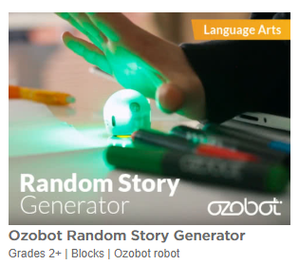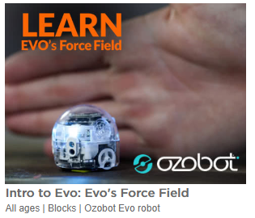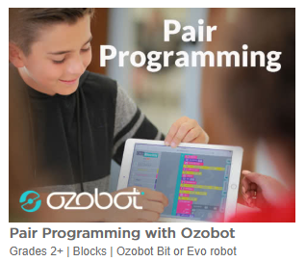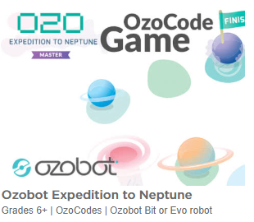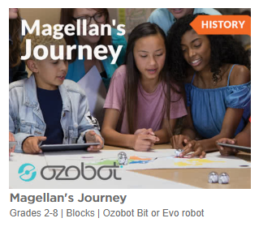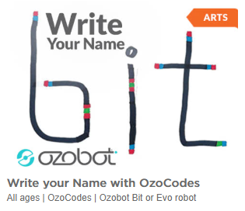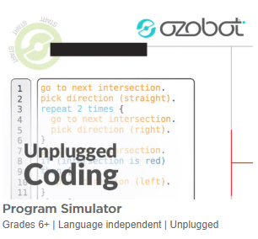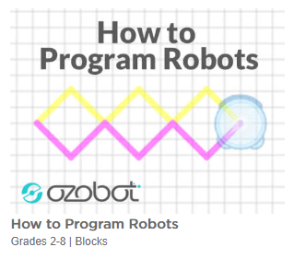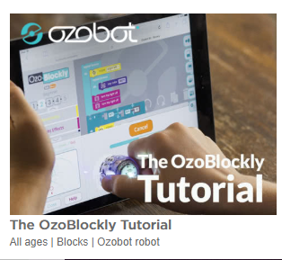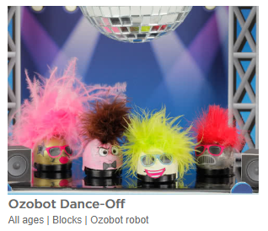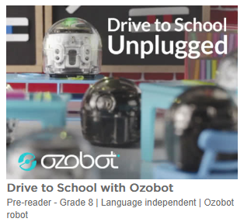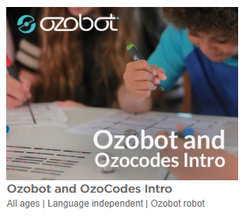

Unplugged Activities
Remember unplugged activities aren’t just for little kids and not just at the start of learning to code. I think unplugged activities are a greater learning experience used after starting to code. Then students can make connections between unplugged and coding. Here are some from the Hour of Code site. You can find them by sorting “no computers or devices”
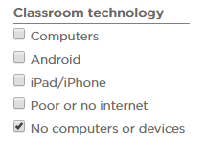
Here is the link to these 4 unplugged activities. https://curriculum.code.org/hoc/ here’s the link to the 23 page PDF: https://curriculum.code.org/hoc/unplugged.pdf
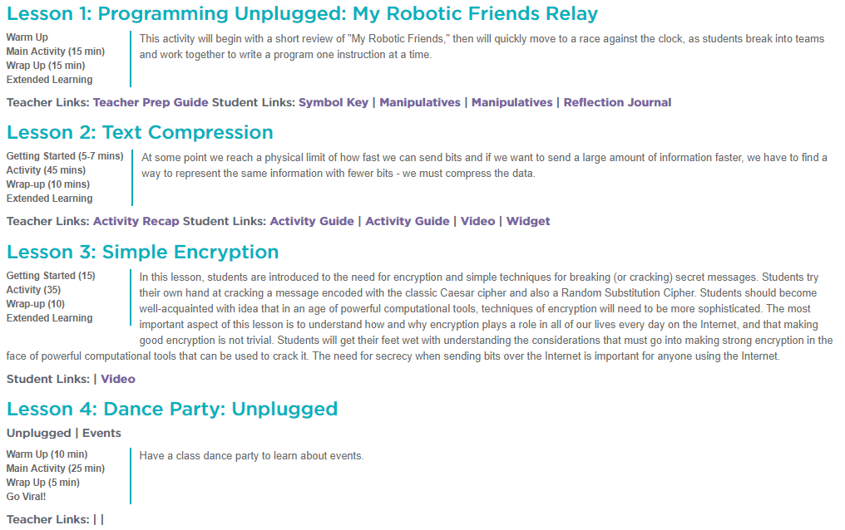
The Thinkersmith Unplugged lessons are great:
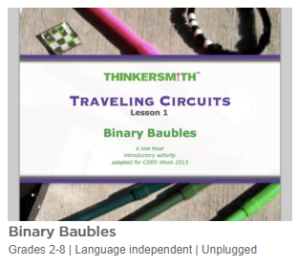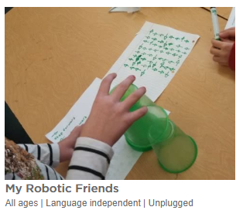
https://hourofcode.com/files/CSEDbinary.pdf https://csedweek.org/unplugged/thinkersmith

Here are several others:
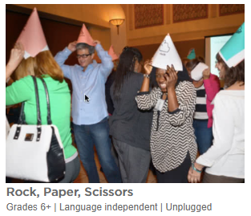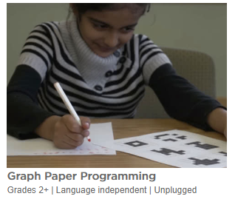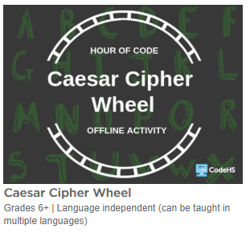
https://hourofcode.com/files/PGUTSRockPaperScissors.pdf
https://studio.code.org/s/course2/stage/1/puzzle/1
https://drive.google.com/file/d/15fij1HordMyCJDkZDGYgelXFyYKGC9Sn/view

Finally, here is the link to Printing Certificates
https://code.org/certificates
