Health Projects Links
Inspirations & Connections: https://ecologyaction.ca/sites/ecologyaction.ca/files/images-documents/OFP%20-%20Plants%20to%20Plates%20Activity%20Guide%20-%20Online.pdf
https://vimeo.com/55484352
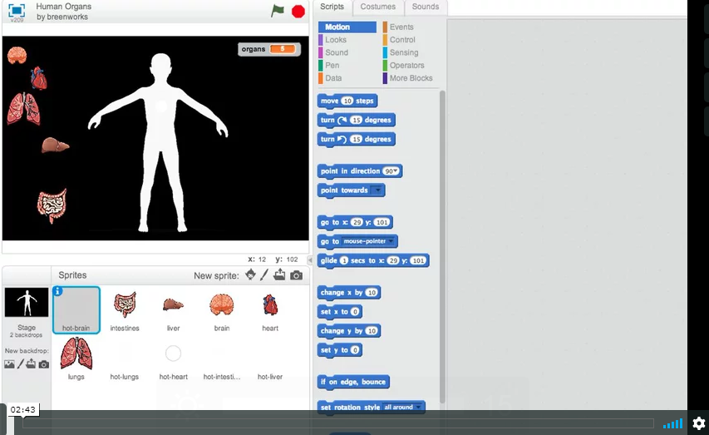
https://scratch.mit.edu/projects/10560706/
Just the start of project only these two pics
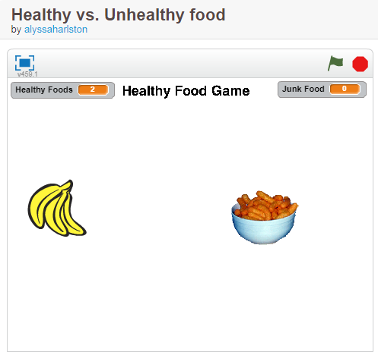

https://scratch.mit.edu/projects/11447752/ Note: Remix hints

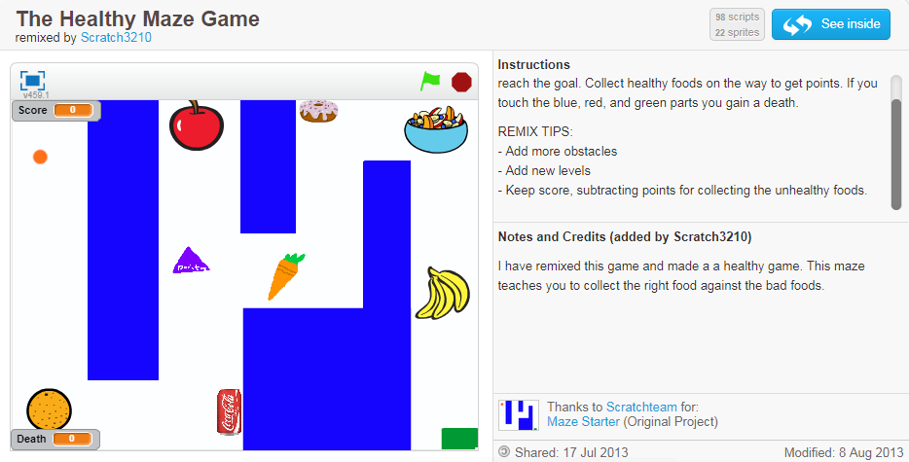
https://scratch.mit.edu/projects/19290521/
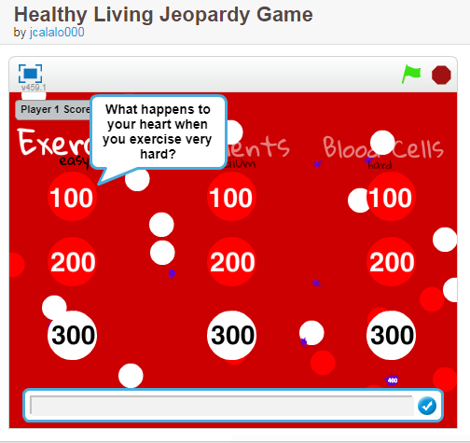
https://scratch.mit.edu/projects/2926682/
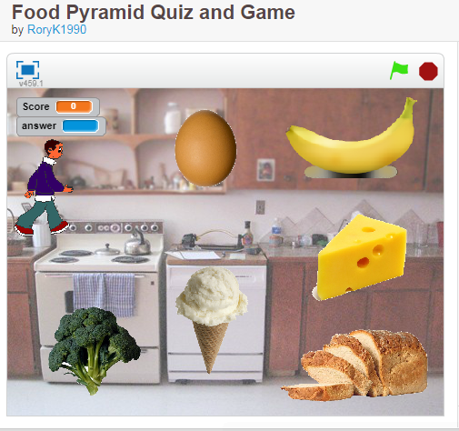

https://scratch.mit.edu/projects/12533282/
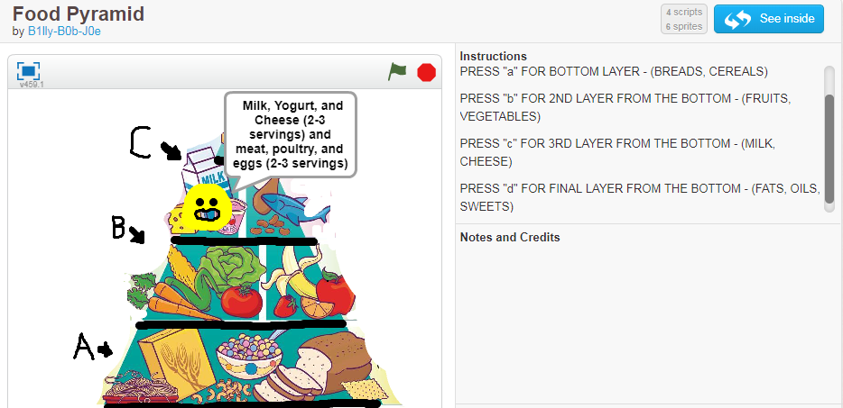

https://scratch.mit.edu/projects/16550463/
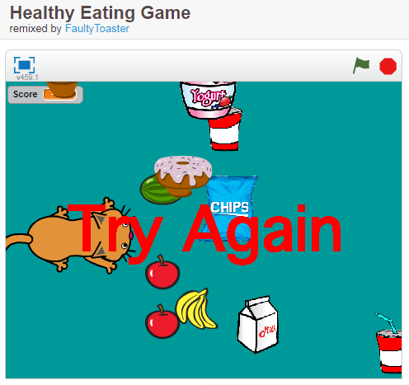
https://scratch.mit.edu/projects/2444526/
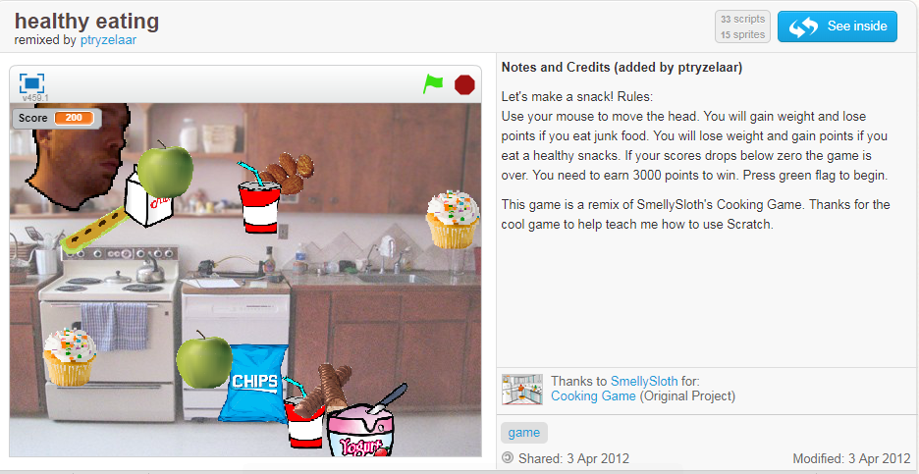
https://scratch.mit.edu/projects/2379660/
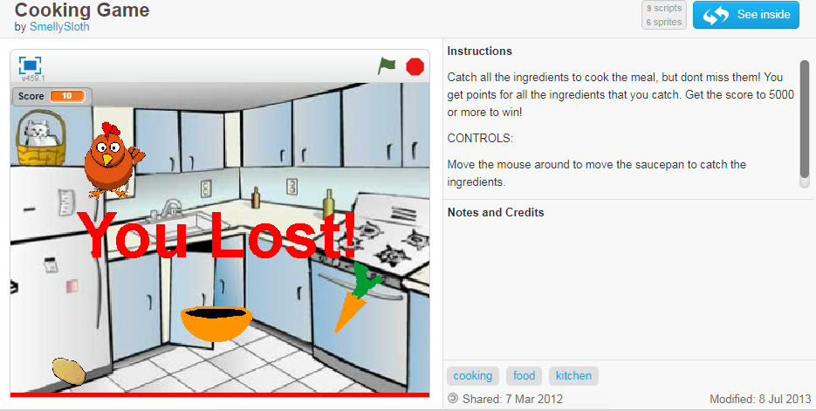
https://scratch.mit.edu/projects/398733/
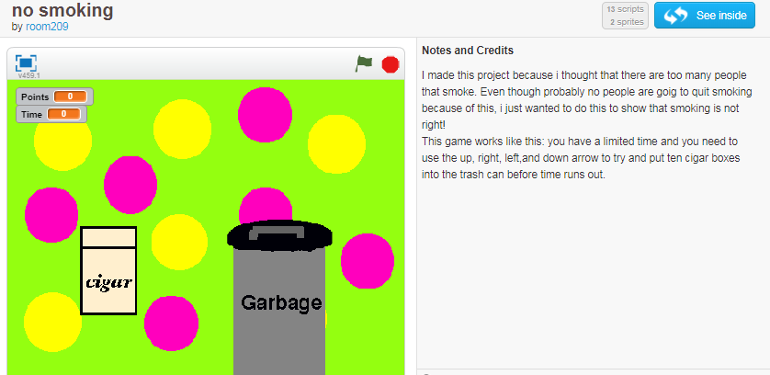
https://scratch.mit.edu/projects/88088649/
https://scratch.mit.edu/users/sbergen33/ teacher and lots of project to check out
