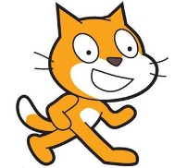 | Guess the Number Project Lesson
Inspirations & Connections: There is a 45 minutes video http://chrisbetcher.com/2016/07/code4kids-building-a-simple-scratch-game/ This is a webcast from Australia. The name of the project is Kelly Webinar. The guest explaining the coding is Chris Betcher and his Scratch name is betchaboy. The Project number is 115765544 but it was NOT shared so you will not be able to see it in Scratch. Make sure to credit him with the project and coding.
Here are my notes from watching the video and some screen shots. They are a little fuzzy because they are taken from the video and not directly from the Scratch screen.
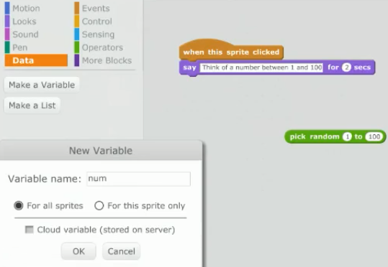
Computer will generate a number but we need a way for it to remember the number so make a variable (13:00)
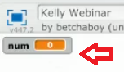 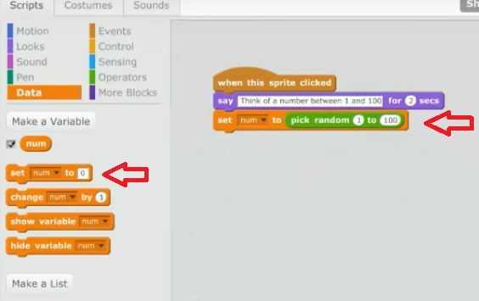 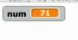 but when the game is running we don’t want the player to see the number so check off this check mark 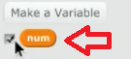
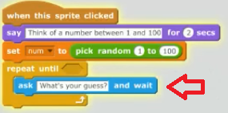 This sensing block creates an answer bar in staging area
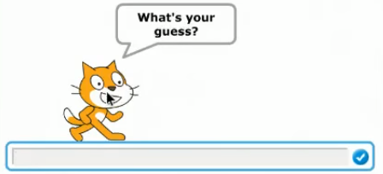
Make another variable called Guess
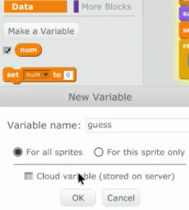
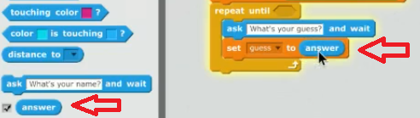
Now we need to start comparing the guess to the actual number. First comparison is Number is < than Guess so computer says Lower
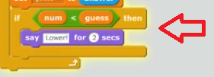
the next comparison is Number is > than Guess

Must set whatever the guess is to match answer so the question can be asked “is the guess equal to the number?” and when it is the game is over.

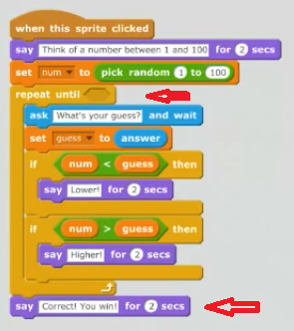
so the final comparison of Number is = to Guess is outside the loop and now we go back to the Repeat Until … block to make the final operator

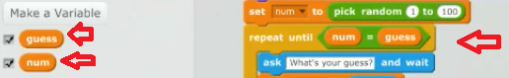
So the final comparison is = . At this point we see still the Number and the Guess because the Variable check mark. We must click them off. With each guess we go through the conditions within the loop, but when the correct answer is given we “fall through the loop” and the coding ends.
Lesson:
Act out the game with the teacher as the computer. Instead of talking the teacher holds up written instructions. A student plays the game. The rest of the class in small groups writes the actions taken by the player and the computer. Then the whole class discusses what blocks are needed. Students can check the original project against their ideas or actually create the code themselves and credit the ideas to Chris Betcher.
Here is a list of statements the robot will show the player as the game proceeds:
Would you like to play a game?
I will think of a number between 1 and 50.
I will not tell you this number.
You will try and guess my number.
OK, I know my number.
What is your first guess?
Higher
Lower
What’s your next guess?
That’s my number!
You WIN

