Grade 6 Space Science Links
https://codeclubprojects.org/en-GB/scratch/moonhack-scratch/
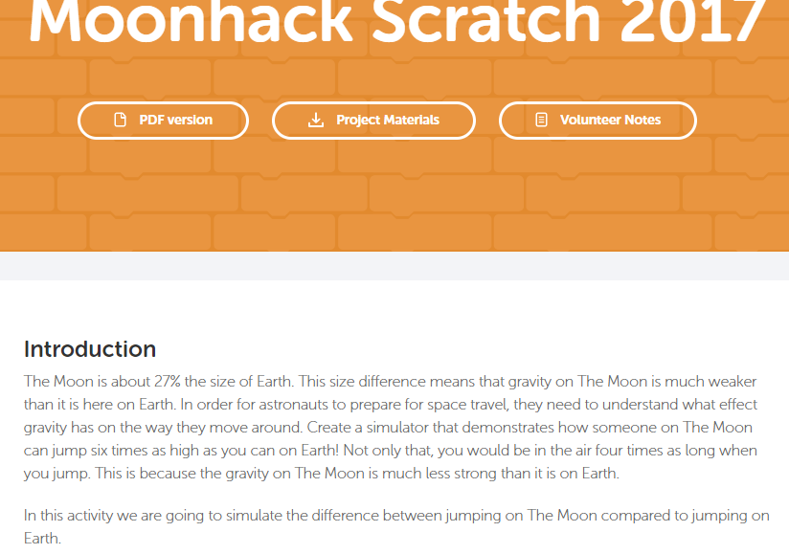

https://codeclubprojects.org/en-GB/scratch/space-junk/
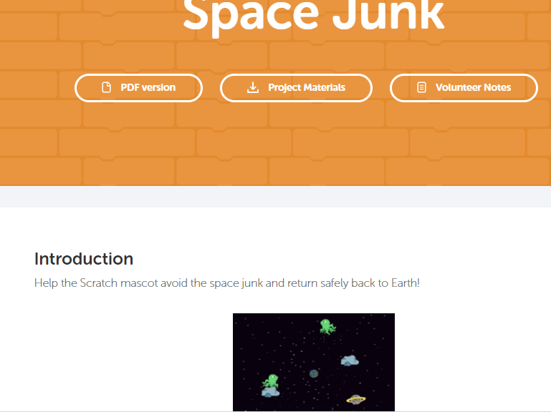
Each month or so Scratch has a new Scratch Design Studio (SDS) (https://en.scratch-wiki.info/wiki/Scratch_Design_Studio ). The list of topics can be a good source of projects based on a single idea or theme. Here is the link to see all the ones to date: https://en.scratch-wiki.info/wiki/Scratch_Design_Studio/Studios
These studios are curated by Scratch people at MIT so the quality of individual projects seems to be higher than other studios. Students should have the list of SDS links.

The 20th was titled Deep Space: https://scratch.mit.edu/studios/51460/
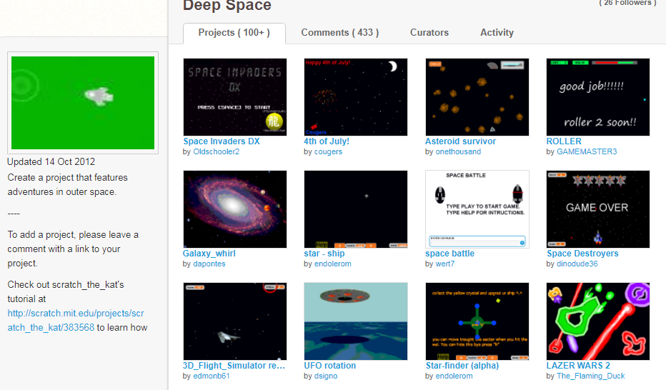
Other projects
https://scratch.mit.edu/projects/191606441/
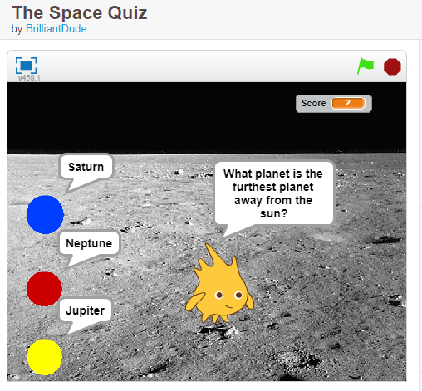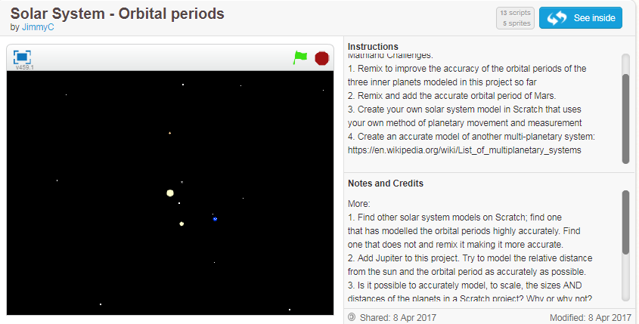
https://scratch.mit.edu/projects/24158475/
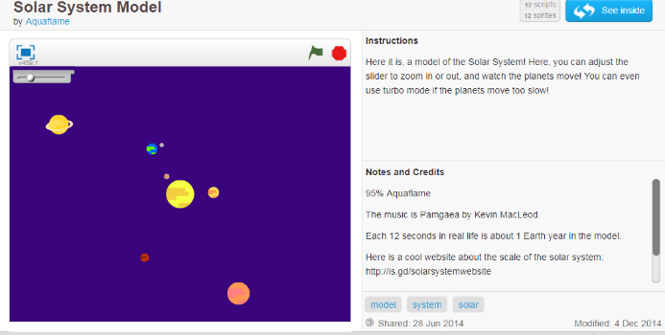

https://scratch.mit.edu/studios/4264738/ Titled Space Studio
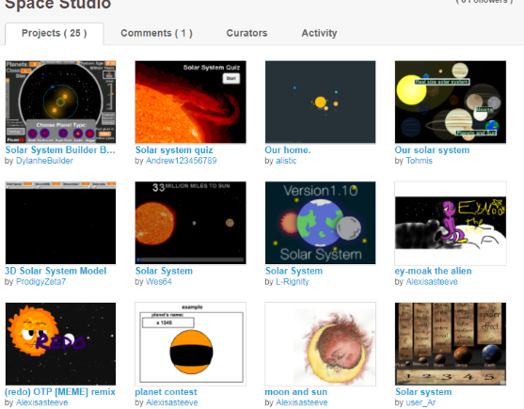
https://scratch.mit.edu/projects/10398130/
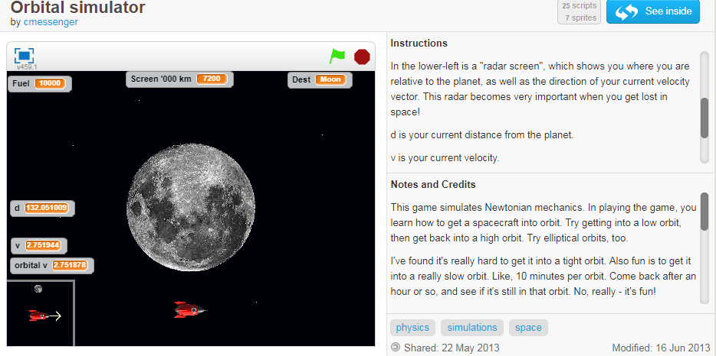
https://scratch.mit.edu/projects/70465568/
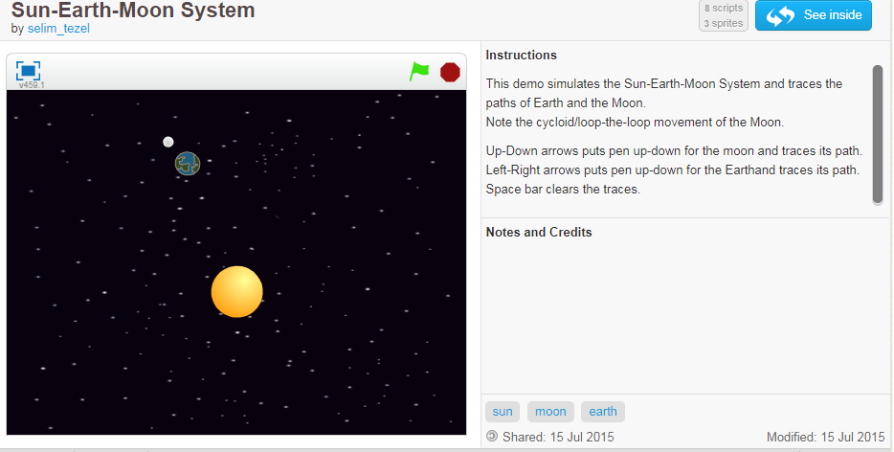
https://scratch.mit.edu/projects/72798680/

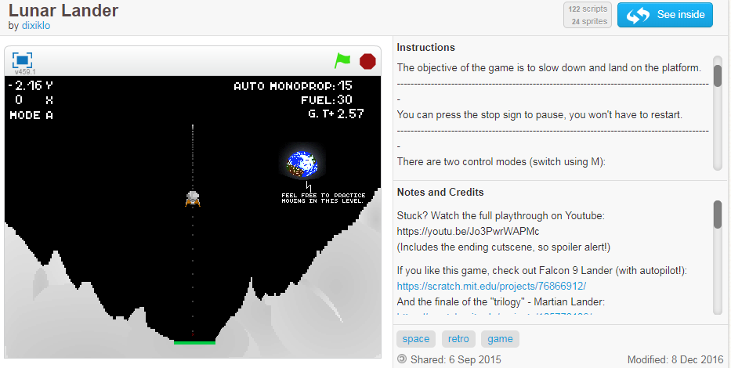
https://scratch.mit.edu/projects/89811578/
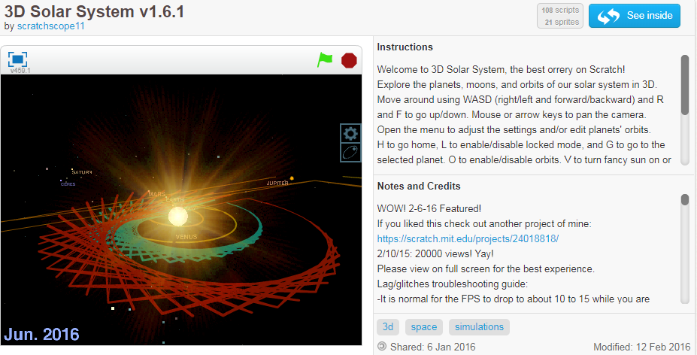
https://scratch.mit.edu/projects/154765384/ not sure the connection to space but simulation to build a city like SIM City games, one other same situation just different
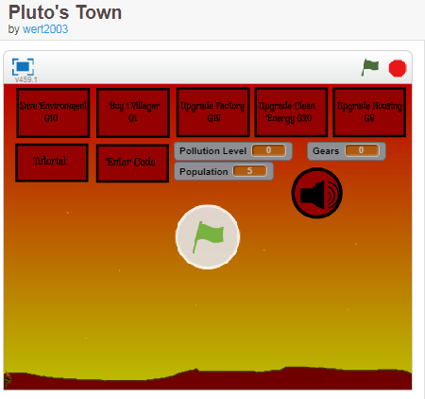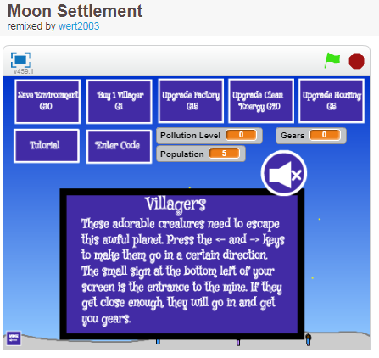

https://scratch.mit.edu/projects/92941727/ https://scratch.mit.edu/projects/82883322/
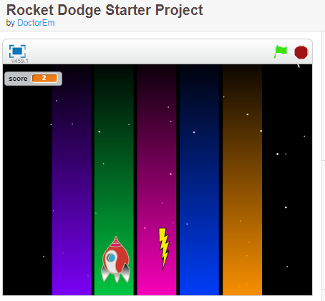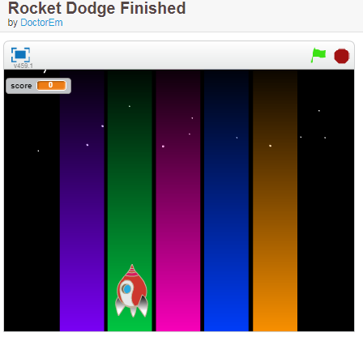

This next project comes with lesson plan and detailed instructions for students to follow to build code.
http://nebomusic.net/advancedscratch.html same info here http://nebomusic.net/scratch.html
Space Ship Project
Project #28 (http://www.nebomusic.net/AsteriodScratch.html)
BCS-BP-6. Students will design solutions for simple programs using basic programming techniques and constructs.
Objectives:
-Use Trigonometric principles to determine Vectors for X and Y Directions for Sprite(Object) Movement.
-Simulate Gravity Physics.
-Use Conditional Statements and While Loops (Repeat Until) to determine action within Game.
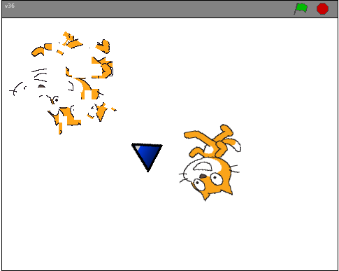 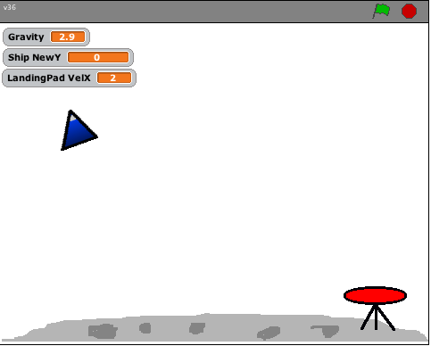 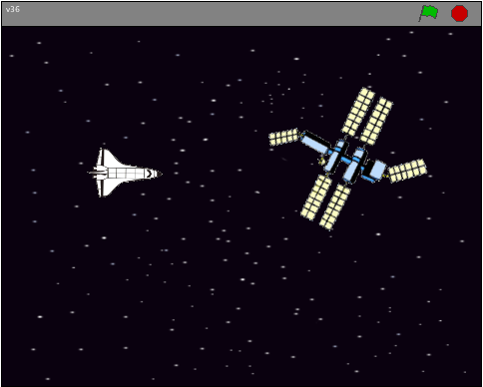
Project Requirements:
1. Create a SpaceShip that Simulates real movement in Space.
2. Up Arrow provides Forward Thrust.
3. Right and Left Arrows turn the Ship
4. Ship can "Pass Through" edges of Screen.
Project Extras:
1. Have the Ship shoot like "Asteriods".
2. Add other ships. (Or Games like "Landing" or "Find the Space Station")
Link for instructions http://nebomusic.net/AsteriodScratch.html Screenshot of start of instructions
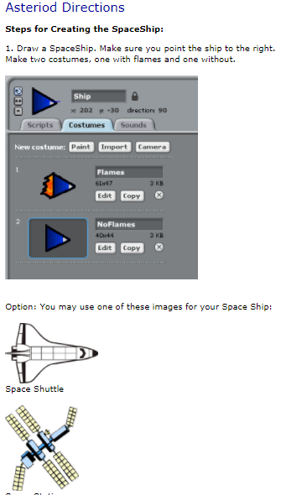
https://scratch.mit.edu/projects/70462430/ good to remix
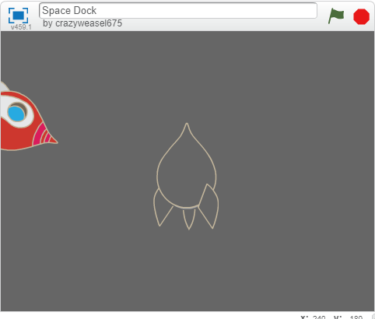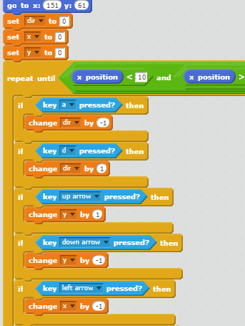

NASA Project https://www.jpl.nasa.gov/edu/teach/activity/explore-mars-with-scratch/
Complete set of plans!!!
