Generic Project Five Facts Lesson
http://kpscobracoders.weebly.com/
This is the first example of a project to integrate into your day. It is a project example of the idea of low floor, high ceiling, and wide walls. This project has minimal coding (low floor) to be successful and yet, the coding can be enhanced and added on to (high ceiling) in any number of ways. The information needed to include in the project can be from any subject area and any grade level (wide walls). Let’s check it out.
https://scratch.mit.edu/projects/10014866/
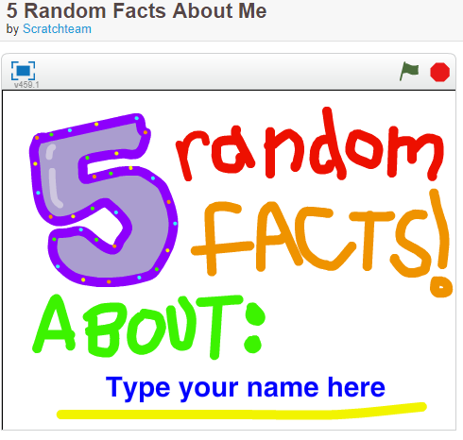
Notice if you are unable to Type your name or add information on the pages it means you are not logged into the Scratch site.
If you have not logged in you will be asked to do so. FYI: If you have been browsing around and have more than one Scratch project open without signing in, signing in to one project will sign you in to ALL the open Scratch windows. Click on Then you will see this
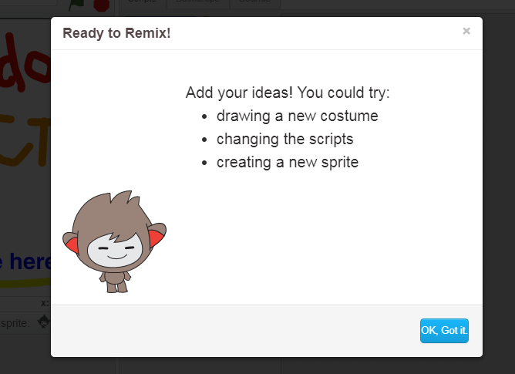
Notice now several things on your screen have changed.
First, the original project # has been replaced. The new project number belongs to my remix and each coder who selects remix will have a different number.
Second, the project title has altered with the addition of the word remix.
Third, in place of the remix button there is a Share button. Until that is clicked only I can see the project.
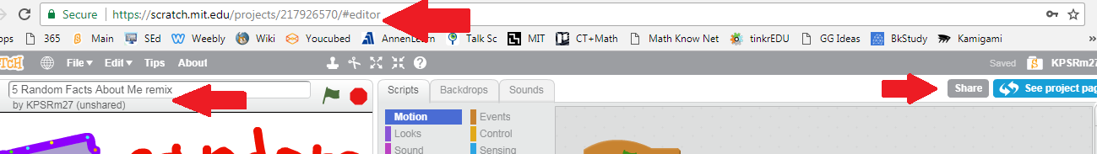
There are also changes to the project front screen.
Original Project Information  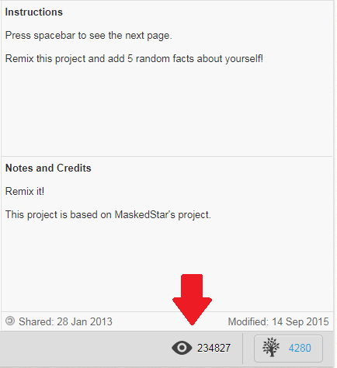 | Adjustments to my Remix Project page:  ● Instead of over 200 000 views I have one because I have not shared it  ● There is a banner at the top reminding me it is not shared  ● My Scratch name is added to the project. This is then a link to my projects and any Studios I have made with that log in name  ● There is a Draft button can be click so that when you share people will know not all coding is complete or debugged  ●There are no Loves or Favorites because it is not shared  ● Instructions section is available to add my ideas  ● Note and Credits section is available to add my ideas  ● Thanks to section has be pre-populated with the Original Project Name and source, in this case, ScratchTeam  ● A place to add 3 Tags (https://en.scratch-wiki.info/wiki/Project_Tags )  ● The date I began the project (right hand side) and is and when I share it that date will appear on the left hand side
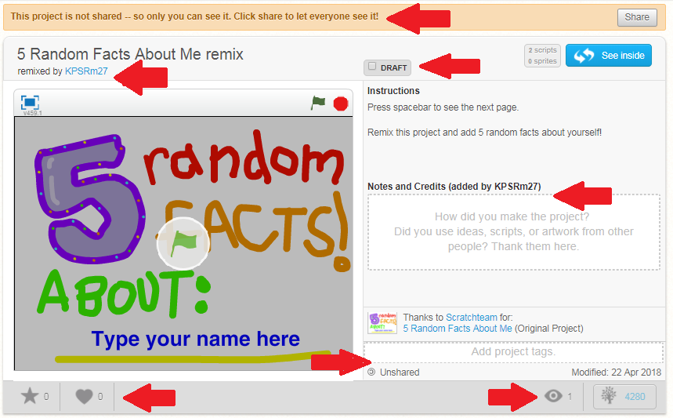
There is one thing I would caution you about using this project. I would make up a starter project on the topic connected to what my class was currently studying (for example, Five Things about Ancient Egypt or Five Things about Persuasive Writing, or Five Things about Quadrilaterals). If you decide to start with a project that students write about themselves you need to be sure they do not reveal any identifiable personal information. It is a genuine time to discuss cyberbullying ( http://www.edu.gov.on.ca/eng/safeschools/respect.html ) or the expectations in Media Literacy component of the Language curriculum. Creating Media Texts:
By the end of Grade 4 & 5, students will: Purpose and Audience 3.1 describe in detail the topic, purpose, and audience for media texts they plan to create
By the end of Grade 6, students will: Purpose and Audience 3.1 describe in specific detail the topic, purpose, and audience for media texts they plan to create, and identify challenges they may face in achieving their purpose
By the end of Grade 7 & 8, students will: Purpose and Audience 3.1 explain why they have chosen the topic for a media text they plan to create, and identify challenges they may face in engaging and/or influencing their audience
Let’s take some time and brainstorm topics we could use for this project as well as ways to DI
as well as create a project rubric

