Fraction Projects Links
https://scratch.mit.edu/projects/17407089/ https://scratch.mit.edu/projects/99002071/
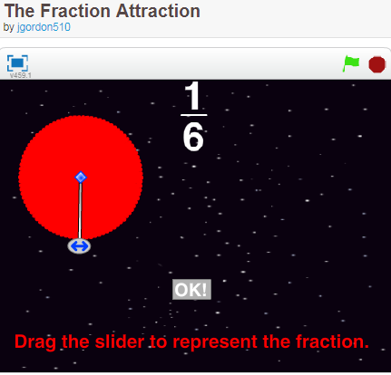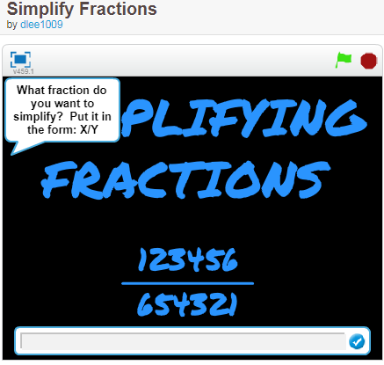
https://scratch.mit.edu/projects/1880790/
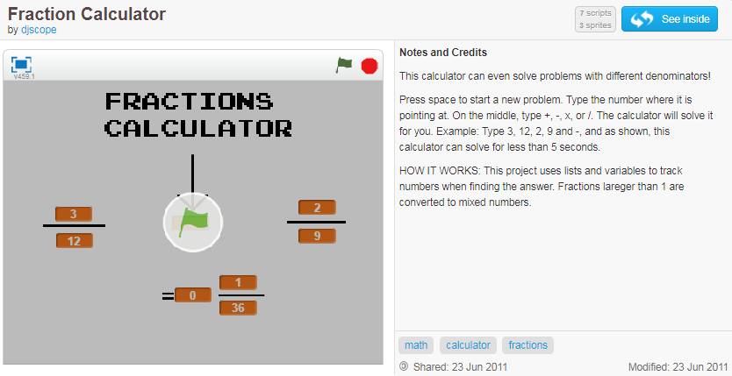
https://scratch.mit.edu/projects/19619339/
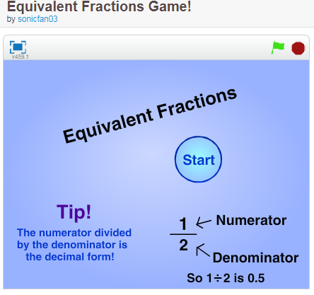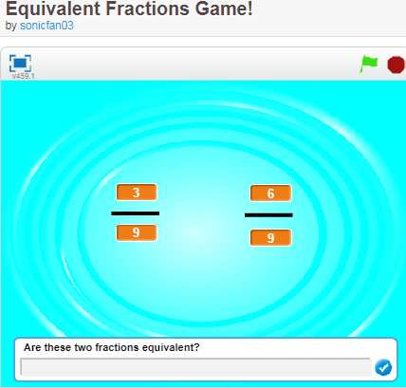
https://scratch.mit.edu/projects/1866823/
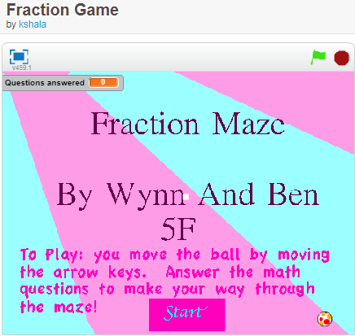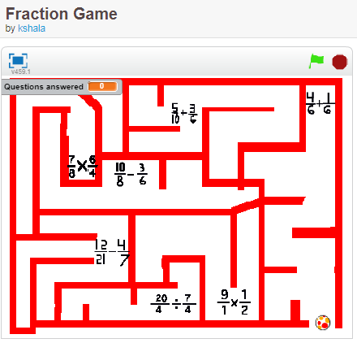

https://scratch.mit.edu/projects/11755180/
This project accompanies the ICAC math lesson plan, Equivalent Fraction/Comparing Fractions. Please visit the ICAC website at www.uab.edu/icac to view the lesson plan and many more!
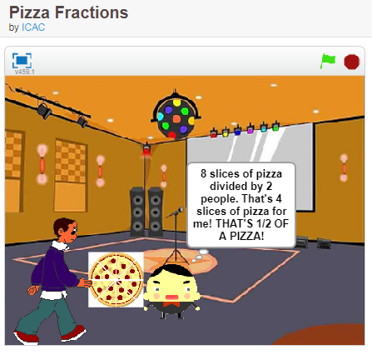

https://scratch.mit.edu/projects/129325016/ good to explain why there is a tiny slice not included in the 360 circle
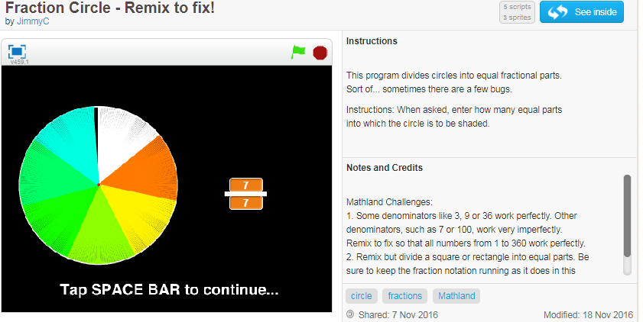
https://scratch.mit.edu/projects/26559896/

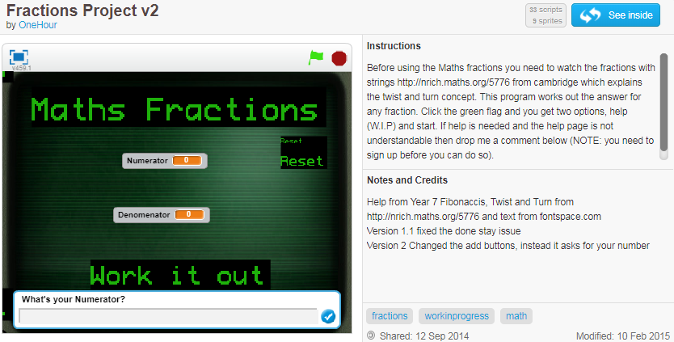
This has a connection to math at nrich site https://nrich.maths.org/5776

Twisting and Turning

Stage: 3
The mathematician John Conway developed an interesting trick you can do with two skipping ropes and a number which we've reproduced in the video below. He only allows two operations: twisting and turning.
Twisting has the effect of adding 1: 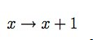
Turning transforms any number into the negative of its reciprocal 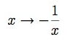
Take a look at this video:
If you can see this message Flash may not be working in your browser
Please see http://nrich.maths.org/techhelp/#flash to enable it.
This is how the ropes got tangled:
Twist, twist, turn, twist, twist, twist, turn, twist, twist, twist, turn.
This is the sequence of numbers it produced:
0, 1, 2, -1/2, 1/2, 3/2, 5/2, -2/5, 3/5, 8/5, 13/5, -5/13...
and this is how they got disentangled:
Twist, turn. twist, twist, turn. twist, twist, twist, turn, twist, twist, twist,
generating these numbers:
...8/13, -13/8, -5/8, 3/8, -8/3, -5/3, -2/3, 1/3, -3, -2, -1, 0.
Starting at zero (with both ropes parallel), what would you end with after the following sequence of moves:
Twist, twist, twist, turn, twist, twist, twist, turn, twist, twist, twist, turn.
What sequence of moves will take you back to zero?
You may want to take a look at More Twisting and Turning after this.

Fraction Studios https://scratch.mit.edu/studios/1887996/
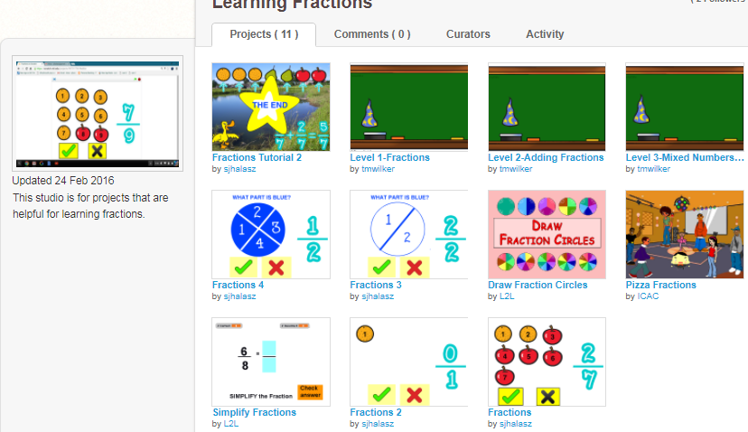

https://wiki.scratch.mit.edu/wiki/Fractions

Fractions
Fractions are rational numbers that are expressed as a single unit composed of a ratio of two or more values. Wikipedia defines a fraction as "any part of a unit". Decimal numbers are fractions written in a different format. For example, 0.5 is a fraction, as it represents the ratio "5/10" or "1/2". -1.4 and 5.67 are also fractions because they are decimal numbers. One-half of an apple is also a fraction of an apple. These numbers can also be called decimal numbers or floating point numbers.
An integer may even be written as a fraction. For example, the integer 2 may be written as "2/1" or "6/3". The numerator of a fraction is the value on the top; the denominator is the value on the bottom. Fractions may even contain other fractions inside of them. These are known as "complex fractions". The base operation relating to fractions is division; the numerator divided by the denominator can convert a fraction into a decimal format, which may be less exact.

Contents
- 1 Glitches with Fractions
  - 1.1 Displaying Fractions on Screen
  - 1.2 Floating Point Calculations
- 2 Scratch's functions returning floating point numbers
- 3 References

Glitches with Fractions

Displaying Fractions on Screen
In Scratch, using a variable or an operation that can return a floating point number, attempting to go to that point can cause problems since a fraction of a pixel cannot exist on screen. Scratch normally handles this itself, but with certain decimal numbers, pen does not show up. This can be a problem for many projects, but is easily fixable. Instead of:

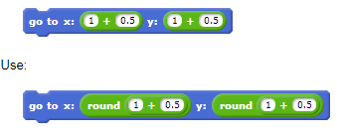Floating Point Calculations
There is also a big glitch with math problems using floating point numbers in general. For example, entering ceiling(5.0) will return 6.^{[1]} Other errors will happen when changing a variable by -0.1. If you want to do this until the variable equals 0, the loop will never stop. This is because computers use binary (1s and 0s). And, 0.1 can not be represented exactly in binary because it is infinite in binary.
More, less obvious glitches are when Scratch gets a floating point calculation wrong because of low accuracy with them.

Scratch's functions returning floating point numbers
Some of Scratch's functions will return fractions. For example, the () of () blocks will almost always return a fraction.

