Find Your Name DASH or BlueBot Activity
This is an activity you can use during the first week of camp. The camper prints his or her name on a piece of paper, puts the paper on the floor and then drives DASH to the name. I folded the top third of the paper so it would stand up and campers could see it rather than just flat on the floor.
Variations can be:
Other words on the paper – vocabulary from a story, basic vocabulary (days of the week, etc.)
Pictures on the paper - “Drive DASH to the red circle, then to the blue triangle and then the yellow trapezoid”
Numbers on the paper either in order or mixed up– “Drive DASH to the numbers and counting by 1’s or 2’s … “
Number sentences on the paper – “Drive DASH to all the number sentences that equal 12 …” (find out from the teachers what the Number Talk will be and try to connect an activity to that idea – see below for info on Number Talks)
BlueBot app variation would be to put the words on a chart paper, take a photo of it and put it in as a background and then code BlueBot to move around to the selected works or numbers.
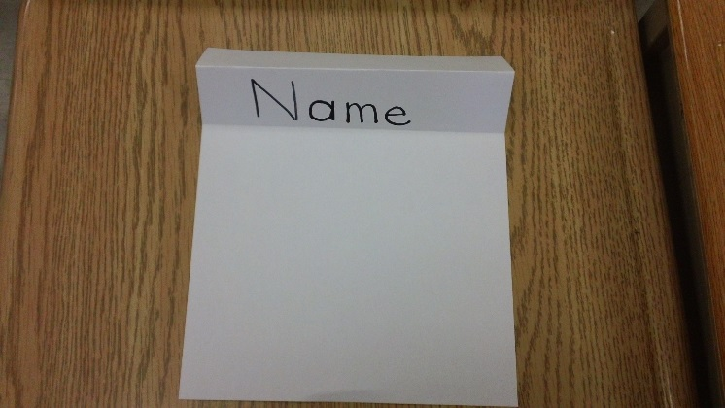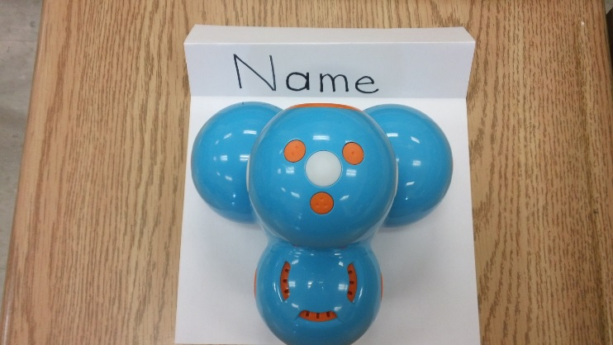
If you aren’t familiar with Number Talks here are some YouTube videos (around ten minutes each):
https://www.youtube.com/watch?v=X18cQkKMlhs
https://www.youtube.com/watch?v=eINuMAKuq0w
https://www.youtube.com/watch?v=94zNNQ-rL88
https://www.youtube.com/watch?v=zGHiS0W2_jQ
https://www.youtube.com/watch?v=gLOZiSX7lT0
Here is a long video (1:15) from Sherry Parrish (https://www.youtube.com/watch?v=twGipANcIqg ) who wrote
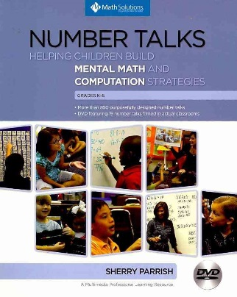
****If you do this activity take photos and share with the rest of us so we can generate ideas for all to use.

