EcoMazes (12 Earth Adventures)
Author: Roxie Munro (2010); Publisher: Sterling Publishing Co., Inc. c/o Canadian Manda Group 165 Dufferin Street Toronto, ON M6K 3H6. https://www.roxiemunro.com/ecomazes.html & https://www.pinterest.ca/pin/99571841732575925/
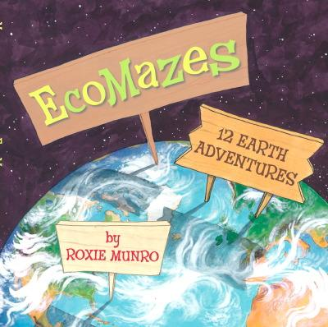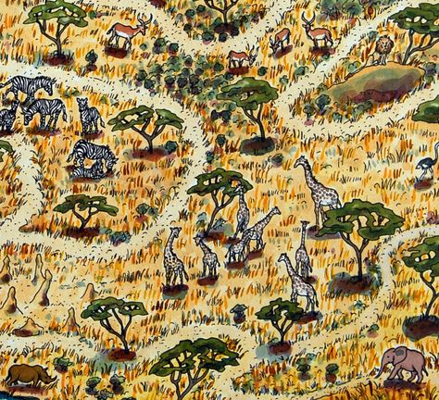
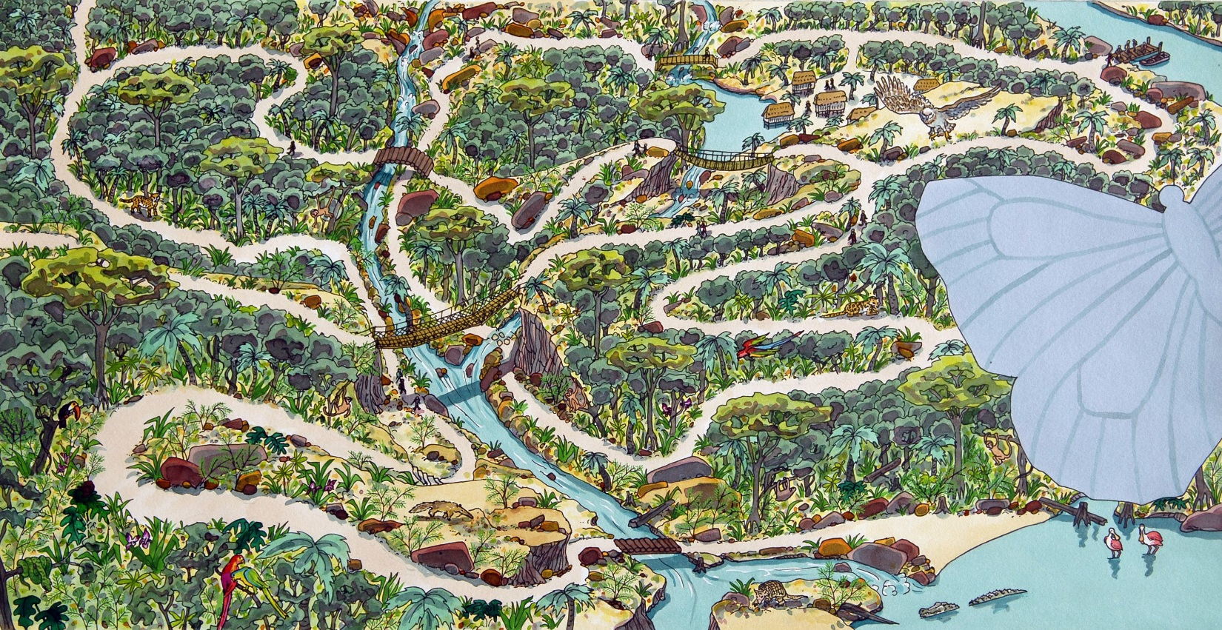

Small Group or Whole Class Project
Supplies: square piece of paper or Bristol board for each individual or small group; art supplies such as colouring pencils, paint, construction paper, etc.; painter’s tape
Focus: Students design and create a section of a grid that when put together will make a maze of an environment and the animals within it based on the book EcoMazes and program DASH to go through the maze.
For example, if 4 students work together and put their 4 squares together they will draw a path for DASH to travel to all four grid cells. At each cell a student has added illustrations of the habitat and animals in that habitat. The coding of DASH will include recording information about the habitat and the animals.
A2 | B2
A1 | B1

Note: making this a whole class project would take much cooperation and coordination to have one DASH go through all the grid cells. Space to lay the paper grid out to code would need to be taken into consideration.
Note: DASH moves in straight lines when coded. If a curved path is drawn you can use the GO app (https://www.makewonder.com/apps/go/) DASH can be “driven” around like a remote controlled car.

