Drummer Project
Red Line (Tracer) moves across the screen “touching” Sprites who make sounds
Live Link to download program

Directions for Creating a Drummer in Scratch
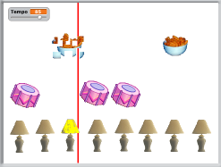
Working Example
Instructions for Creating Drummer Project
1. Make Variable "Tempo"
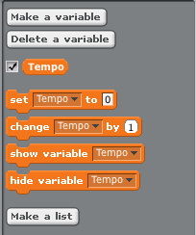

2. Create Tracer Sprite (One Vertical Line). Add these scripts and test.
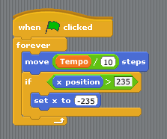
3. Import Drum Image and create two costumes. Add these scripts:
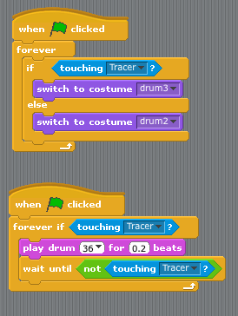
4. Add additional Sprites with different "drums" to create a beat!
5. Save and test your program!
Credit to: Nebo Elementary School, Department of Fine Arts, Mr. Michaud
http://nebomusic.net/scratchdrummer.html

