Doodle for Google Canada
4 minute video for project is located in several spots, first at the CLC site, http://teacherslearningcode.com/en/lessons/doodle-4-google
or on the You Tube site, https://www.youtube.com/watch?v=MYlfiWBMHjc
You could also access it through the Canada Learning Code Channel https://www.youtube.com/channel/UCGe1pjWRuqXDMp2WbZjbrWQ
The video is directed towards teachers and explains how to alter the letter sprites in the Costumes Tab.
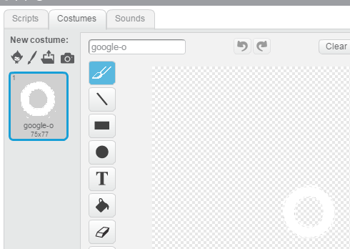
And then shows several ideas for Scripts that involve motion and sound. However, these two actions are not the only things the Letter Sprites can do. Although it is not mentioned the Events Block, broadcast can be used to connect the motions of the Letter Sprites rather than have each Letter Sprite react to the Event Block, when this sprite clicked.
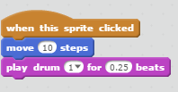
The starter Scratch project is: https://scratch.mit.edu/projects/149772967/ (Unlike the other CLC Scratch projects there is NO Final project).
Activity 1
- In groups of 6 have students brain-storm a theme that they will use across their team doodle.
  - These themes could include: Canada’s history, Canada today, Canadian foods, Canadian animals, Canadian technology, Canadian innovation etc.
- Students will play a game that is traditionally called exquisite corpse where they will each add a letter drawing inspired by their theme to their doodle
  - Have students fold a sheet of paper into 6 even parts (a larger sheet of paper may be best).
  - Students should decide the order they want to go in from 1-6.
  - Students will draw a letter on the sheet then fold it to hide their letter from the next person.
  - Have the first student draw their doodle just for the letter ‘G’, the second ‘O’, third ‘O’, fourth ‘G’, and so on until the group has drawn Google.
  - Once every student has drawn a letter, have the group unfold the paper to look at their completed doodle.
- Have the small groups reflect on what they liked about the activity, what they noticed (are there similarities in some of the drawings), and what they think they will change when creating their own original doodles.

Activity 2
- Watch these two videos to get students inspired to doodle.
  - Imagine
  - https://www.youtube.com/watch?v=2xfrdrkDZkA (October 18, 2015, Doodle 4 Google) This is a 4 minute video produced by Google with actual Google Doodlers explaining their creative process.
  - The Doodle 4 Google You Tube Channel has many interesting Doodles for students to view:
  - https://www.youtube.com/channel/UCdq61m8s_48EhJ5OM_MCeGw
- 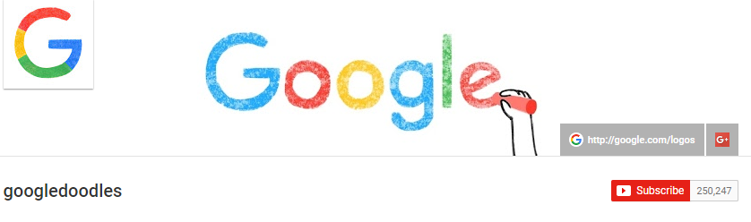
  - Create
  - https://www.youtube.com/watch?v=W82fLngt0P8 (October 18, 2015, Doodle 4 Google) This is a 3:24 minute video produced by Google
- Using any materials available have students individually create a doodle.
  - This could include: clay, paint, pencils, or any other materials that allow them to express their inner artist.

Activity
Open up the Scratch template, https://scratch.mit.edu/projects/149772967/
(1) click See Inside 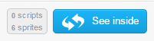
(2) select remix
(3) rename your project by adding your name
You’ll see all the G-O-O-G-L-E Letter Sprites on the stage.
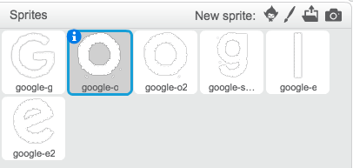
Click on a letter. Then, click on the Costumes tab to begin designing the letter.
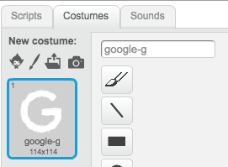
Explore the changes you can make like drawing, making lines, adding images, shapes, etc.
Here’s an example to show to how to make the letter shape still visible while changing the look and feel of the letter.
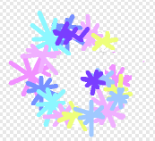
Once all your Letter Sprites are decorated let’s learn how to make them dance!
Click on a Letter Sprite to start with and switch back to the Scripts tab. Add an Events Block, when this sprite clicked block.
Add a Motion Block, move 10 steps. The number of steps in this block is a variable that can be changed.
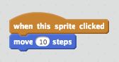
This letter needs a beat to dance to so add a Sound Block, for example, play drum 1 for 0.25 beats (decide what instruction or sound you want for your Letter and how long you want the sound to play).
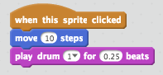
Now you can make the letter take a step back by adding another motion block but this time you take advantage of the variable in the move block to move the letter -10 steps. If it moves 10 in one direction and then
moves -10 it will end up back in the same spot it started.
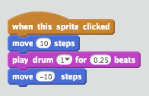
If you want to add a second sound go ahead. You may want to switch up the drum this time. Click on the black arrow for the dropdown menu choices to select a different drum sound or a different instrument or sound.
