DASH Life Cycle Resources YouTube Videos
https://www.youtube.com/watch?v=EADIWFaxsH4 Frog Life Cycle (5:10) series of videos of small group projects. Stages are drawn on white paper and laid on a blue plastic sheet on top of tiled floor. DASH moves to each picture and students’ recording tells what is happening at each stage.
https://www.youtube.com/watch?v=gIPGv0eu25k (0:36) Frog Life cycle but instead of children’s drawing, professional pictures of each stage are used.
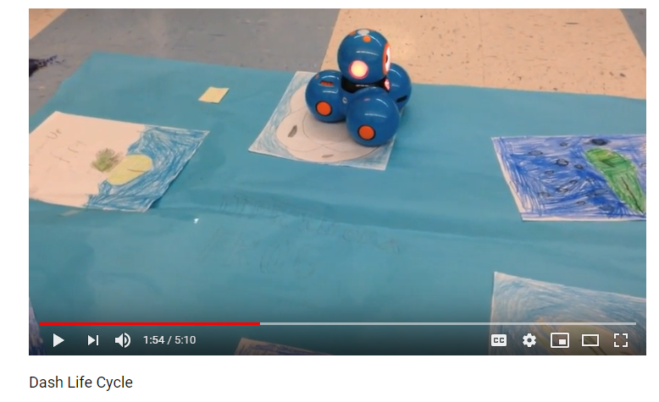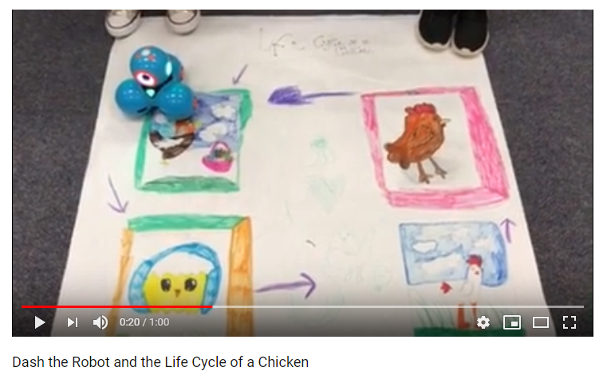
https://www.youtube.com/watch?v=998LWcoTC5U (1:00) Children draw pictures

https://www.youtube.com/watch?v=5PiT9MGqzqE (1:33) video done in a home. Floor has painter tape grid on floor and professional pictures are in grid cells while DASH moves around grid and recordings state info about each stage
