DASH and The Smushy Bus
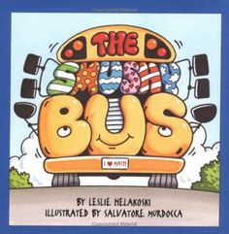
Author: Leslie Helakoski Illustrator: Salvatore Murdocca ISBN: 0-7613-1917-4
Publisher: (2002) Millbrook Press of Lerner Publishing Group Minneapolis: MN

Story Summary: At the end of a school day the regular school bus is out for repairs. Mr. Mathers comes to pick up the students at Addington School. The first half of the book talks about how he groups the students to fit into the bus (for example, “16 kindergarteners were trying to get on the bus. Looking around, Mr. Mathers noticed 8 bookshelves about the seats. He slide 2 kindergarteners, toes in first, onto each shelf. They were a bit slipper from crying so they fit in quite easily”). Second half of book talks about many children are dropped off (for example, “When the bus stopped at Second Street, 61 children groaned, 16 children jumped out of the windows, and 5 children slid off the top of the bus. “Be sure to use the proper steps,” said Mr. Mathers”).
There are three different options for tasks with this book. One is a story map task. The second, is a number line task. The third is a grid task. Each have value depending on your focus for the activity.
Story Map: When driving or coding DASH it can go from place to place like the tasks for Ten Black Dots or Big Chickens. In this task students draw a school and DASH starts there. Then they draw a street corner labelled First Street and DASH goes there. At this point the Students can say “there were 76 students on the bus. 16 jumped out the window and 5 slide off the top of the bus. That means there are 55 students still on the bus.” The placement of the “artwork” of the various places from the book (i.e., the school, First Street, Second Street …) is random and can be moved around to increase or decrease the difficulty of thee driving or coding.
Number Line: DASH can go up and down a single straight line. This way shows visually the total increasing when adding and decreasing when subtracting. It can be demonstrated (and practiced) using a number line on chart paper like we do so often in our Number Talks.
There are 76 students getting on the Smushy Bus. So the masking tape line will need to be 7.6 metres long. It could be marked off at 10 cm intervals to make a number line from 0 to 76. For the start, 16 kindergarteners load on so DASH would move 160 cm along the line (or to the number 16). Depending on how the students decide to code they can change the distance variable and the speed variable.
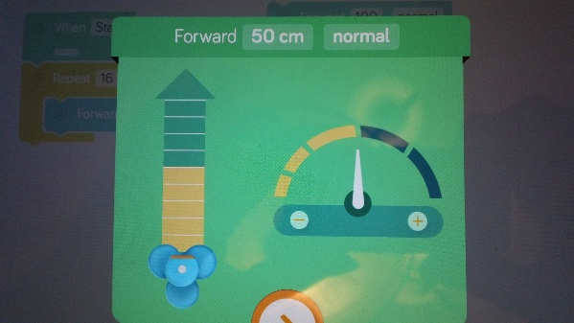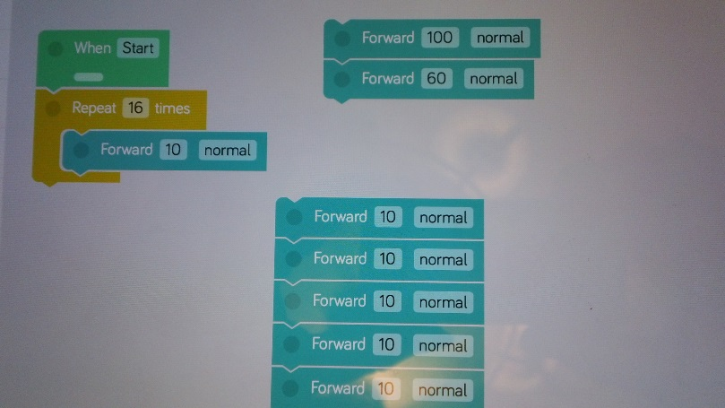
So the coding could be: 16 Forward 10 Blocks; a Repeat 16 times Forward 10 Block; or any combination to have 160 (smallest amount is 10 and largest amount is 100).
Then at the end of the number line (when the Smushy Bus gets to the first stop) DASH can either turn around and use the Forward Block or use the Backward Block.
Grid: Mark off a grid on the floor (or mat) with 10 cm cells. In various cells put different story locations. For example, Cell A1 is the location of Addington Elementary School and Cell D5 is First Street. Then driving or coding DASH involves the math curriculum concept of location and movement of objects in a grid system. It can be demonstrated (and practiced) using chart grid paper.
Extensions:
● Have your students create their own version of The Smushy Bus story with their own school, number of students, and bus route.
● Do your students want to use “bigger” numbers? Then change the bus to a train or plane.
● Here is an art blog with students’ art of book cover: http://eshelmanartcca.blogspot.ca/2011/03/

DASH and The Smushy Bus Task Card - Story Map

Directions:
Make a list of all the places the Smushy Bus goes in this story and the number of children who get on and off.
Draw pictures of the places.
Arrange the place pictures on the floor.
Use Go app or Controller in Wonder app.
Decide who is the Robot Driver and Manager to start.
The Robot Driver drives DASH to the first place.
The Robot Manager tells what happens at this place and how many children are on the bus.
Switch roles, so the Robot Manager becomes the Driver and goes to the next place. The other student tells what happens at that place.
Go to all the places in the order to retell the story.
Now can you use Blockly app and code DASH to go to all the places?
Next, are you ready to make your OWN bus route and decide how many get on and off? Go for it!

DASH and The Smushy Bus Task Card – Number Line
Make a number line long on paper enough for all the students on the bus (Hint: 76 students).
Move on top of the number line to show how many students get ON the bus and move on the bottom of the number line to show how many students get OFF the bus.
Find a safe spot to make a masking tape number. Mark off each 10 cm and print 0 to 76 on each hash mark.
Use Go app or Controller in Wonder app.
Decide who is the Robot Driver and Manager to start.
The Robot Driver drives DASH to the first number.
The Robot Manager tells how many children are on the bus.
Switch roles, so the Manager becomes the Driver, goes to the next number. The other student tells how many children are on the bus.
When you get to the end of the number line turn around or go backwards to show the students getting off the bus.
Now can you use Blockly app and code DASH to go to all the numbers?
Next, are you ready to make your OWN bus route and decide how many get on and off? Go for it!

DASH and The Smushy Bus Task Card – Grid

Make a town grid on chart graph paper. Label the rows and columns. Decide where the bus will stop. Make lists of the number of people who get on and off at each stop. Create a code tree that makes a bus route with all the stops.

Find a safe spot to make a grid with cell squares.
Add vertical & horizontal grid ID’s (letters & numbers or street names & avenue names). Add buildings, parks, schools, homes, etc.
Use Go app or Controller in Wonder app.
Decide who is the Robot Driver and Manager to start.
The Robot Driver drives DASH to the first bus stop.
The Robot Manager tells how many people get on, off and how many are on the bus. For example at “Stop A3 (corner of A Street & 3rd Avenue) pick up 5 people. Now there are 11 people on the bus.”
Switch roles, so the Manager becomes the Driver and goes to the next stop. The other student tells the information.
Don’t forget the bus repeats the same route over again.
Now can you use Blockly app and code DASH to go to all the stops?

Addington School
How many children attended Addington School from …
Grade | Number of Students in this grade | Number of Students altogether
Kindergarten

Grade 1

Grade 2

Grade 3

Grade 4

Grade 5

Total Number of Students

Mr. Mathers’ Bus Route
Bus Stop | Number of Students on the Bus | Number of Students who get off the Bus | Number of Students left on the Bus
First Street

Second Street

Third Street

Fourth Street

Fifth Street

