DASH and The Greedy Triangle
Marilyn Burns (1994). ISBN 0-590-48991-7. Marilyn Burns Brainy Day Books, Scholastic Inc. NY: NY
Suggestions:
● Use masking tape or sections of measuring tape (cut in varying 10 cm lengths, 10 cm, 20 cm … 100 cm). DASH travels in 10 cm intervals. Sometimes it is easier to tape down the two meeting ends of a measuring tape so that students can see the length of a side.
An additional conversation can be built around the question, “If the DASH Forward-Block moves 10 cm, how many blocks will you need for 80 cm?”
“8 Forward 10 blocks” “1 Repeat 8 block and 1 Forward 10 block” “2 Forward blocks, Forward 40 and Forward 40” …
● It is also a good idea to test out how sticky the tape is and how EASY it will be to pull it off after the activity is done!!!!
● Finding the correct spot and angle to start DASH will take some debugging. DASH should either travel on the tape or parallel to the tape. Students soon come to see that a small number of degrees angling off the perimeter gets greater and greater the farther DASH goes. It will be useful to always start at this position each time. Marking it with masking tape is useful.
● Understanding how DASH turns can take some time and support for some students.

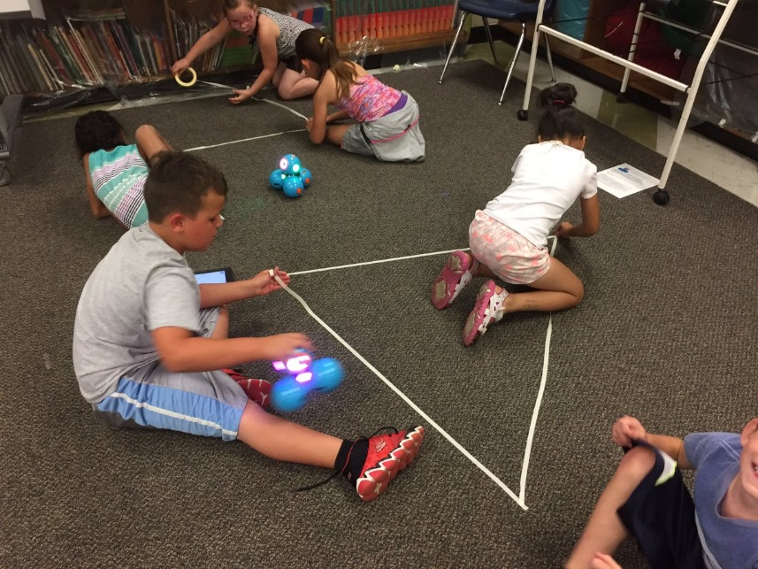
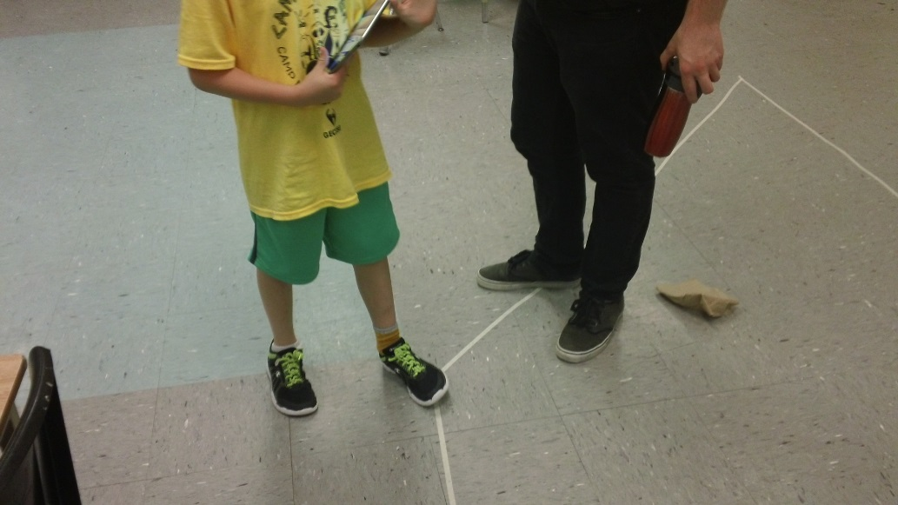

What Else?
Can you design a device to attach to DASH so DASH can draw your polygon?
https://www.youtube.com/watch?v=0Xh__bvTIj8
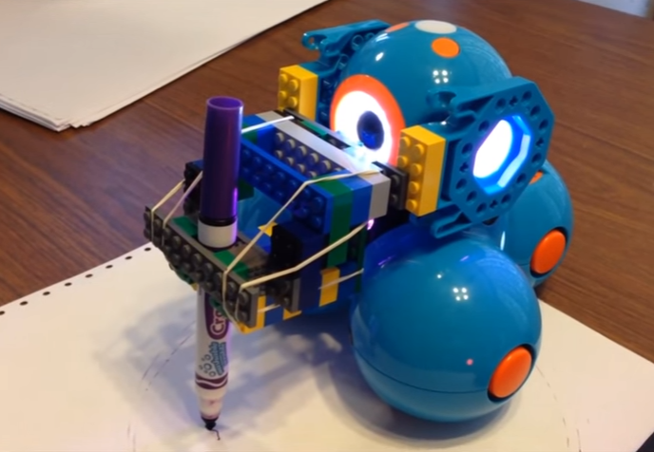

https://www.youtube.com/watch?v=gkvzjHdRLuk
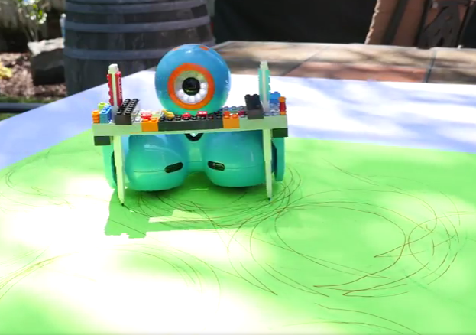

The Greedy Triangle
We are going to make a …
___ triangle ___ quadrilateral ___ pentagon ___ hexagon ___ heptagon
___ octagon ___ nonagon ___ decagon ___ undecagon ___ dodecagon
___ _ _ _ _ _ _ _ _ agon
It will have ____ sides and _____ angles. It will be _____ regular or _____ irregular.
Here is a sketch of our polygon. It is a shape with sides that are straight line segments. The word polygon comes from the Greek language – poly means many and gon means angle. When all angles are equal and all sides are equal it is regular polygon, otherwise it is irregular.

Greedy Triangle Task Card

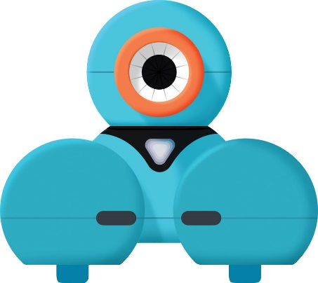

Decide what kind of polygon you are going to make.
Design your polygon and draw it on the worksheet.
Find a spot where you can have your polygon on the floor and make it.
Decide who will begin as the Robot Programmer and who will be the Robot Manager.
Decide if you will … Drive DASH using Go app or Wonder app or … Code DASH using Blockly app.

The Robot Programmer codes the first side.
The Robot Manager handles DASH. It might take some debugging to find the correct spot and position to start. You might need to debug the length of a polygon side.
At the first angle switch jobs.
Continue to program and manage DASH until you have coding the perimeter of the polygon.
Decide if you want to take a screen shot of your coding to write about your program.

