Equal Shmequal and DASH
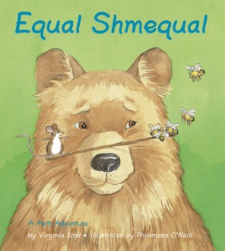
Equal Shmequal A math Adventure
Author: Virginia Kroll; Illustrator: Philomena O’Neill. Charlesbridge Publishing, Inc. 2005 Watertown, MA ISBN 978-1-60734-155-0
Story read on You Tube https://www.youtube.com/watch?v=zzQ-Mv7RCv8 (book reading starts at 3:15)
Ontario Ministry of Education Math Curriculum Connections (http://www.edu.gov.on.ca/eng/curriculum/elementary/math.html)
Introduction: Strands in the Mathematics Curriculum Introduction: Patterning and Algebra.
One of the central themes in mathematics is the study of patterns and relationships… A second focus of this strand is on the concept of equality. Students look at different ways of using numbers to represent equal quantities. Variables are introduced as “unknowns”, and techniques for solving equations are developed. Problem solving provides students with opportunities to develop their ability to make generalizations and to deepen their understanding of the relationship between patterning and algebra (p. 10)
Expressions and Equality (p. 40)
By the end of Grade 1, students will:
– demonstrate examples of equality, through investigation, using a “balance” model (Sample problem: Demonstrate, using a pan balance, that a train of 7 attached cubes on one side balances a train of 3 cubes and a train of 4 cubes on the other side.);
– determine, through investigation using a “balance” model and whole numbers to 10, the number of identical objects that must be added or subtracted to establish equality (Sample problem: On a pan balance, 5 cubes are placed on the left side and 8 cubes are placed on the right side. How many cubes should you take off the right side so that both sides balance?).

Expressions and Equality (p. 50)
By the end of Grade 2, students will:
– demonstrate an understanding of the concept of equality by partitioning whole numbers to 18 in a variety of ways, using concrete materials (e.g., starting with 9 tiles and adding 6 more tiles gives the same result as starting with 10 tiles and adding 5 more tiles);
– represent, through investigation with concrete materials and pictures, two number expressions that are equal, using the equal sign (e.g., “I can break a train of 10 cubes into 4 cubes and 6 cubes. I can also break 10 cubes into 7 cubes and 3 cubes. This means 4 + 6 = 7 + 3.”);
– determine the missing number in equations involving addition and subtraction to 18, using a variety of tools and strategies (e.g., modelling with concrete materials, using guess and check with and without the aid of a calculator) (Sample problem:
Use counters to determine the missing number in the equation 6 + 7 = + 5.);
– identify, through investigation, and use the commutative property of addition (e.g., create a train of 10 cubes by joining 4 red cubes to 6 blue cubes, or by joining 6 blue cubes to 4 red cubes) to facilitate computation with whole numbers (e.g., “I know that 9 + 8 + 1 = 9 + 1 + 8. Adding becomes easier because that gives 10 + 8 = 18.”)

Expressions and Equality (p. 62)
By the end of Grade 3, students will:
– determine, through investigation, the inverse relationship between addition and subtraction (e.g., since 4 + 5 = 9, then 9 – 5 = 4; since 16 – 9 = 7, then 7 + 9 = 16);
– determine, the missing number in equations involving addition and subtraction of one- and two-digit numbers, using a variety of tools and strategies (e.g., modelling with concrete materials, using guess and check with and without the aid of a calculator) (Sample problem: What is the missing number in the equation 25 – 4 = 15 +?);
– identify, through investigation, and use the associative property of addition to facilitate computation with whole numbers (e.g., “I know that 17 + 16 equals 17 + 3 + 13. This is easier to add in my head because I get 20 + 13 = 33.”).

Expressions and Equality (p. 74)
By the end of Grade 4, students will:
– determine, through investigation, the inverse relationship between multiplication and division (e.g., since 4 x 5 = 20, then 20 ÷ 5 = 4; since 35 ÷ 5 = 7, then 7 x 5 = 35);
– determine the missing number in equations involving multiplication of one- and two-digit numbers, using a variety of tools and strategies (e.g., modelling with concrete materials, using guess and check with and without the aid of a calculator)
(Sample problem: What is the missing number in the equation x 4 = 24?);
– identify, through investigation (e.g., by using sets of objects in arrays, by drawing area models), and use the commutative property of multiplication to facilitate computation with whole numbers (e.g., “I know that 15 x 7 x 2 equals 15 x 2 x 7.
This is easier to multiply in my head because I get 30 x 7 = 210.”);
– identify, through investigation (e.g., by using sets of objects in arrays, by drawing area models), and use the distributive property of multiplication over addition to facilitate computation with whole numbers (e.g.,“I know that 9 x 52 equals 9 x 50 + 9 x 2. This is easier to calculate in my head because I get 450 + 18 = 468.”).

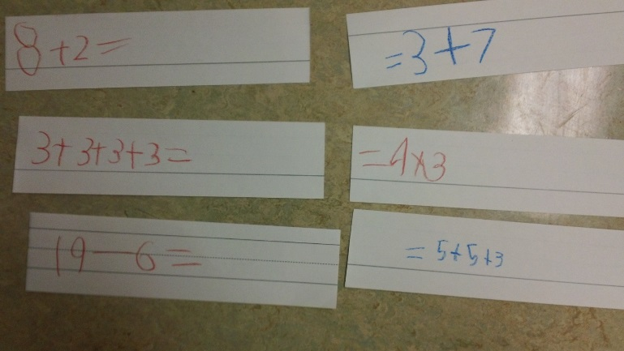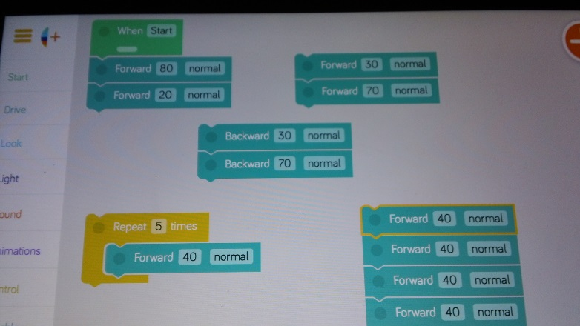
2nd photo of Blockly screen shows different coding trees for the following description of tasks …

With DASH students code number sentences and then prove or disprove they are equal. For example:
For the number sentences 8 + 2 and 3 + 7 code DASH to go 8 units (10cm) and then 2 units (see photo). Make a starting line on the floor. Execute the coding. Put a piece of tape where DASH ends. Then code 3 units and 7 units. Put DASH at the starting line and execute the coding. DASH should end up at the same spot. A second way to accomplish the same task is to mark of the end and then turn DASH around and make the end the start. Then, if the number sentences are equal DASH should end up at the original start. A third way is to determine the sum of 8 + 2 as 10 and to subtract (go backwards) 7 units, then 3 units and see if DASH returns to the starting line.
Hint: Make a number line on the floor with masking tape or tape measures helps students “see” the values of the number sentences.
With multiplication number sentences the idea of Loops (see photo of Blocky screen above) in coding has DASH repeat the coding blocks according to the variable selected. For example code 4 + 4 + 4 + 4 + 4 and mark off the end point. Then code 4 X 5 by using move forward 4 units within a loop and repeat 5 times. Execute the coding and see if DASH can prove them equal.
Web 2.0 balance math application http://www.crickweb.co.uk/ks2numeracy-calculation.html#nbKS2
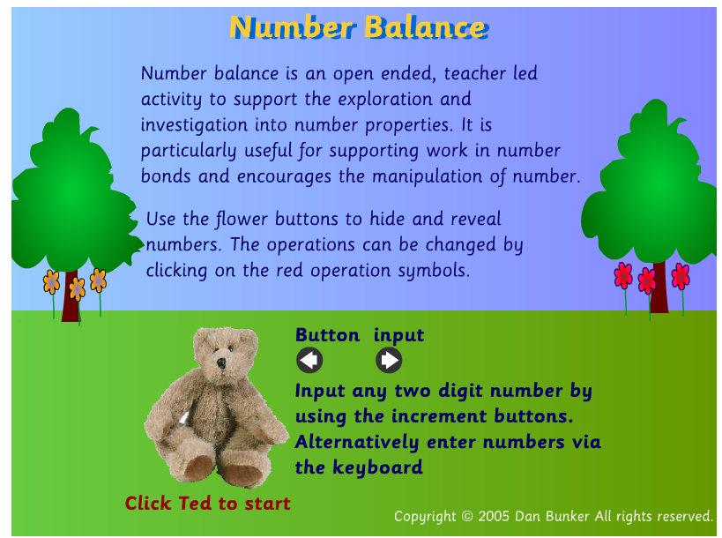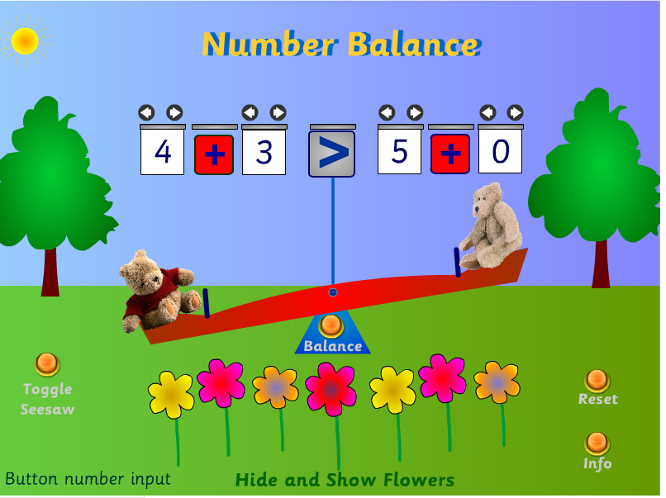
NCTM has three different interactive apps for balancing (Shapes, Numbers and Expressions)
Pan Balance Shapes: https://illuminations.nctm.org/Activity.aspx?id=3531
Pan Balance Equations: https://illuminations.nctm.org/Activity.aspx?id=3530
Pan Balance Expressions: https://illuminations.nctm.org/Activity.aspx?id=3529
