DASH and Counting Books
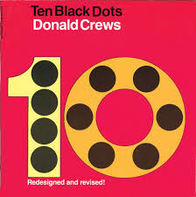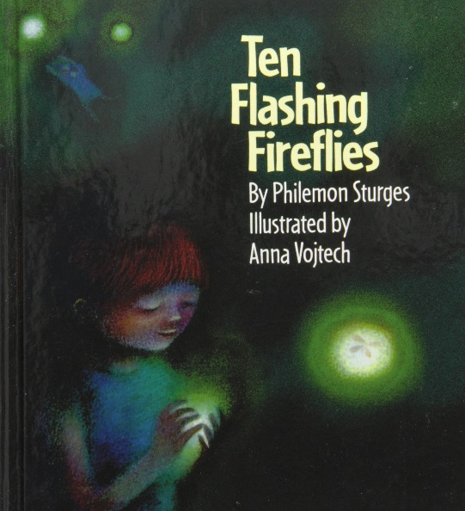
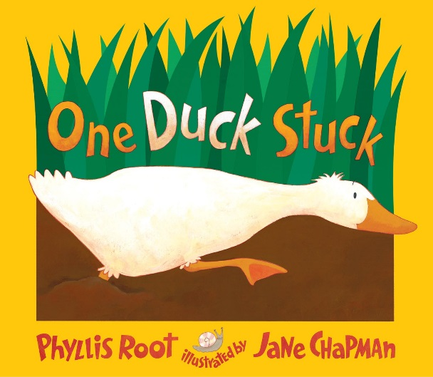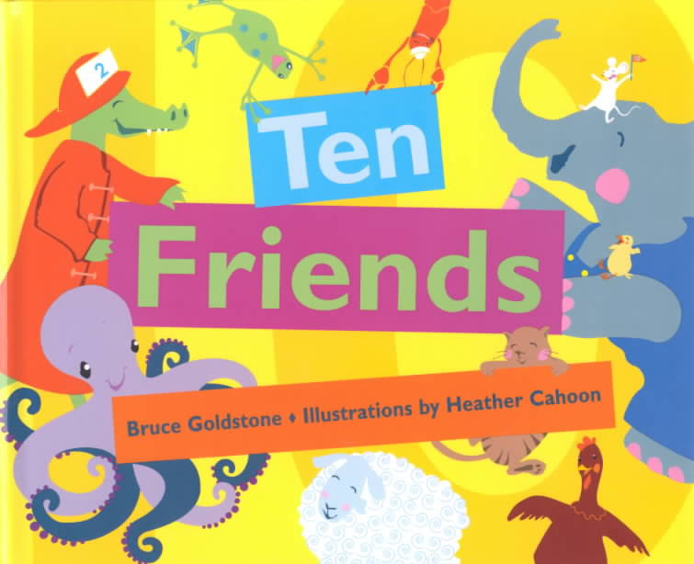

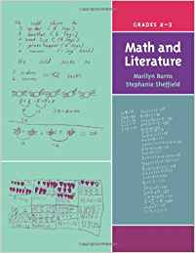 One Duck Stuck p. 59 to 72 and Ten Friends p. 120-127

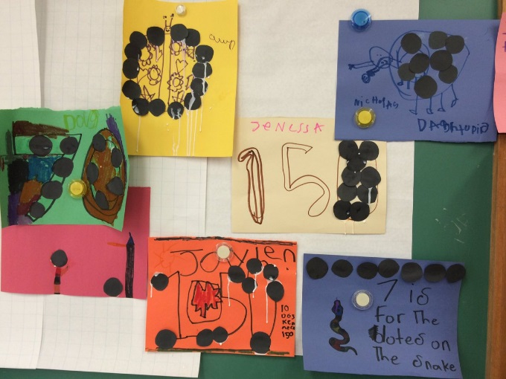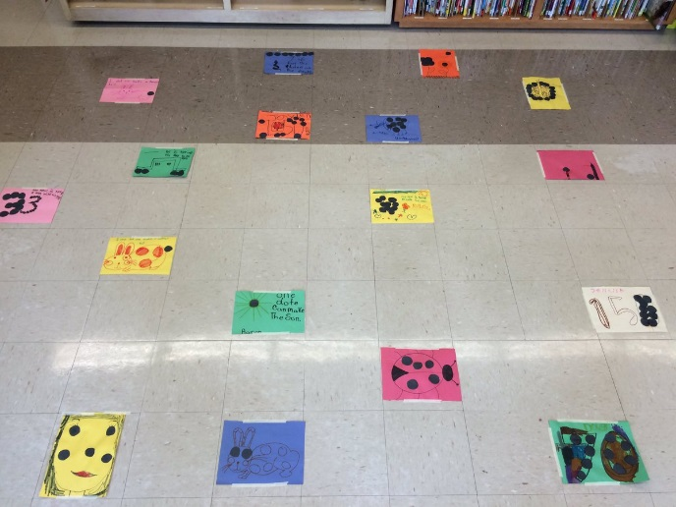

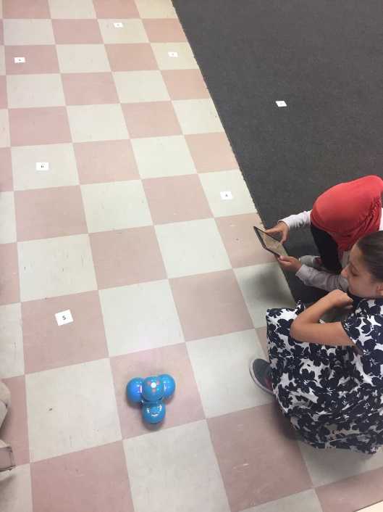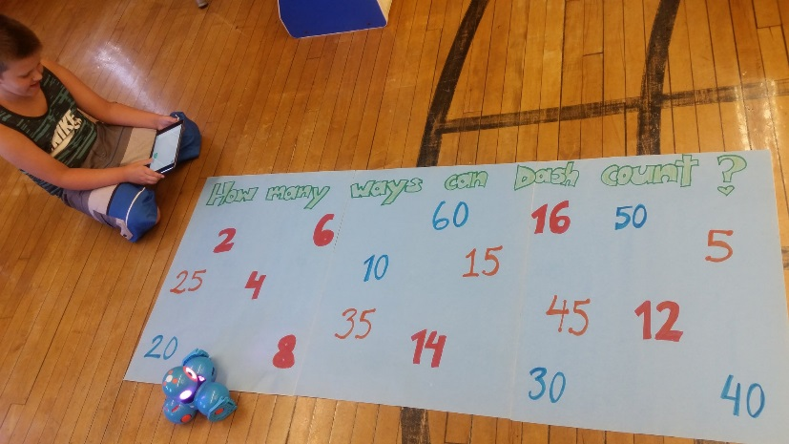

Ten Black Dots Task Card
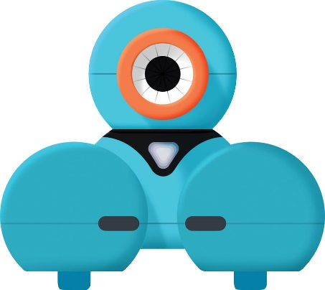

Lay the dot art work on the floor.
Spread then out and make sure the order is mixed up.
Pick one of these tasks to complete with your partner. Make sure to share the Robot Programmer and Robot Manager jobs.

Drive DASH from the least number of dots to the most number of dots.
Code DASH to find two Ten Partner numbers.
Code DASH to go to three dot art works that add together to make the greatest sum.

Print other numbers on cards and lay them out on the floor.
Drive DASH from the least/smallest number to the greatest/biggest number.
Code DASH to go to three numbers that add together to make the greatest sum.
Code DASH to go to three numbers that when added together make a sum that
… is an odd number
… ends with 5 in the ones place value position
… is a multiple of 4
Make up your own problem and share with another group of students.

