DASH and Big Chickens

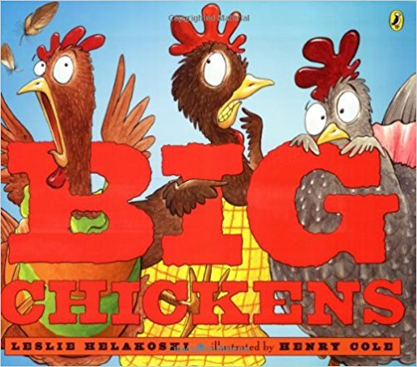
Book Information
Author: Leslie Helakoski Illustrator: Henry Cole (2006), ISNB: 0-525-47575-3
Dutton Children’s Books, a division of Penguin Young Readers Group, NY: NY
List of places in story setting: chicken coop, woods, deeper into the woods, deep ditch, mud in the bottom of the ditch, cow pasture, fence, lake, boat on lake, floating log on lake, and cave.

Big Chickens Task Card
Directions:
Make a list of all the places the chickens go in this story.
Draw pictures of the places.
Arrange the place pictures on the floor.
Use Go app or Controller in Wonder app.
Decide who is the Robot Driver and Manager to start.
The Robot Driver drives DASH to the first place.
The Robot Manager tells what happens in the story at this place.
Switch roles, so the Robot Manager becomes the Driver and goes to the next place and the other student tells what happens at that place in the story.
Go to all the places in the order the chickens do in the story and retell the story.
Don’t forget to get the chickens going back home at the end.
Now can you use Blockly app and code DASH to go to all the places?

