DASH and As the Crow Flies: Books that support Story Maps
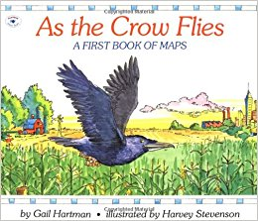
Author Gail Hartman Illustrator Harvey Stevenson (1993). ISBN 10-0689717628 Aladdin Publishers.
Ontario Ministry of Education Social Studies curriculum (http://www.edu.gov.on.ca/eng/curriculum/elementary/sshg.html )
Speaking to Communicate: Visual Aids/ Analyzing Texts
By the end of Grade 1 students will: | 2.7 use one or more appropriate visual aids (e.g., pictures, photographs, props, puppets, masks) to support or enhance oral presentations (e.g., use a set of plastic  animals during an oral recount about a visit to a zoo)
By the end of Grade 2 students will: | 2.7: use a few different visual aids, (e.g., photographs, artefacts, a story map) to support or enhance oral presentations (e.g., use a family photograph as part of an oral recount of an event; use a story map to retell a story)
By the end of Grade 3, students will: | 1.7: identify and explain the importance of significant ideas and information in oral texts (e.g., rank information in order of importance; compare key aspects of two oral texts using a Venn diagram; represent the main elements of an oral text on a web organizer or story map)

Reading for Meaning: Variety of Texts
By the end of Grade 1 students will: | 1.1 read a few different types of literary texts (e.g., pattern books, rhymes, books  from home, simple fiction stories), graphic texts (e.g., calendars, environmental  print, signs), and informational texts (e.g., morning messages, strategy charts,  instructions, simple non-fiction books, labels)
By the end of Grade 2 students will: | 1.1: read some different literary texts (e.g., poetry, folk tales, fairy tales from diverse cultures, stories, books from home in their first language), graphic texts (e.g., simple maps, charts, diagrams, graphs), and informational texts (e.g., “How to” books, non-fiction books about topics of personal interest, electronic texts, primary dictionaries)
By the end of Grade 3, students will: | 1.1: read a variety of literary texts (e.g., fables, traditional Aboriginal stories, poetry, chapter books, adventure stories, letters, diaries), graphic texts (e.g., comic books, posters, charts, tables, maps, graphs), and informational texts (e.g., “How to” books, print and electronic reference sources, magazine articles)
Writing: Developing and Organizing Content: Review
By the end of Grade 3, students will: | 1.6: determine whether the ideas and information they have gathered are relevant and adequate for the purpose, and gather new material if necessary (e.g., discuss the content with a peer or reading buddy; review material using a story map or web)
Other books to inspire mapping:
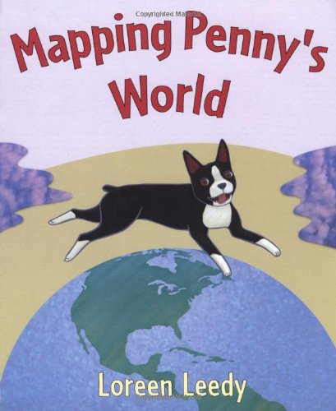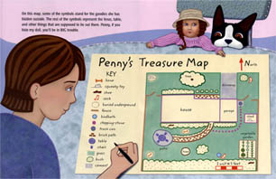
Author: Loreen Leedy (http://www.loreenleedy.com/index.html ) (2000)
ISBN 0-8050-6178-9 Henry Holt & Co. NY: NY
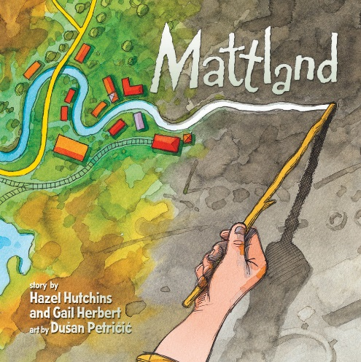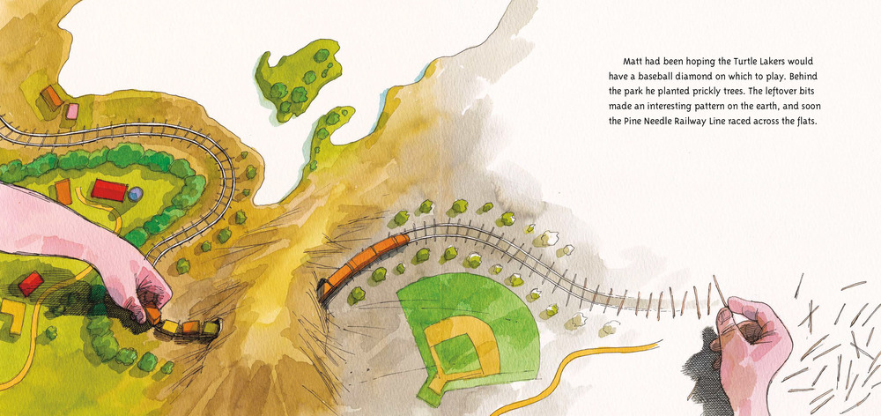
Authors: Hazel Hutchins & Gail Herbert Illustrator: Dušan Petričić (2008)
ISBN 0-978-1-55451-121-1 Firefly Books Ltd. For Annick Press. Richmond Hill: ON.
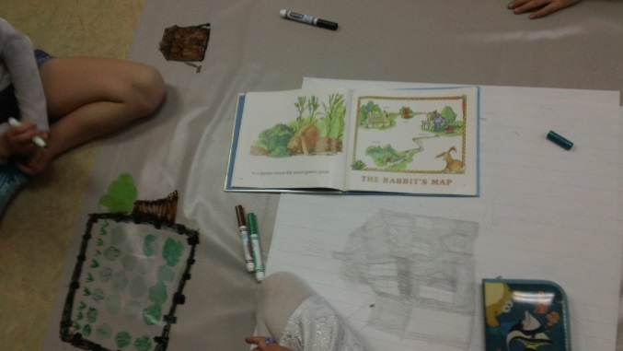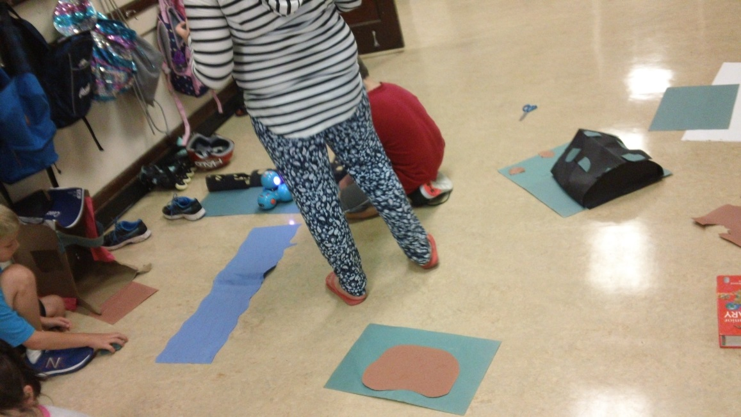
(1st Photo) Students made maps then coded DASH to travel using washable markers on vinyl. (2nd Photo) Students wrote story, created landmarks (some 3D!), coded DASH to retell story.

