DASH and Animals by the Numbers: Books that Support Inquiry

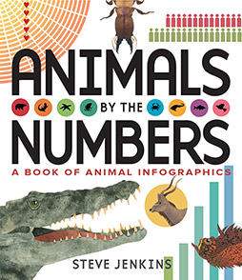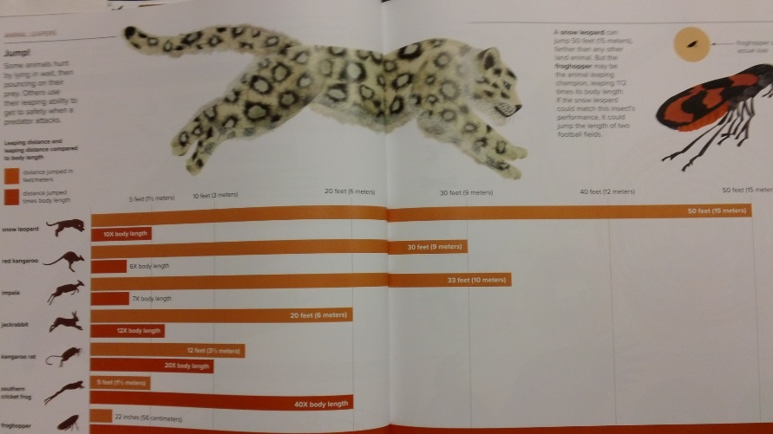
Chart of how far animals can leap.
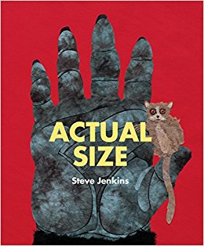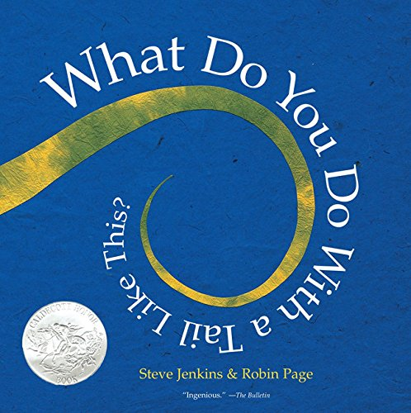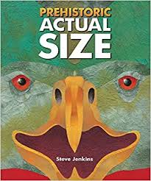

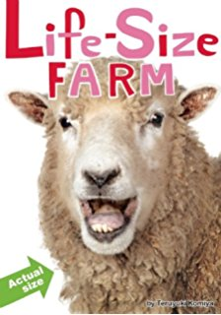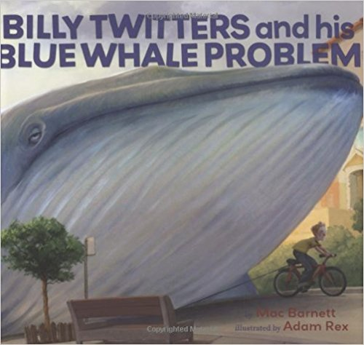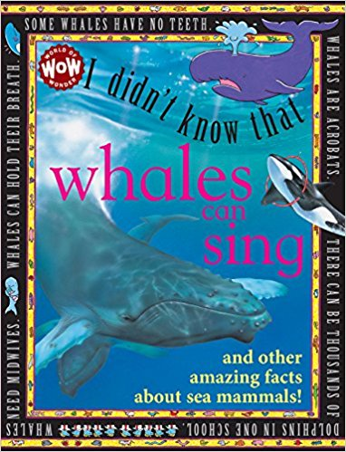
Students research animals. Draw them life size. Add facts. Code DASH to go around the perimeter of the animal or another aspect of animals (for example see photo of how far various animals can leap). Code DASH to go to fact and either record the information for DASH to “speak” or student reads fact when DASH stops at card.

Ontario Ministry of Education Language Curriculum Expectations
Speaking to Communicate: Clarity and Coherence
By the end of Grade 1, students will: | 2.3 communicate ideas and information orally in a clear, coherent manner (e.g., use a logical framework such as a beginning, middle, and end sequence to retell a story read aloud by the teacher)  … when explaining the coding of DASH robot  OR … when explain the facts discovered in the research project for …
By the end of Grade 2, students will: | 2.3 communicate ideas, opinions, and information orally in a clear, coherent manner using simple but appropriate organizational patterns (e.g., give an oral account of a current event using the five W’s to organize the information; restate the main facts from a simple informational text in correct sequence)  … when explaining the coding of DASH robot  OR … when explain the facts discovered in the research project for …
By the end of Grade 3, students will: | 2.3 communicate orally in a clear, coherent manner, presenting ideas, opinions, and information in a logical sequence (e.g., use an organizational pattern such as comparison or chronological order in presenting a short oral report)  … when explaining the coding of DASH robot  OR … when explain the facts discovered in the research project for …
Media Literacy 2:Understanding Media Forms, Conventions, and Techniques – Producing Media Texts
By the end of Grade 1, students will: | 3.4 produce some short media texts for specific purposes and audiences, using a few simple media forms and appropriate conventions and techniques  … when explaining the coding of DASH robot  OR … when explain the facts discovered in the research project for …
By the end of Grade 2, students will: | 3.4 produce media texts for specific purposes and audiences, using a few simple media forms and appropriate conventions and techniques  … when explaining the coding of DASH robot  OR … when explain the facts discovered in the research project for …
By the end of Grade 3, students will: | 3.4 produce media texts for specific purposes and audiences, using a few simple media forms and appropriate conventions and techniques  … when explaining the coding of DASH robot  OR … when explain the facts discovered in the research project for …

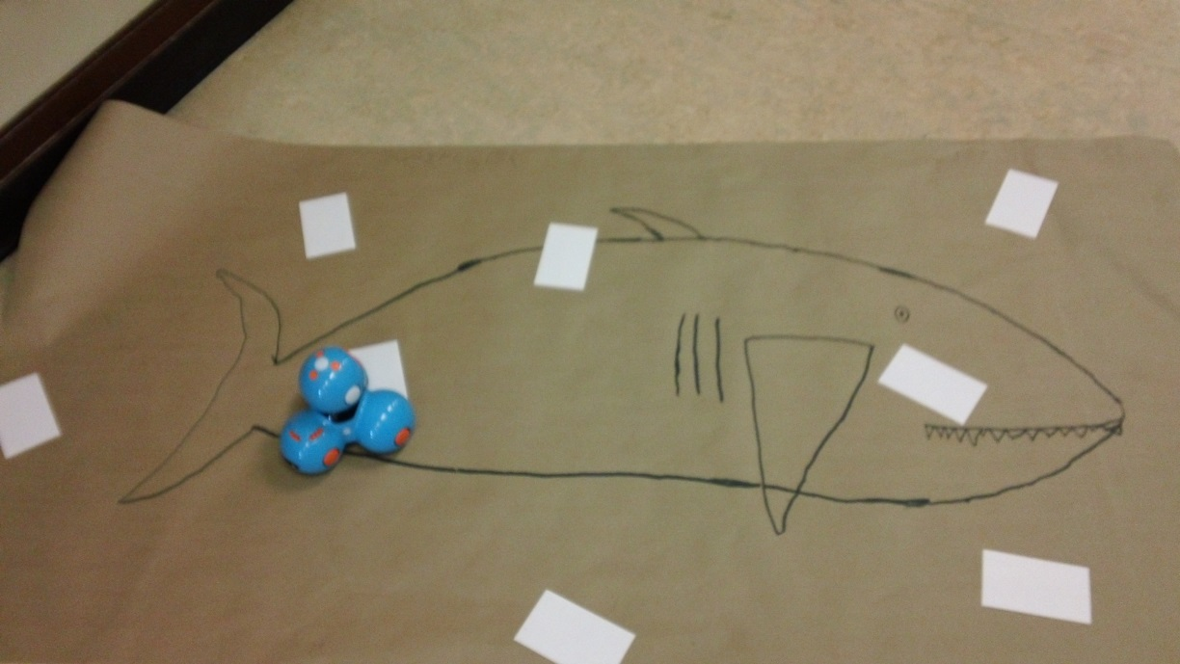
Research project on Sharks. Students drew life size shark and added facts they collected about sharks.

