DASH and A Remainder of One
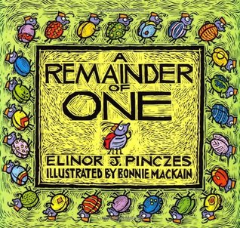
Author: Elinor Pinczes Illustrator: Bonnie MacKain ISBN: 0-618-25077-8
Publisher: (1995) Houghton Mufflin Co. NY: NY

YouTube Videos of Book reading: https://www.youtube.com/watch?v=Ubm16pTOUhk
& https://www.youtube.com/watch?v=s4zsaoAlMpM & https://www.youtube.com/watch?v=arT7OSEdu3U
Other Resources: Marilyn Burns (Math Solutions) Lesson Plan: https://www.mathsolutions.com/documents/0-941355-46-2_L.pdf
Also 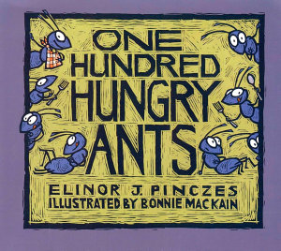 in 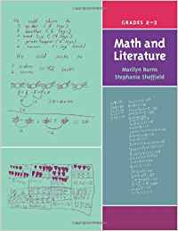 pages 73 to 83
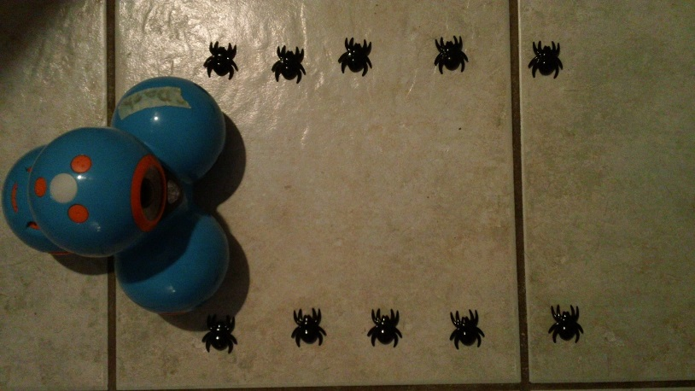
Dash and A Remainder of One

Use chart graph paper to arrange your bugs in an array.
Plan out your coding ideas.
Find a safe spot on the floor.
Arrange the bugs of the 25th Squadron in a parade formation (array) on the floor.
Make sure there is room for DASH to move through the rows or columns.
DASH is the parade queen and will need a crown.
Decide who will start as Robot Programmer and Robot Manager.
Decide if you will … Drive DASH using Go app or Wonder app or … Code DASH using Blockly app.
Have DASH inspect the squadron members by going back and forth through their ranks.
Decide when you will switch roles.
If you choice to code DASH can you use the Loop block to decrease the number of blocks used?
Pick a different Squadron. Repeat the task.

